THE INFLUENCE OF EXPERIMENTAL CONTEXT ON LEXICAL AMBIGUITY EFFECTS

THE INFLUENCE OF EXPERIMENTAL CONTEXT ON LEXICAL AMBIGUITY EFFECTS

Abstract

Previous research with visual lexical decision task demonstrated that polysemous words (multiple related senses) have a processing advantage when compared to unambiguous words, whereas homonymous words (multiple unrelated meanings) have a processing disadvantage. Although the same pattern of results was observed in Serbian, the two effects were investigated in separate studies. The aim of this study was to test whether the effects can be replicated when both types of ambiguity are presented within the same experimental list. To test this, we conducted three experiments. In the first one, mixed presentation of unambiguous, homonymous, and polysemous words did not reveal any of the ambiguity effects, leading to the conclusion that the experimental context may affect the presence of the results. The other two experiments were conducted to explicitly control for the experimental context. In both experiments, we presented each ambiguity type within the same block and counterbalanced the order of the block presentation. These experiments revealed the presence of the polysemy advantage, but not the homonymy disadvantage, which is a common pattern in the literature. Polysemy effects typically emerge relatively easily, whereas homonymy disadvantage requires additional conditions. Finally, we conclude that experimental context does play a role in ambiguity processing, although the order of presentation does not affect the overall results.

KEYWORDS: lexical ambiguity, polysemy, homonymy, experimental context

УТИЦАЈ ЕКСПЕРИМЕНТАЛНОГ КОНТЕКСТА НА ЕФЕКТЕ ВИШЕЗНАЧНОСТИ РЕЧИ

Апстракт

Претходна истраживања са задатком визуелне лексичке одлуке показала су да се полисемичне речи (више повезаних значења) обрађују брже од једнозначних речи, док се хомоними (више неповезаних значења) обрађују спорије. Премда је исти склоп резултата забележен и у српском језику, два ефекта су забележена у одвојеним експериментима. Циљ овог рада био је да се испита да ли се ови ефекти могу поновити када су обе врсте вишезначности налазе у оквиру исте експерименталне листе. Како би се то тестирало, изведена су три експеримента. У првом експерименту није забележен ниједан од ефеката вишезначности, што је довело до закључка да експериментални контекст може утицати на ефекте вишезначности. Друга два експеримента су настојала да додатно контролишу експериментални контекст. У оба експеримента, свака врста вишезначности је приказана унутар једног блока, а редослед излагања блокова је био контрабалансиран. У оба случаја је забележен ефекат полисемије, међутим ефекат хомонимије није, што је уобичајени склоп резултата у литературе. Ефекти полисемије се уобичајено јављају релативно лако, док су за јављање ефеката хомонимије потребни посебни услови. Коначно, можемо закључити да експериментални контекст утиче на обраду вишезначних речи, мада редослед излагања не утиче на типично забележене резултате.

Кључне речи: вишезначност речи, полисемија, хомонимија, експериментални контекст

INTRODUCTION

Lexical ambiguity is a very frequent linguistic phenomenon, in which one orthographic/phonological form may have different meanings/senses. Although there are multiple variants of such ambiguity, this paper focuses on two types, where one phonological and orthographic form can denote one or more meanings or senses, depending on ambiguity type. This subgroup is referred to in the literature as ‘semantic ambiguity’ (Eddington & Tokowicz, 2015), considering that the only differences exist within the semantic representations. Semantically ambiguous words can be divided into two subgroups – polysemous and homonymous words. Polysemous words are words with multiple related senses, such as the word paper, which can denote both writing paper, scientific paper and wrapping paper. On the other hand, homonyms are words with multiple unrelated meanings, such as the word bank, which denotes both a financial institution and land alongside a river (Stanojčić & Popović, 1995). Polysemy is much more widespread compared to homonymy. In some dictionaries, polysemous words make up over 80% of entries, whereas homonyms make up about 7% (Rodd et al., 2004). Another difference is in the fact that polysemes emerge as a systemic phenomenon, where language productivity plays a part and semantic field is extended to novel referents (Allan, 2009; Gortan-Premk, 2004). For instance, in Serbian, the word linija, whose meaning of “one-dimensional figure that extends to infinity in both directions” extended to name the bus route (but also train route, airplane route etc.). In contrast, homonyms arise from the coincidental match in form (Allan, 2009). For example, the word pop in Serbian can refer to both a priest and the pop music. This came about by music interpretation coming into Serbian from the English language.
Research on ambiguity processing started within the research on storing words with multiple meanings in the mental lexicon. The results were mostly inconclusive on how these words were processed (Azuma, 1996; Chumbley & Balota, 1984; Forster & Bednall, 1976; Hino & Lupker, 1996; Jastrzembski, 1981; Kellas et al., 1988; Millis & Bution, 1989; Rayner & Duffy, 1986; Rubenstein et al., 1970; Simpson, 1994; Twilley et al., 1994). Later research started relying on long known categorizations from semantics (Allan, 2009; Lyons, 1977) and taken into account the complexity within lexical ambiguity phenomenon. Separating ambiguity into polysemy and homonymy, revealed a relatedness effect. Related senses of polysemes facilitated processing or, in other words, led to polysemy advantage, whereas unrelated meaning made processing slower and more difficult – homonymy disadvantage (Azuma & Van Orden, 1997; Klein & Murphy, 2001; Klepousniotou, 2002; Rodd et al., 2002). This pattern of results was explained by postulating two different mechanisms of how meaning/sense representations are interconnected. According to this view, upon the presentation of a word, all possible meanings/senses are activated, although commonalities between polysemous senses allow cooperation, while differences in homonymous word’s meanings lead to competition. Multiple modelling efforts managed to confirm these dynamics (Armstrong & Plaut, 2016; Joordens & Besner, 1994; Rodd et al., 2004; Rueckl, 1995), although with varying accuracy rates.
Research that followed further established this opposite pattern of results, while examining in more details different factors that affect the processing, such as the degree of relatedness among the referents, number of meanings/senses, meanings/sense dominance, differences in distribution of meaning/sense probabilities, parts of speech, etc. (Armstrong & Plaut, 2016, 2008, 2011; Beretta et al., 2005; Eddington & Tokowicz, 2015; Filipović Đurđević, 2019; Filipović Đurđević et al., 2009; Filipović Đurđević & Kostić, 2008, 2017; 2021; Hino et al., 2002, 2006, 2010, 1998; Klepousniotou et al., 2008, 2012; Klepousniotou & Baum, 2007; Lopukhina et al., 2018; MacGregor et al., 2015; Maciejewski et al., 2018; Maciejewski & Klepousniotou, 2020; Pexman et al., 2004; Rice et al., 2019; Rodd, 2020; Rodd et al., 2012; Yurchenko et al., 2020). We must note that research presented thus far, pertains to words presented in isolation, because some of these effects are not present when word is presented within a biasing context. Although the existing work reveals differences in ambiguity resolution for homonyms and polysemes (Armstrong & Plaut, 2016, appendix; Eddington & Tokowicz, 2015), this exceeds the scope of this paper, and will not be discussed further.
When tested in Serbian, both polysemy and homonymy exhibited expected effects. Compared to unambiguous words, polysemous words were processed faster (Filipović Đurđević & Kostić, 2008), and homonyms were processed slower (Filipović Đurđević, 2019). However, both types of ambiguity have never previously been tested in the same experiment, as they were traditionally contrasted (cf. Klepousniotou, 2002; Rodd et al., 2002). Therefore, the aim of this research was methodological in nature. We wished to contrast two opposite effects that polysemes and homonyms have on processing within one experimental context in Serbian. In order to test this, we have conducted three experiments. Based on the previous findings, we expected to observe polysemy advantage and homonymy disadvantage.

EXPERIMENT 1

Experiment 1 was conducted to test the presence of both polysemy advantage and homonymy disadvantage in the same experimental context. Three groups of words, polysemous, homonymous and unambiguous words are presented within the same task.

Method

Participants. Thirty-nine psychology students from [removed for peer review] participated in this study for course credits. All were native Serbian speakers and had normal or corrected-to-normal vision.
Stimuli. Word stimuli were selected from Rečnik Matice srpske (1974) and published polysemy norms (Filipović Đurđević & Kostić, 2017) and homonymy norms (Filipović Đurđević, 2019). A total of 105 stimuli were selected out of all available polysemes, homonyms and unambiguous words, 35 in each group, to be presented to participants. Three word groups were matched by controlling for lemma frequency, familiarity, and concreteness (all p’s > .05). The difference in word length (in letters) between groups was statistically significant, although numerically negligible, since average length per group did not differ by more than two letters (Table 1). Number of meanings/senses was determined in a norming study where participants listed meanings/senses for words assumed to be homonymous/polysemous based on the dictionary (Filipović Đurđević & Kostić, 2017 for polysemous words; Filipović Đurđević, 2019 for homonyms). In addition, 105 pseudowords were presented in the task, therefore the total number of stimuli in the experiment was 210.

Table 1.
Descriptive statistics of word stimuli
 | Homonyms |  | Polysemes |  | Unambiguous
 | M | SD | M | SD | M | SD
Word lengthª | 3.86 | .94 | 5.23 | .81 | 4.60 | 1.19
Frequency^{b} | 75.95 | 125.64 | 81.49 | 144.85 | 81.15 | 107.65
Familiarity^{c} | 5.79 | .90 | 6.05 | .43 | 5.88 | 1.01
Concreteness^{c} | 5.26 | 1.41 | 4.90 | 1.50 | 5.18 | 1.71
NoS/NoM^{d} | 2.97 | 1.01 | 2.97 | 1.01 | - | -
a – in letters, b – per 2 million (Kostić, 1999), c – estimated on a seven-point Likert scale (Filipović Đurđević, 2019; Filipović Đurđević & Kostić, 2017), d – estimated in a norming study (Filipović Đurđević, 2019; Filipović Đurđević & Kostić, 2017).

Design. The experiment followed a 2×3 factorial design, with both factors being within-subject. One factor was lexicality (word/nonword) and the second one was ambiguity (polysemes/homonyms/unambiguous). Additionally, we also controlled for the trial order of presented stimuli. Dependent variable was reaction time, measured in milliseconds and error rates for participants and stimuli.
Procedure. Visual lexical decision task was run in OpenSesame 3.0 software (Mathôt et al., 2012). A trial began by presentation of a fixation cross (1000ms) and a blank screen (500ms), succeeded by a stimulus presented until the participants response with the maximum duration of 1500ms. If the presented stimulus were a word, participants were instructed to press ‘m’ on the keyboard, or press ‘c’ if it were a pseudoword.
Before participants began the experimental block, they went through a short practice session block where 9 words (3 for each level of ambiguity factor) and 9 pseudowords were presented. Stimuli within each block were presented in a random order. Reaction times measured in practice trials were not included in the analysis.

Results

Participants and stimuli with accuracy less than 75% were removed from the dataset. This led to the removal of the data from one participant and eight nouns (five of which were unambiguous, three homonymous). Additionally, reaction times pertaining to incorrect responses were removed from the dataset. In total, approximately 14% of the original data was removed prior to analysis.
Data were analysed in R statistical software (R Core Team, 2018) by Linear Mixed Effects Regression analysis (Baayen et al., 2008), using lme4 (Bates, Mächler, et al., 2015) and lmerTest (Kuznetsova et al., 2017) packages. Results were plotted in the ggplot2 package (Wickham, 2016).
Reaction times were inversely transformed (-1000/RT; Baayen & Milin, 2010; Brysbaert, 2017) in order to resemble the normal distribution. Trial order was included in the analysis to control for fatigue or practice effects (Baayen & Milin, 2010) and was transformed to z-scores (Gelman & Hill, 2007).
Fixed effects consisted of trial order and three-level ambiguity factor. The effect of ambiguity was treatment contrast coded (Schad et al., 2020), with unambiguous words set as the reference level. Random effects structure was specified by following the recommendations of keeping the key interactions and the key predictors as random effects if such models reach convergence (Barr, 2013; Barr et al., 2013). In order to avoid overparametrisation, rePCA function (RePsychLing package; Bates, Kliegl, et al., 2015) was used as a diagnostic tool, to remove random effect parameters that were not supported by the data (Matuschek et al., 2017). The final random effects structure consisted of random intercepts for both participants and stimuli and random participant slopes for trial order. Correlation parameter for random slopes for trial order was dropped due to correlation being estimated near zero (ρ = -.08; Bates, Kliegl, et al., 2015, p. 7). Data points with residuals larger than ±2.5 SD were removed, and the model was refitted.
The final model revealed no ambiguity effects whatsoever (Table 2). Both polysemy and homonymy showed no differences in processing when compared to unambiguous words. Also, no trial order effect was found, likely due to the length of the experiment not being sufficient for practice or fatigue effects to emerge.

Table 2.
Summary of the mixed effect model with inverse RT as dependent variable and ambiguity type and trial order as predictors.
Random effects
 | Variance | SD
Items (Intercept) | .016 | .126
Subject (Intercept) | .032 | .179
Residual | .062 | .249

Fixed effects
 | Coefficient | S.E. | df | t | p
Intercept (Ambiguity: Unambiguous) | -1.646 | .038 | 88.48 | -43.567 | <.001
Trial order | -.061 | .004 | 3312.00 | -1.416 | .157
Ambiguity: Homonymy | .008 | .034 | 95.20 | .249 | .804
Ambiguity: Polysemy | .004 | .033 | 95.01 | .128 | .898

Discussion

In the experiment 1 we tested for the lexical ambiguity effects, i.e. the polysemy advantage and the homonymy disadvantage within the same experimental context. Our prediction was based on the two effects having previously been demonstrated separately (Filipović Đurđević, 2019; Filipović Đurđević & Kostić, 2008; 2021). However, no ambiguity effect whatsoever was found in this experiment. Possible cause for the vanishing of the effects was presenting of the words in the randomised order within the same experimental context. Considering the inconsistent detection of the homonymy disadvantage throughout the literature (Armstrong & Plaut, 2016; Eddington & Tokowicz, 2015), the lack of that effect in this experiment was less surprising. However, polysemy advantage was routinely detected (Armstrong & Plaut, 2016; Rodd et al., 2002), even when the homonymy disadvantage was not. This led us to hypothesize that a cause for not detecting such a robust effect, may be due to methodological factors. This was further motivated by these effects being present when tested separately in Serbian (Filipović Đurđević, 2019; Filipović Đurđević & Kostić, 2008; 2021). In order to test whether mixing of ambiguity types was truly the cause of the null effects, we conducted the second experiment.

EXPERIMENT 2

The experiment two was conducted to test whether the order of presentation of polysemous and homonymous words was the cause of the lack of expected effects. Therefore, the aim was to test whether the order in which one encounters different types of ambiguity may affect the processing. Therefore, we controlled for the presentation order for the same stimuli as in the experiment 1. Instead of a randomised presentation of three word groups, we presented each group within one block. Our main comparison concerned whether polysemous word block appeared first, or the homonymous one. Therefore, we tested two possible orders, with the addition of the unambiguous word block, as the control group. The latter block could be at the beginning or at the end of the experiment so it would not interrupt between two ambiguous word blocks. This allowed us to explicitly test whether the ambiguity type that is presented first may affect the processing of the type presented the second.

Method

Participants. Fifty-four first year students from [removed for peer review] took part in the experiment for course credits. All had normal or corrected-to-normal vision and were native Serbian speakers.
Stimuli and design. Same stimuli from experiment 1 were used in this experiment. This experiment followed a factorial 2×3×2×2 design. The first factor was lexicality (word/pseudoword), ambiguity (homonymous – H / polysemous – P / unambiguous - U), order of ambiguous blocks (homonymy then polysemy / polysemy then homonymy) and unambiguous word position (beginning / end position). Combining the latter two factors, resulted in four different block orders – HPU, UHP, PHU, UPH. Lexicality and ambiguity factors were within participants, whereas ambiguous block order was manipulated between participants. Dependent and control variables remained the same as in experiment 1.
Procedure. The task was the same as in the experiment 1, with differences in presentation order of different types of ambiguity. Instead, a randomised presentation within practice and experimental parts was presented within blocks. Blocks would consist of only one group of words (homonymous, polysemous, or unambiguous). Within each block, words were presented in a random order. Order of the blocks was counterbalanced which resulted in the list structures presented in Stimuli and design section. Participants were randomly assigned to only one of the four lists.
Before the experimental trials, participants would be presented with warm up trials. The structure of the practice block reflected the order of blocks in the experimental part, each block containing three stimuli and nine pseudowords overall. Reaction times measured in practice trials were not included in the analysis.

Results

Data preprocessing and analyses were conducted following the same procedure as in experiment 1. During preprocessing, 17% percent of the original dataset was removed, including two participants, and 12 stimuli (6 homonyms, 5 unambiguous and 1 polysemous word). The final model included random intercepts for participants and stimuli as random effect parameters. Fixed effect parameters included ambiguity and order of the homonymy and polysemy blocks. Both were treatment contrast coded with reference level being unambiguous word and homonyms then polysemous block order, respectively. Additionally, trial order was included to control for possible practice or fatigue effects.
Final model result summary is presented in table 3. Once again, trial order did not reveal any effects in this experiment. We found an interaction between block order and ambiguity type. Therefore, polysemy advantage and homonymy disadvantage were absent when the block of homonyms was first presented. On the other hand, while homonymy disadvantage was still absent, polysemy advantage was marginally significant in the order in which polysemes were presented first (Figure 1). Inclusion of the position of the unambiguous word block as a factor and the three-way interaction was not justified by the data.

Table 3.
Summary of the mixed effect model with inverse RT as dependent variable and ambiguity type, block order, and trial order as predictors.
Random effects
 | Variance | SD
Items (Intercept) | .013 | .114
Subject (Intercept) | .025 | .158
Residual | .048 | .219

Fixed effects
 | Coefficient | S.E. | df | t | p
Intercept (Unambiguous, PH) | -1.577 | .038 | 125.50 | -41.885 | .000
Trial order | -.002 | .004 | 5483.00 | -.570 | .569
Homonymy | .011 | .032 | 108.80 | .356 | .723
Polysemy | -.039 | .031 | 109.60 | -1.270 | .207
PH | .013 | .041 | 71.09 | .320 | .750
Order HP: Homonymy | .007 | .016 | 5481.00 | .453 | .651
Order HP: Polysemy | .025 | .015 | 5481.00 | 1.650 | .099

Figure 1
The interaction between ambiguity type and polysemous and homonymous block order in experiment 2
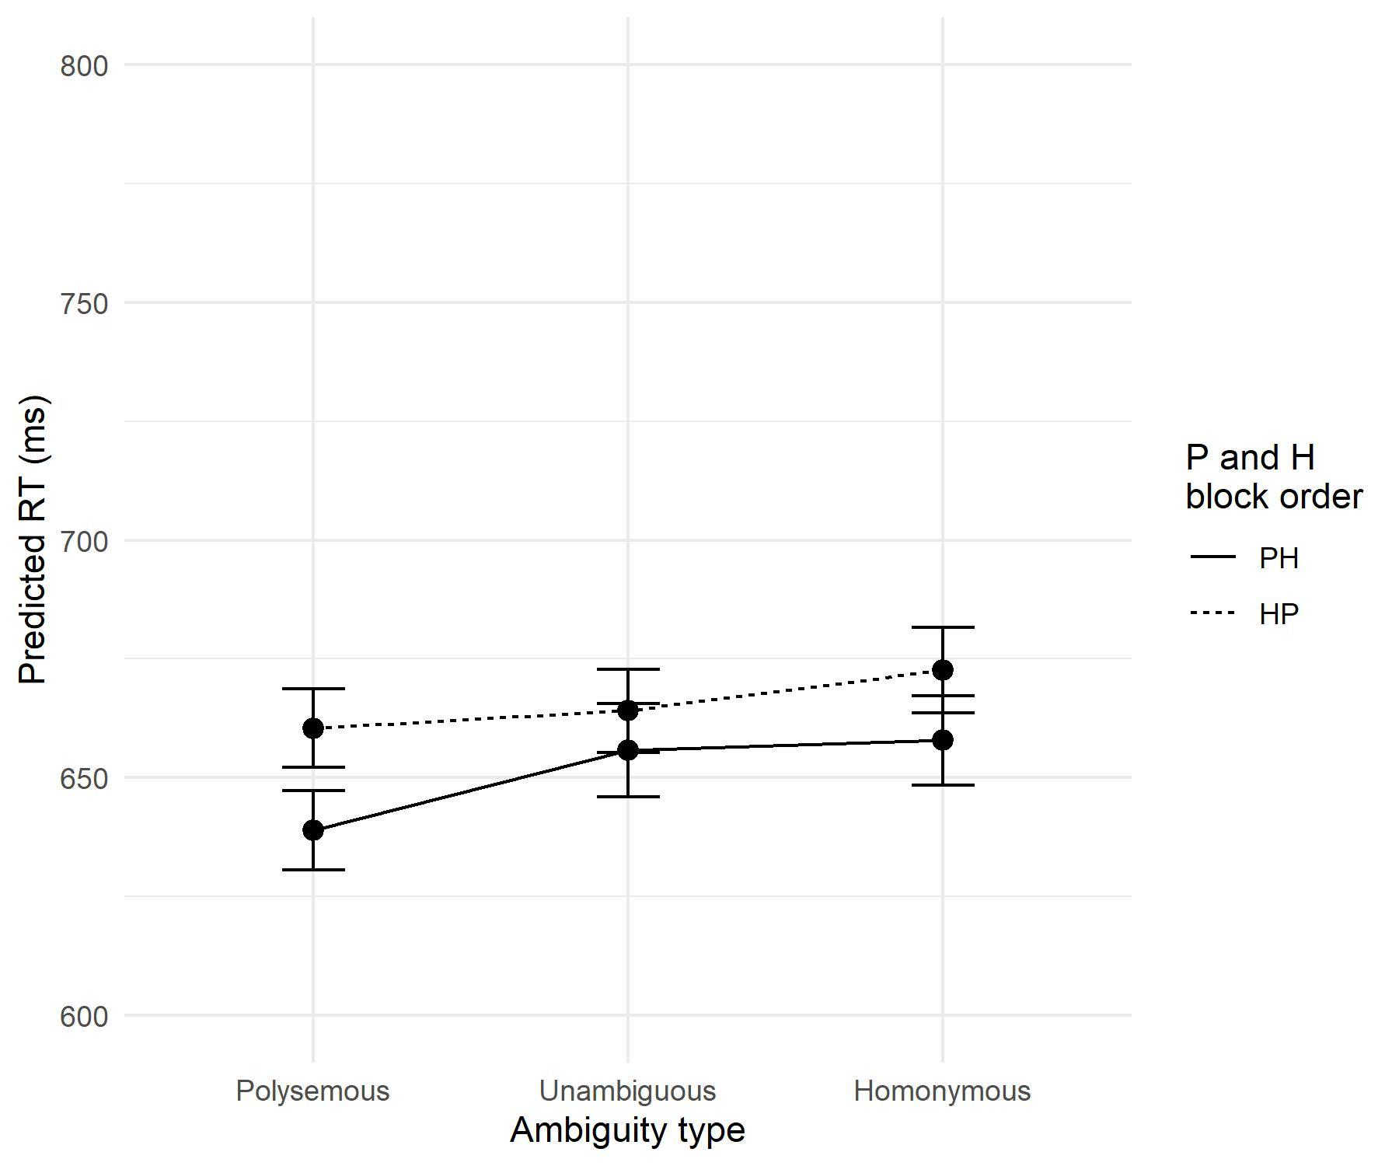

Discussion

The second experiment revealed some trends compared to the randomly presented and mixed ambiguous words in the first experiment. Emergence of a marginal polysemy effect when polysemous words are presented first suggests that presentation order may play a role in the absence of these effects. The task effects on ambiguity processing had been known throughout the literature (Armstrong & Plaut, 2016; Azuma & Van Orden, 1997; Borowsky & Besner, 1993; Hino et al., 2002; Hino & Lupker, 1996; Jager et al., 2016; Rodd et al., 2002). In order to further explore this variability of effects as a consequence of methodological decisions, such as presentation order, we conducted a third experiment.

EXPERIMENT 3

The aim of experiment 3 was twofold, first one being a replication of the findings from the experiment 2. Second aim was to expand the design, to try to include interrupted orders of presentation of ambiguous blocks, where the unambiguous block is in between. This will allow us to see whether the pattern remains the same in a separate participant sample, and also whether any effects will emerge after a break between polysemous block and a homonymous block.

Method

Participants. Eighty-one participant took part in the study. All were first year students from the [removed for peer review]. Participants were native Serbian speakers and had normal or corrected-to-normal vision.
Stimuli and design. Same stimuli from experiment 1 and 2 were used in this experiment. Compared to experiment 2, we included another level of the unambiguous words position factor – in the middle of the homonymous and polysemous blocks, making the design 2x3x2x3. Two additional block orders emerging from this addition were PUH and HUP orders. Again, lexicality and ambiguity were manipulated within participants, whereas ambiguous block order was. All other aspects of the design remained the same.
Procedure. The experimental procedure remained the same as in experiment 2, with the addition of two more block orders (see Stimuli and design section).

Results

Data preprocessing and analyses were conducted following the same procedure as in experiment 1. We dropped 13% of the original dataset. No participants were excluded, while nine words were (3 homonyms, 5 unambiguous, and 1 polysemous). The final model included trial order, ambiguity type, and the order of the homonymous and polysemous block. Both categorical predictors were treatment contrast coded. Reference level for ambiguity type were unambiguous words, and for homonymy/polysemy order, the reference was the HP order.
Analysis (Table 4) revealed an interaction between the ambiguity type and HP order. In both orders, the polysemy effect was present, whereas the homonymy effect was absent (Figure 2). Trial order revealed small practice effect during this experiment. Three-way interaction between ambiguity, homonymy and polysemy block order, and position of unambiguous words was not justified by the data, as well as inclusion of the unambiguous block position factor.
Considering that the polysemy effect, which is typically stable, was present here and not in the second experiment, we ran the analysis on the two experimental conditions that were the only difference between this and the second experiment (PUH, HUP). This only revealed a polysemy effect when polysemous block was introduced first.

Table 4.
Summary of the mixed effect model with inverse RT as dependent variable and ambiguity type, HP order, and trial order as predictors.
Random effects
 | Variance | SD
Items (Intercept) | .014 | .117
Subject (Intercept) | .029 | .169
Residual | .049 | .222

Fixed effects
 | Coefficient | S.E. | df | t | p
Intercept (Unambiguous, PH) | -1.461 | .035 | 163.20 | -41.608 | .000
Trial order | -.013 | .003 | 7101.00 | -3.747 | .000
Homonymy | .024 | .031 | 106.30 | .761 | .448
Polysemy | -.069 | .031 | 106.00 | -2.231 | .028
HP | -.057 | .039 | 87.74 | -1.472 | .145
Order HP: Homonymy | -.029 | .014 | 7100.00 | -2.038 | .042
Order HP: Polysemy | .032 | .014 | 7099.00 | 2.335 | .020

Figure 2
The interaction between ambiguity type and polysemous and homonymous block order in experiment 3
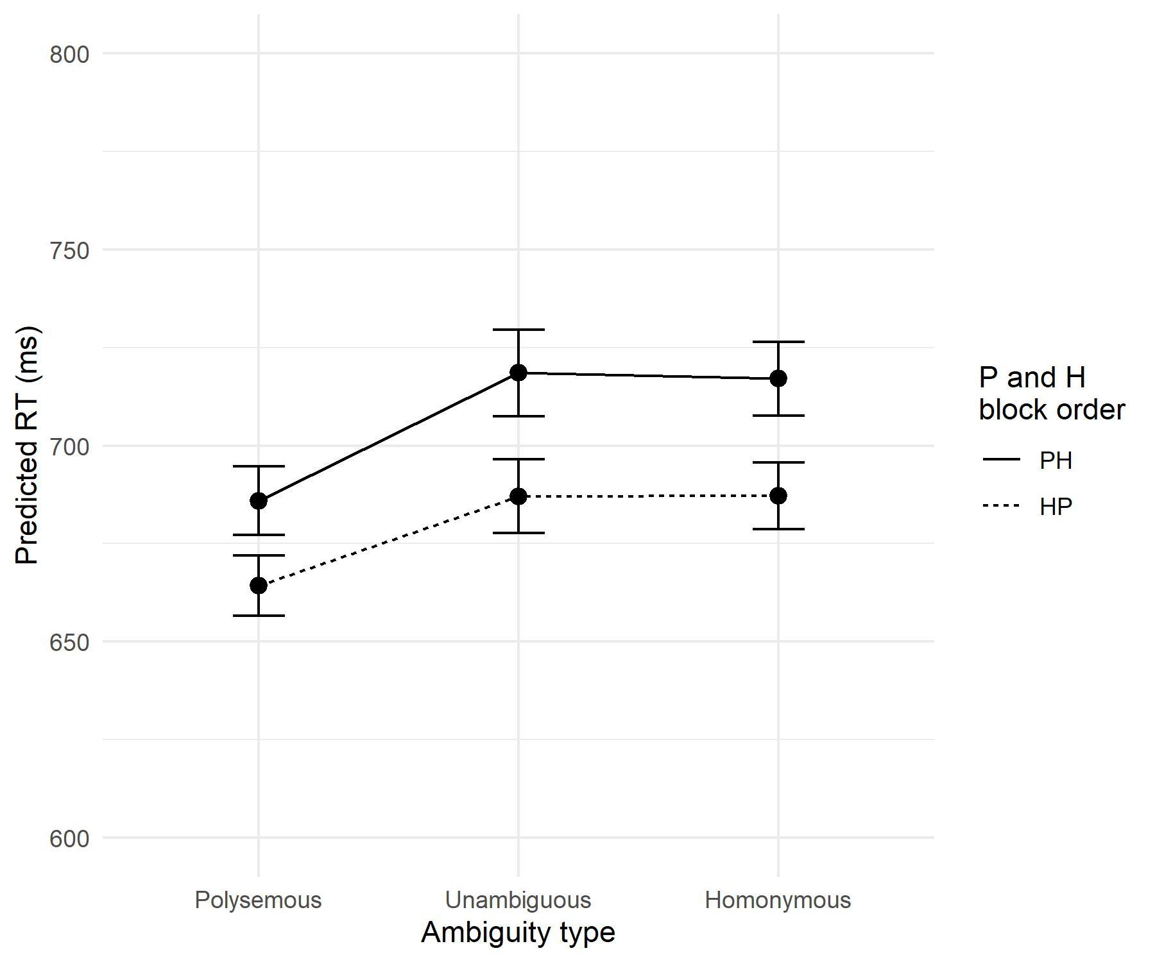

Discussion

The third experiment in this series was conducted with a goal to test all possible orders of three blocks. Compared to experiment 2, two more orders were added, both with the unambiguous words between polysemes and homonyms, and vice versa. Results revealed the polysemy advantage in both ambiguous block orders, while homonymy disadvantage was once again, absent. Firstly, the appearance of polysemy advantage in this experiment and not in the previous, raised a question of whether the two additional experimental conditions were driving the effect. Considering the lack of the three-way interaction was not justified, nor the effect was present in just the two new blocks, we may rule out the possibility that position of the unambiguous block affected ambiguity effects. On the other hand, the fact that polysemy advantage was detected in both orders of ambiguous blocks goes against the hypothesis that order plays a major role. Secondly, the lack of homonymy disadvantage was not a surprising pattern of results, considering additional factors that are required in order to reliably capture it (Armstrong & Plaut, 2016; Eddington & Tokowicz, 2015; Hino et al., 2010; Rodd et al., 2002).

GENERAL DISCUSSION

The aim of this study was to attempt to put together separately tested polysemy and homonymy effects in Serbian (Filipović Đurđević, 2019; Filipović Đurđević & Kostić, 2017, 2021) in the same experiment. We tested whether the experimental context contributes to the effect detection. This study was methodological in nature, considering we manipulated properties of the experiment, to be precise, the order of the presentation.
Surprisingly, both effects were absent in the experiment 1, so we conducted two more. In those experiments, we controlled for the order of presentation by moving away from randomly mixed polysemous, homonymous, and unambiguous words, to each group of words being presented within a block (experiments 2 and 3). Additionally, the order of the ambiguous word blocks was controlled (experiments 2 and 3) and the effect of the position of the unambiguous block (experiment 3). Experiment 2 revealed only a marginal polysemy advantage when polysemous block was presented first, while experiment 3 had a strong polysemy advantage in both ambiguous block orders. No homonymy effect was detected whatsoever across all three experiments.
Overall, the initial hypothesis that the experimental context affects ambiguity processing was confirmed, since polysemy advantage was detected in later experiments. This hypothesis came from different task effects that were detected throughout the literature (Armstrong & Plaut, 2016; Eddington & Tokowicz, 2015; Hino et al., 2010; Rodd et al., 2002). Differences between the first and the other two experiments, gives further evidence for the necessity of being aware of different task characteristics in order to reliably detect ambiguity effects.
Going into more detail regarding the particular aspects of the task, experiment 2 suggests that controlling for the order of presentation may be the necessary condition for ambiguity effects detection but experiment 3 seemed to disprove that. Detecting polysemy advantage in both orders, rejected the idea that the order in which we encounter different ambiguity types during the experiment affects polysemy advantage. On the other hand, homonymy disadvantage was not detected in any of the experiments. As previously stated, this may not (only) be a consequence of mixed random presentation of ambiguity types, but a general issue of homonymy disadvantage needing longer processing in order to emerge at all (Armstrong & Plaut, 2016; Medeiros & Armstrong, 2017).
Further evidence for experimental context playing an important role was the fact that stimuli were taken directly from two experiments in which two ambiguity effects were demonstrated separately (Filipović Đurđević, 2019; Filipović Đurđević & Kostić, 2008; 2021). Also, when different ways of describing ambiguity were used, such as number of meanings/senses, measures describing meaning/sense probability distributions, etc., the effects were present and reliable. This approach also gives a better insight into ambiguity processing (Armstrong et al., 2012; Filipović Đurđević, 2019; Filipović Đurđević & Kostić, 2008, 2017; 2021), considering matching groups by many variables, when comparing ambiguity types as groups may lead to multiple statistical deficiencies (Baayen, 2010).
To conclude, our study found that polysemy advantage and homonym disadvantage are affected by experimental context. Our attempt at controlling the order of the ambiguous word blocks did succeed in allowing polysemy advantage to emerge. Because it was detected in both orders of polysemy and homonymy blocks, we may not conclude that this effect is affected by this order. The lack of homonymy disadvantage may not be disentangled from the general difficulty of detecting this effect.

REFERENCES

Allan, K. (Ed.). (2009). Concise Encyclopedia of Semantics. Elsevier.
Armstrong, B. C., & Plaut, D. C. (2016). Disparate semantic ambiguity effects from semantic processing dynamics rather than qualitative task differences. Language, Cognition and Neuroscience, 31(7), 940–966. https://doi.org/10.1080/23273798.2016.1171366
Armstrong, B. C., & Plaut, D. C. (2011). Inducing homonymy effects via stimulus quality and (not) nonword difficult: Implications for models of semantic ambiguity and word recognition. Proceedings of the 33rd Annual Meeting of the Cognitive Science Society, 33, 2223–2228. https://escholarship.org/uc/item/0v05b8fz
Armstrong, B. C, & Plaut, D. C. (2008). Settling Dynamics in Distributed Networks Explain Task Differences in Semantic Ambiguity Effects: Computational and Behavioral Evidence. Proceedings of the Annual Meeting of the Cognitive Science Society, 30. https://escholarship.org/uc/item/6rv2c5hh
Armstrong, B. C., Tokowicz, N., & Plaut, D. C. (2012). eDom: norming software and relative meaning frequencies for 544 English homonyms. Behavior Research Methods, 44(4), 1015–1027. https://doi.org/10.3758/s13428-012-0199-8
Azuma, T. (1996). Familiarity and relatedness of word meanings: Ratings for 110 homographs. Behavior Research Methods, Instruments, and Computers, 28(1), 109–124. https://doi.org/10.3758/bf03203645
Azuma, T., & Van Orden, G. C. (1997). Why SAFE Is Better Than FAST: The Relatedness of a Word’s Meanings Affects Lexical Decision Times. Journal of Memory and Language, 36(4), 484–504. https://doi.org/10.1006/jmla.1997.2502
Baayen, R. H. (2010). A real experiment is a factorial experiment? Mental Lexicon, 5(1), 149–157. https://doi.org/10.1075/ml.5.1.06baa
Baayen, R. H., Davidson, D., & Bates, D. (2008). Mixed-effects modelling with crossed random effects for subjects and items. Journal of Memory and Language, 59(4), 390–412. https://doi.org/10.1016/j.jml.2007.12.005
Baayen, R. H., & Milin, P. (2010). Analyzing Reaction Times. International Journal of Psychological Research, 3(2), 12–28. https://doi.org/10.1287/mksc.12.4.395

Barr, D. J. (2013). Random effects structure for testing interactions in linear mixed-effects models. Frontiers in Psychology, 4(December), 328. https://doi.org/10.3389/fpsyg.2013.00328
Barr, D. J., Levy, R., Scheepers, C., & Tily, H. J. (2013). Random effects structure for confirmatory hypothesis testing: Keep it maximal. Journal of Memory and Language, 68(3), 255–278. https://doi.org/10.1016/j.jml.2012.11.001
Bates, D., Kliegl, R., Vasishth, S., & Baayen, R. H. (2015). Parsimonious mixed models. https://arxiv.org/abs/1506.04967
Bates, D., Mächler, M., Bolker, B. M., & Walker, S. C. (2015). Fitting linear mixed-effects models using lme4. Journal of Statistical Software, 67(1), 1–48. https://doi.org/10.18637/jss.v067.i01
Beretta, A., Fiorentino, R., & Poeppel, D. (2005). The effects of homonymy and polysemy on lexical access: an MEG study. Brain Research. Cognitive Brain Research, 24(1), 57–65. https://doi.org/10.1016/j.cogbrainres.2004.12.006
Borowsky, R., & Besner, D. (1993). Visual Word Recognition: A Multistage Activation Model. Journal of Experimental Psychology: Learning, Memory, and Cognition, 19(4), 813–840. https://doi.org/10.1037/0278-7393.19.4.813
Brysbaert, M. (2017). Age of acquisition ratings score better on criterion validity than frequency trajectory or ratings “corrected” for frequency. Quarterly Journal of Experimental Psychology, 70(7), 1129–1139. https://doi.org/10.1080/17470218.2016.1172097
Chumbley, J. I., & Balota, D. A. (1984). A word’s meaning affects the decision in lexical decision. Memory & Cognition, 12(6), 590–606. https://doi.org/10.3758/BF03213348
Eddington, C. M., & Tokowicz, N. (2015). How meaning similarity influences ambiguous word processing: the current state of the literature. Psychonomic Bulletin & Review, 22, 13–37. https://doi.org/10.3758/s13423-014-0665-7
Filipović Đurđević, D. (2019). Balance of Meaning Probabilities in Processing of Serbian Homonymy. Primenjena Psihologija, 12(3), 283–304. https://doi.org/10.19090/pp.2019.3.283-304
Filipović Đurđević, D., Đurđević, Đ., & Kostić, A. (2009). Vector based semantic analysis reveals absence of competition among related senses. Psihologija, 42(1), 95–106. https://doi.org/10.2298/PSI0901095F
Filipović Đurđević, D., & Kostić, A. (2008). The effect of polysemy on processing of Serbian nouns. Psihologija, 41(1), 69–86. https://doi.org/10.2298/PSI0801059F
Filipović Đurđević, D., & Kostić, A. (2017). Number, Relative Frequency, Entropy, Redundancy, Familiarity, and Concreteness of Word Senses: Ratings for 150 Serbian Polysemous Nouns. In S. Halupka-Rešetar & S. Martinez-Ferreiro (Eds.), Studies in Language and Mind (pp. 13–77). Faculty of Philosohy, University of Novi Sad. http://digitalna.ff.uns.ac.rs/sadrzaj/2017/978-86-6065-446-7
Filipović Đurđević, D., & Kostić, A. (2021). We probably sense sense probabilities. Language, Cognition and Neuroscience. https://doi.org/0.1080/23273798.2021.1909083
Forster, K., & Bednall, E. S. (1976). Terminating and exhaustive search in lexical access. Memory & Cognition, 4(1), 53–61. https://doi.org/10.3758/BF03213255
Gelman, A., & Hill, J. (2006). Data Analysis Using Regression and Multilevel/Hierarchical Models. Cambridge University Press. https://doi.org/10.1017/CBO9780511790942
Gortan-Premk, D. (2004). Polisemija i organizacija leksičkog sistema u srpskome jeziku. [Polysemy and the organisation of the lexical system in Serbian language]. Zavod za udžbenike i nastavna sredstva.
Hino, Y., Kusunose, Y., & Lupker, S. J. (2010). The relatedness-of-meaning effect for ambiguous words in lexical-decision tasks: when does relatedness matter? Canadian Journal of Experimental Psychology = Revue Canadienne de Psychologie Expérimentale, 64(3), 180–196. https://doi.org/10.1037/a0020475
Hino, Y., & Lupker, S. J. (1996). Effects of polysemy in lexical decision and naming: An alternative to lexical access accounts. Journal of Experimental Psychology: Human Perception and Performance, 22(6), 1331–1356. https://doi.org/10.1037/0096-1523.22.6.1331
Hino, Y., Lupker, S. J., & Pexman, P. M. (2002). Ambiguity and Synonymy Effects in Lexical Decision, Naming, and Semantic Categorization Tasks: Interactions between Orthography, Phonology, and Semantics. Journal of Experimental Psychology: Learning Memory and Cognition, 28(4), 686–713. https://doi.org/10.1037/0278-7393.28.4.686
Hino, Y., Lupker, S. J., Sears, C. R., & Ogawa, T. (1998). The effects of polysemy for Japanese katakana words. 241–270. https://doi.org/10.1007/978-94-015-9161-4_12

Hino, Y., Pexman, P. M., & Lupker, S. J. (2006). Ambiguity and relatedness effects in semantic tasks: Are they due to semantic coding? Journal of Memory and Language, 55(2), 247–273. https://doi.org/10.1016/j.jml.2006.04.001
Jager, B., Green, M., & Cleland, A. A. (2016). Polysemy in the Mental Lexicon: Relatedness and Frequency affect Representational Overlap. Language, Cognition and Neuroscience, 31(3), 425-429. https://doi.org/10.1017/CBO9781107415324.004
Jastrzembski, J. E. (1981). Multiple meanings, number of related meanings, frequency of occurrence, and the lexicon. Cognitive Psychology, 13(2), 278–305. https://doi.org/10.1016/0010-0285(81)90011-6
Joordens, S., & Besner, D. (1994). When Banking on Meaning Is Not (Yet) Money in the Bank: Explorations in Connectionist Modelling. Journal of Experimental Psychology: Learning, Memory, and Cognition, 20(5), 1051–1062. https://doi.org/10.1037/0278-7393.20.5.1051
Kellas, G., Ferraro, R. R., & Simpson, G. B. (1988). Lexical Ambiguity and the Timecourse of Attentional Allocation In Word Recognition. Journal of Experimental Psychology: Human Perception and Performance, 14(4), 601–609. https://doi.org/0096-J523/88/S00.75
Klein, D. E., & Murphy, G. L. (2001). The Representation of Polysemous Words. Journal of Memory and Language, 45(2), 259–282. https://doi.org/10.1006/jmla.2001.2779
Klepousniotou, E. (2002). The Processing of Lexical Ambiguity: Homonymy and Polysemy in the Mental Lexicon. Brain and Language, 81(1–3), 205–223. https://doi.org/10.1006/brln.2001.2518
Klepousniotou, E., & Baum, S. R. (2007). Disambiguating the ambiguity advantage effect in word recognition: An advantage for polysemous but not homonymous words. Journal of Neurolinguistics, 20(1), 1–24. https://doi.org/10.1016/j.jneuroling.2006.02.001
Klepousniotou, E., Pike, G. B., Steinhauer, K., & Gracco, V. (2012). Not all ambiguous words are created equal: An EEG investigation of homonymy and polysemy. Brain and Language, 123(1), 11–21. https://doi.org/10.1016/j.bandl.2012.06.007
Klepousniotou, E., Titone, D., & Romero, C. (2008). Making Sense of Word Senses: The Comprehension of Polysemy Depends on Sense Overlap. Journal of Experimental Psychology: Learning Memory and Cognition, 34(6), 1534–1543. https://doi.org/10.1037/a0013012

Kostić, Đ. (1999). Frekvencijski rečnik savremenog srpskog jezika [Frequency dictionary of the contemporary Serbian language]. Institut za eksperimentalnu fonetiku i patologiju govora i Laboratorija za eksperimentalnu psihologiju.
Kuznetsova, A., Brockhoff, P., & Christensen, R. (2017). lmerTest Package: Tests in Linear Mixed Effects Models. Journal of Statistical Software 82(13), 1–26. https://doi.org/10.18637/jss.v082.i13
Lopukhina, A., Laurinavichyute, A., Lopukhin, K., & Dragoy, O. (2018). The mental representation of polysemy across word classes. Frontiers in Psychology, 9, 192. https://doi.org/10.3389/fpsyg.2018.00192
Lyons, J. (1977). Semantics, volume 2. Cambridge University Press. https://doi.org/10.1017/CBO9781139165693
MacGregor, L. J., Bouwsema, J., & Klepousniotou, E. (2015). Sustained meaning activation for polysemous but not homonymous words: Evidence from EEG. Neuropsychologia, 68, 126–138. https://doi.org/10.1016/j.neuropsychologia.2015.01.008
Maciejewski, G., & Klepousniotou, E. (2020). Disambiguating the ambiguity disadvantage effect: Behavioral and electrophysiological evidence for semantic competition. Journal of Experimental Psychology: Learning, Memory, and Cognition. https://doi.org/10.1037/xlm0000842.supp
Maciejewski, G., Rodd, J. M., Mon-Williams, M., & Klepousniotou, E. (2020). The cost of learning new meanings for familiar words. Language, Cognition and Neuroscience, 35(2), 188-210. https://doi.org/10.1080/23273798.2019.1642500
Mathôt, S., Schreij, D., & Theeuwes, J. (2012). OpenSesame: An open-source, graphical experiment builder for the social sciences. Behavior Research Methods, 44(2), 314-324. https://doi.org/10.3758/s13428-011-0168-7
Matuschek, H., Kliegl, R., Vasishth, S., Baayen, R. H., & Bates, D. (2017). Balancing Type I error and power in linear mixed models. Journal of Memory and Language, 94, 305–315. https://doi.org/10.1016/j.jml.2017.01.001
Medeiros, J., & Armstrong, B. C. (2017). Semantic Ambiguity Effects: A Matter of Time? Proceedings of the 39th Annual Conference of the Cognitive Science Society (pp. 2693–2698). Lawrence Erlbaum Associates. https://cogsci.mindmodeling.org/2017/papers/0509/
Millis, M. L., & Bution, S. B. (1989). The effect of polysemy on lexical decision time: Now you see it, now you don’t. Memory & Cognition, 17(2), 141–147. https://doi.org/10.3758/BF03197064
Pexman, P. M., Hino, Y., & Lupker, S. J. (2004). Semantic ambiguity and the process of generating meaning from print. Journal of Experimental Psychology: Learning Memory and Cognition, 30(6), 1252–1270. https://doi.org/10.1037/0278-7393.30.6.1252
R Core Team. (2018). R: A language and environment for statistical computing. R Foundation for Statistical Computing. https://www.r-project.org/
Rayner, K., & Duffy, S. A. (1986). Lexical complexity and fixation times in reading: Effects of word frequency, verb complexity, and lexical ambiguity. Memory & Cognition, 14(3), 191–201. https://doi.org/10.3758/BF03197692
Rice, C. A., Tokowicz, N., Fraundorf, S. H., & Liburd, T. L. (2019). The complex interactions of context availability, polysemy, word frequency, and orthographic variables during lexical processing. Memory and Cognition, 47(7), 1297–1313. https://doi.org/10.3758/s13421-019-00934-4
Rodd, J. M. (2020). Settling Into Semantic Space: An Ambiguity-Focused Account of Word-Meaning Access. Perspectives on Psychological Science, 15(2), 411-427. https://doi.org/10.1177/1745691619885860
Rodd, J. M., Berriman, R., Landau, M., Lee, T., Ho, C., Gaskell, G., & Davis, M. H. (2012). Learning new meanings for old words: Effects of semantic relatedness. Memory & Cognition, 40(7), 1095–1108. https://doi.org/10.3758/s13421-012-0209-1
Rodd, J. M., Gaskell, G., & Marslen-Wilson, W. (2002). Making Sense of Semantic Ambiguity: Semantic Competition in Lexical Access. Journal of Memory and Language, 46(2), 245–266. https://doi.org/10.1006/jmla.2001.2810
Rodd, J. M., Gaskell, G., & Marslen-Wilson, W. (2004). Modelling the effects of semantic ambiguity in word recognition. Cognitive Science, 28(1), 89–104. https://doi.org/10.1016/j.cogsci.2003.08.002
Rubenstein, H., Garfield, L., & Millikan, J. A. (1970). Homographic entries in the internal lexicon. Journal of Verbal Learning and Verbal Behavior, 9(5), 487–494. https://doi.org/10.1016/S0022-5371(70)80091-3
Rueckl, J. G. (1995). Ambiguity and Connectionist Networks - Still Settling Into a Solution - Comment on Joordens and Besner (1994). Journal of Experimental Psychology-Learning Memory and Cognition, 21(2), 501–508. https://doi.org/10.1037/0278-7393.21.2.501
Schad, D. J., Vasishth, S., Hohenstein, S., & Kliegl, R. (2020). How to capitalize on a priori contrasts in linear (mixed) models: A tutorial. Journal of Memory and Language, 110, 104038. https://doi.org/10.1016/j.jml.2019.104038
Simpson, G. B. (1994). Context and the Processing of Ambiguous Words. In M. A. Gernsbacher (Ed.), Handbook of Psycholinguistics (pp. 359–374). Academic Press.
Stanojčić, Ž., & Popović, L. (1995). Gramatika srpskoga jezika [Grammar of the Serbian language] (4th ed.). Zavod za udžbenike i nastavna sredstva.
Twilley, L. C., Dixon, P., Taylor, D., & Clark, K. (1994). University of Alberta norms of relative meaning frequency for 566 homographs. Memory & Cognition, 22(1), 111–126. https://doi.org/10.3758/BF03202766
Wickham, H. (2016). ggplot2: Elegant Graphics for Data Analysis. Springer-Verlag New York. https://ggplot2.tidyverse.org
Yurchenko, A., Lopukhina, A., & Dragoy, O. (2020). Metaphor Is Between Metonymy and Homonymy: Evidence From Event-Related Potentials. Frontiers in Psychology, 11(2113). https://doi.org/10.3389/fpsyg.2020.02113

УТИЦАЈ ЕКСПЕРИМЕНТАЛНОГ КОНТЕКСТА НА ЕФЕКТЕ ВИШЕЗНАЧНОСТИ РЕЧИ

Резиме

Преходна истраживања се показала да се различити типови вишезначних речи обрађују на различит начин у задатку лексичке одлуке. Полисемичне речи (више повезаних значења) обрађују брже од једнозначних речи, док се хомоними (више неповезаних значења) обрађују спорије од једнозначних речи. Овај склоп резултата реплициран је и у српском језику, мада у одвојеним студијама. Циљ овог рада био је да се испита да ли се ови ефекти могу поновити када су обе врсте вишезначности налазе у оквиру исте експерименталне листе.
Први експеримент није показао разлику у обради ниједног типа вишезначности у односу на једнозначне речи. Овај налаз је у складу са великим делом литературе у ком је пронађено да се у различитим експерименталним задацима бележе различити резултати. На основу овога, закључено је сам експериментални контекст (мешана презентација различитих типова вишезначности), може утицати на резултате.
Друга два експеримента, настојала су да контролишу управо сам експериментални контекст. Све три групе речи приказане у првом експерименту (полисемичне речи, хомоними и једнозначне речи), приказане су унутар истог блока, док је редослед блокова био контрабалансиран. Циљ овога је био да се испита да ли контролисање редоследа излагања може да помогне у бележењу ефеката вишезначности. У другом експерименту забележен је маргинални ефекат полисемије, док је у трећем забележен ефекат полисемије у оба редоследа блокова са вишезначним речима.
Имајући у виду да се у литератури типично најчешће бележи ефекат полисемије, док су за јављање ефекта хомонимије потребни додатни услови. Резултати забележени у три изложена експеримента показују да контекст утиче на јављање ефеката полисемије. Иако контрола редоследа излагања омогућава јављање ефекта полисемије, није довела и до јављања ефекта хомонимије. Овакав склоп резултата указује на то да су за потпуну репликацију експеримената у којима су оба ефекта забележена истовремено, потребни другачији експериментални услови.

For words with frequency over 10 per million

