Changing the Linguistic Landscape: Vlach Romanian in Eastern Serbia

Abstract
This paper discusses the increased visibility of Vlach Romanian in the linguistic landscape of rural and small-town Eastern Serbia, analyzing it in the context of the revitalization measures the community has undertaken in the last 20 years. Our research was conducted in a mainly rural area, comprising four neighbouring municipalities in Eastern Serbia, with a high concentration of Vlach population. We investigate a sample of the inscriptions we encountered, focusing on the intended audience of the inscriptions and correlating it with the basic functions of the signs (informational and symbolic). We show that, in the area under discussion, the signs have mainly symbolic values, being used as identity markers, as support for legitimization of the language or as indexes of authenticity, while their informational function is apparent only in relation with the commodification of the language.

Key words: linguistic landscape, Vlach Romanian variety, Eastern Serbia, language standardization, commodification.

Промена језичког пејзажа: појава влашког НА НАТПИСИМА у источној Србији

Апстракт
Рад анализира појаву и видљивост влашког варијетета у језичком пејзажу источне Србије. Овај феномен се посматра у контексту мера ревитализације које влашка заједница предузима у последњих 20 година. Истраживање је спроведено у претежно руралном подручју које обухвата четири суседне општине у источној Србији, у којима живи велики проценат влашког становништва. Натписи на влашком варијетету су анализирани са фокусом на њихову циљану публику и основне функције (информативну и симболичку). Резултати показују да у овој области натписи имају углавном симболичку функцију, користе се као маркери идентитета, као вид легитимизације језика или као показатељи аутентичности, док је њихова информативна функција очигледна само у односу на комодификацију језика.

Кључне речи: језички пејзаж, влашки варијетет, источна Србија, језичка стандардизација, комодификација.

INTRODUCTION
Starting with Rodrigue Landry and Richard Y. Bourhis’s seminal paper (1997), linguistic landscape studies have dealt with “language in spaces and places” (Shohamy & Gorter, 2009, p. 1), namely with the language of “public road signs, advertising billboards, street names, place names, commercial shop signs, and public signs on government buildings” (Landry & Bourhis, 1997, p. 25). The study of the visibility and salience of a language in a public space can have a “diagnostic value” (Blommaert, 2013, p. 2), by giving the visitor or the researcher a quick insight into the linguistic characteristics of an area (e. g. is it monolingual or multilingual, what is the hierarchy and the power relation between languages in a multilingual setting, what language policies, if any, are in force etc.). In a minority or endangered language context, the presence or absence of a language from the linguistic landscape can speak volumes, pointing towards the (perceived) status and vitality of that language, but also towards literacy practices and identity issues of the community speaking it (Cenoz & Gorter, 2006; Marten, Van Mensel & Gorter, 2012).
In general, the study of the linguistic landscape tends to focus mainly on urban settings (see Gorter’s, 2013) overview of the papers written and the approaches used in studying the linguistic landscape). Florian Coulmas (2009, p. 14) emphasizes that “linguistic landscape is really linguistic cityscape, especially in multilingual contexts” (italics in original) and that “it is on cities that LL research must be focused”, while Bernard Spolsky argues that
“outside the city, we find a limited class of direction signs and place names, and the roadside billboards often assumed to ruin the landscape.” (Spolsky, 2009, p. 33)

However, the recent years have seen an increased interest in the linguistic landscape of rural and small-town environments of Italy (Dal Negro, 2009), South Africa (Kotze & Du Plessis, 2010), an area above the Arctic Circle, spanning parts of four countries (Pietikäinen, Lane, Salo & Laihiala-Kankainen, 2011), Galicia, Spain (Dunlevy, 2012), Gambia (Juffermans & Coppoolse 2012), Oregon, USA (Troyer, Cáceda & Giménez Eguíbar, 2015), Ethiopia (Sisay Mendisu, Malinowski & Woldemichael, 2016), northern Germany (Reershemius, 2020).
Our paper aims to contribute to this growing body of research, by exploring the increasing visibility of Vlach Romanian, a non-dominant variety of Romanian, in the linguistic landscape of rural Eastern Serbia. We argue that the relatively recent appearance and displaying of public signage in Vlach Romanian in the traditionally monolingual landscape of this region should be seen in the context of the revitalization measures the community has undertaken in the last 20 years. To this end, we will first introduce the community and its language and the general sociolinguistic context, including the recent changes in attitude towards the vernacular and its public usage. We will then present the area under investigation and the methodology for data collection and interpretation, and in the last part we will examine some of the signs we found, looking at their intended audience and functions.

VLACHS OF EASTERN SERBIA AND THE USE OF VLACH ROMANIAN
Our research focuses on a mainly rural and conservative community living in Eastern Serbia, the Vlachs, and on the recent changes in their language and literacy practices. However, the term Vlach needs some explanation, in order to avoid confusion, as it can be used to refer to different historical Romance-speaking populations living today in Albania, Greece, North Macedonia, Bulgaria, Montenegro, Croatia, Romania, etc., also known as Aromanians (or Macedo-Romanians), Megleno-Romanians or Istro-Romanians (see Friedman, 2001, p. 26-28). In Serbia on the other hand, the term is mainly used to designate the ethnic group inhabiting the eastern part of the country, along the rivers Timok, Mlava, Morava and Pek, whose presence in the area can be traced back to spontaneous migrations from different regions of what is now Romania, mainly in the 19th century, but also earlier (Weigand, 1900 (2008), p. 85-87). Therefore, in this paper, the term Vlach refers solely to this community.
According to the censuses conducted in Yugoslavia and Serbia throughout the time (starting with 1948, when the Vlach ethnicity and language were first registered, and ending with the latest one, in 2011), there has always been a discrepancy between the number of people declaring Vlach ethnicity and the number of people declaring Vlach (Srb. vlaški) as their mother tongue, with the latter being significantly larger. Thus, in 1953, for example, 198.861 people declared Vlach as their mother tongue (2011 Census of Population, Households and Dwellings in the Republic of Serbia: Religion, Mother Tongue and Ethnicity, p. 16), but only 28.047 people said they were Vlachs (2011 Census of Population, Households and Dwellings in the Republic of Serbia: Religion, Mother Tongue and Ethnicity, p. 21). By 2011, the official numbers have dropped, but the disparity still stands (43.095 people declared Vlach as their mother tongue, while 35.330 declared Vlach ethnicity).
This asymmetry points towards the complicated simultaneous identities at play in this bilingual community, which are mirrored by the double ethnonyms used for self-identification: the members of the community generally call themselves rumîni in the vernacular, but Vlasi when speaking Serbian, and, accordingly, they call their language rumîńește in the vernacular, but use the Serbian word, vlaški, when they speak Serbian. However, this distinction is less clear-cut than it seems, as the exonym Vla(h) and the glossonyms vlašešće and ljimba vlaha (as translated in the vernacular) have been gaining ground and have started to be used by some members of the community in the vernacular as well. The preference for one or the other of the ethnonyms and glossonyms when speaking in the vernacular generally correlates with two main ideological attitudes showcased by the engaged members of the community. Thus, in what concerns the origin of the language and of the community, the reintegrationist, pro-Romanian group considers that their vernacular is a variety of Romanian, brought to Serbia through migration, and therefore use the rumîn – rumîńește dyad. On the other hand, the independentist, pro-Vlach group view their vernacular as a completely distinct language, that has no relation with Romanian, spoken by a population indigenous to the area, and therefore prefer the Vla(h) and vlašešće / ljimba vlaha denominations. Similar ideological distinctions can be found in the writing systems and orthographic conventions created by different members of the two factions (Authors, 2018b) or in the presence and use of the language online (Authors, 2019, Author, 2021).
In order to bring together these two opposing stances, we call the language Vlach Romanian, a more neutral and encompassing term, which includes both usages and attitudes found in the community and concurs with the pluricentric language approach we favor (Authors, 2018a). From a historical and structural point of view, Vlach Romanian is an archaic, dialectal variety of Romanian (on its way to become a distinct, Ausbau language), which until recently has been restricted to the family domain. The language has no official status in Serbia and used to have low prestige both with the in-group and with the out-group. However, in the last 20 years, both factions, but especially the independentist one, have taken several language planning and revitalization measures, which resulted in dramatic changes as far as overt language use is concerned. Thus, several writing systems have been created and the one put forward by the Gergina NGO (of independentist orientation) in 2012 has been declared official (although this does not mean that it is indeed used by everyone) (Authors, 2018b). The norms of the vernacular are codified in a grammar of this variety, written in Serbian (Jovanović, 2013), and in several dictionaries (lu Boža Kići, 2004, 2015), including an online one, initiated by Paun Durlić (see Author, 2012). Several books have been published so far: a translation of the Gospel (lu Boža Kići, 2006), different anthologies of texts such as funeral songs (Gacović, 2000), fairy tales (lu Boža Kići, 2011), nursery rhymes and children’s poems (lu Boža Kići, 2010; Slobodan Golubović, 2013; Jović Kolerović, Dragić, Paunjelović, Stojanjelović & Mitrović Mitra, 2014), children’s creations (Milena Golubović, Đorđević & Babić, 2017, Milena Golubović, Đorđević & Savić 2018) or folk oral creations (Durlić, 2020). Since 2013, the language is taught as an optional subject in a few schools in Eastern Serbia, with the help of two textbooks (Milena Golubović, 2014, 2016). In September 2015, the Vlach National Council passed a resolution on the standardization of the Vlach language, which was then published in the Official Gazette of Serbia a month later (Službeni glasnik RS, br. 88/2015, October 23, 2015). Apart from this, Vlach Romanian has started to have a more constant presence online in the last years, on social networks, online newspapers, or websites in general (Authors, 2019).
All these revitalization measures, taken within the space of less than 20 years, show that the members of the community have started to overtly express their ethnic and linguistic identity, a fact that was simply unimaginable before. That is why we decided to see if this improvement in the self-image of the community and all the developments we discussed above have any influence on the configuration of the linguistic landscape of Eastern Serbia, in other words to see if Vlach Romanian has become visible. We went in search for palpable evidence of change.

DATA COLLECTION AND METHODOLOGY
Our research focuses on four neighboring municipalities in Eastern Serbia: Kučevo, Majdanpek, Negotin and Kladovo (see Figure 1, in which Kučevo is green, Majdanpek is blue, Negotin is brown and Kladovo is yellow), an area that we visited in 2016 and 2017. There were several reasons for choosing this territory. First, the area is mainly rural, with just a few small towns that serve as administrative centers of the municipalities (the biggest of them, Negotin, has 16.882 inhabitants – see 2011 Census of Population, Households and Dwellings in the Republic of Serbia: Comparative Overview of the Number of Population in 1948, 1953, 1961, 1971, 1981, 1991, 2002 and 2011). Another reason is the high concentration of Vlach population in the area (although only 12% of the population of these 4 municipalities declared Vlach or Romanian ethnicity, they make out 30% of all declared Vlach population in Serbia– see 2011 Census of Population, Households and Dwellings in the Republic of Serbia: Religion, Mother Tongue and Ethnicity). Last, two of the towns that function as administrative centers, Negotin and Kladovo, are relevant for our research, as they host some important organizations and institutions representing the two factions described before (see Pietikäinen et al., 2011 for a similar perspective). Thus, Negotin (the town) is the home of the Vlach Party, of the Gergina NGO (both of pro-Vlach inclination) and of the Romanian Orthodox church (pro-Romanian); Kladovo (the town) is the headquarters of the Romanian Cultural Centre (pro-Romanian) and hosts a branch of the National Council of the Romanian Minority (pro-Romanian, as opposed to the pro-Vlach National Council of the Vlach Minority, headquartered in the town of Petrovac na Mlavi, in the Braničevo municipality). Moreover, the town is situated across the Danube from the Romanian city Drobeta-Turnu Severin (26 km on the road), which makes it a touristic and shopping destination for Romanians.
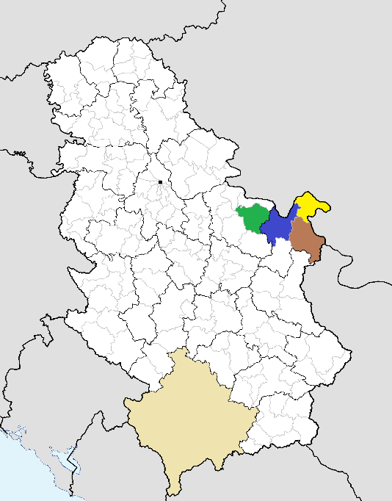
Figure 1. Map of the municipalities of Serbia. Licensed under Creative Commons. Changes were made to the original document (https://commons.wikimedia.org/wiki/File:Municipalities_of_Serbia.png).

In what concerns the methodology of collecting and analyzing the data, we depart from the quantitative approach generally used in linguistic landscape studies, as we agree with Thom Huebner (2009, p. 72) that “in conducting LL research the choice of sampling domain is driven by the purpose of the study”. We will not focus, therefore, on counting the signs and the languages found on them in the area under discussion, neither on the predominance of a certain language or on the hierarchy of languages in use in a certain area. What we will do here will not concern the presence of Serbian: it is obvious that signs in Serbian, both in the Cyrillic and in the Latin script, will be the predominant sight in the linguistic landscape, as Serbian is the state language, the “language by default”, the one that includes the Vlach community among its addressees. At the same time, the presence of English and of other global languages in the linguistic landscape has been well documented all over the world by now, so we were bound to find it in our area of research as well.
What we found relevant was the mere presence of the signs in Vlach Romanian, as a very new development that definitely signals a shift in the attitude towards the vernacular. Our focus was therefore on the new visibility of Vlach Romanian, for now still irrelevant in the linguistic landscape from a quantitative and statistical point of view (we found less than 50 signs altogether), but definitely symptomatic of change, as Jan Blommaert (2013, p. 46) notices: “the statistically insignificant can be a sign of momentous change”. The methodology we employed relies on ethnographic observation and comparison with the situation before, known to us from previous fieldwork (conducted mainly by Author in the last 15 years) and research of the community, which gives us an in-depth knowledge of the community and of its evolution. While we are aware that we can be accused of impressionism, this is, to a certain extent, what we aimed for: since the linguistic landscape can reflect the ethnic and linguistic composition of an area, can someone visiting the four municipalities really perceive that the Vlach community has started to express its ethnolinguistic identity more overtly and make a voice for themselves? How visible is Vlach Romanian in the linguistic landscape and who are the signs meant for?

ANALYSIS
Our analysis takes into account a sample of the signs we encountered and focuses on their intended readership. The intended audience of a sign can be inferred by determining who the authors of the signs are and what their known or presupposed intentions are when choosing a certain language or variety. This is, in Spolsky and Cooper’s model for language choice,
“the ‘presumed reader condition’: prefer to write a sign in a language which can be read by the people you expect to read it” (Spolsky, 2009, p. 33).

However, the author of the signs is often “only somewhat in control of the meanings that are read from his or her written ‘utterances’” (Malinowski, 2009, p. 108), so an analysis of the signs’ emplacement can prove fruitful, as “signs are placed in a specific space, a non-random place and their emplacement defines their effects” (italics in the original) (Blommaert, 2013, p. 43).
In the area we observed, the expected audience is composed either mainly of members of the Vlach community, or mainly of outsiders. Discussing the linguistic landscape of a territory, Landry et al. (1997, p. 25-29) contend that it serves two basic functions: an informational and a symbolical one. On the one hand, the linguistic landscape marks the territorial and linguistic boundaries of a language community, indicates that a language can be used in a certain place and can reflect the status of competing languages in a multilingual environment. On the other hand, the linguistic landscape can convey value, strength, vitality of a language, or, on the contrary, lack of value and weakness. While Landry and Bourhis refer to the functions of the language landscape seen as a conglomerate of signs, each sign by itself can also have the same two functions (with one of them being usually more prominent than the other), as the presence of any sign in the linguistic landscape can be seen as “either reflective of or required of its audience” (Huebner, 2009, p. 74). In what follows, we will analyze how the language choices of the authors of the signs in our corpus imply a certain audience (of insiders or outsiders) and how the intended readership correlates with the two basic functions of the signs.

An Audience of Insiders
First, the main intended audience of signs in or containing Vlach Romanian is obviously the Vlach community. The community is addressed in a number of top-down signs put up by the political, cultural and religious organizations belonging to the two factions described above. While the function of the official, top-down signage in the civic frame (Kallen, 2010) is usually informational, complying with and reflecting official language policies, we contend that in the area under discussion the main function of these signs is symbolic. As the language has no official status in Eastern Serbia, there is no official policy or regulations regarding the use of Vlach Romanian in the public space (in other words, all these signs are transgressive, using Aneta Pavlenko’s (2012, p. 36) extension of the meaning of the term). Moreover, the community is by and large bilingual and proficient in Serbian, therefore the use of the vernacular is meant not so much to give information to the audience, but to promote the used variety and empower its speakers.
This is noticeable especially in the case of the posters put up by the Vlach Party and the Gergina NGO, for example the ones concerning the elections of members for the Vlach National Council. In Image 1, the two identical posters urge the members of the community to use their right to speak Vlach and to choose their identity and their ethnonym, but they do it entirely in Serbian. The second sign (Image 2), a campaign poster for the elections, uses Serbian to convey the information (that there are elections and who is running), and Vlach Romanian, quite inconspicuously, only for the catchphrase at the bottom of the poster, which roughly translates as “Let’s awake, Vlachs!”. This is similar to Peter Backhaus’s (2007, p. 97-99) finding, that in the polyphonic signs he identified in the Japanese linguistic landscape, “English and English-looking expressions are used mainly for slogans, catch-phrases, business names, and titles” (Backhaus, 2007, p. 99), while the information is given in Japanese. In other words, although they address the community, these top-down signs seem to signal that Vlach Romanian exists, but also play down its communicative utility for the community, therefore giving Vlach Romanian a mainly symbolic value. At the same time, this tokenistic use of Vlach Romanian may reveal the community’s attitudes towards their vernacular, which is still not considered apt of transmitting information and it is still on its way of becoming a ‘proper’, ‘established’ language, like Serbian or Romanian (languages that can be found on other top-down signs we encountered, not shown here – e.g. the official inscriptions on the Romanian Orthodox church in Negotin, the Romanian Cultural Center and the National Council of the Romanian Minority in Kladovo).
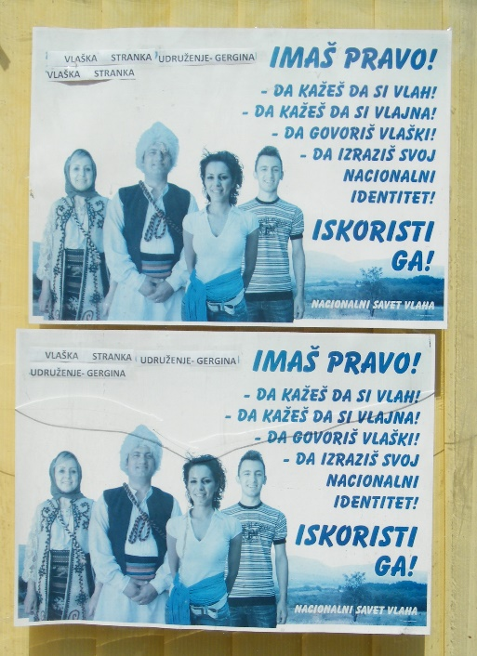
Image 1. Negotin, Vlach Party Headquarters. © Author.

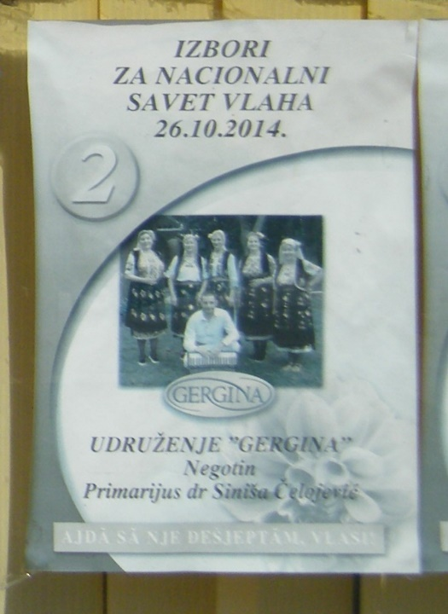
Image 2. Negotin, Vlach Party Headquarters. © Author.

The community is the main recipient of the signs in another instance as well, namely in the case of the funerary inscriptions found in some rural cemeteries in the area (see Authors, 2016, Authors, 2017 for more). Images 3 and 4, taken in the cemetery of the village Dušanovac (Negotin municipality), exhibit the two sides of a funerary monument. The front of the funerary monument (Image 3) contains the official, Serbian names of the deceased, Jelena Kikić and Kosta Kikić. However, the back of the monument (Image 4) displays their hypocoristic names and the Vlach patronymic, by which they (exclusively) are known within the community, Ljana and Kostika Aljčoni (in Cyrillic script, with the conjunction and in Vlach Romanian as well). In this particular case (and others we found, not shown here), the use of Vlach Romanian is at the same time informational and symbolic. On the one hand, it tells the community and the informed outsider that those buried there were part of the Vlach community (for other linguistic and non-linguistic clues, see Authors, 2017). More importantly though, using Vlach Romanian gives the inscriptions the symbolic function of marking the ethno-linguistic and cultural identity both of the deceased, and of those who erected and paid for the monument. Moreover, since the tradition in Eastern Serbia is to erect your own funerary monument while still alive, the choice of including Vlach Romanian is a conscious one and points to an “identification of self through the language” (Yigezu & Blackwood, 2016, p. 140).
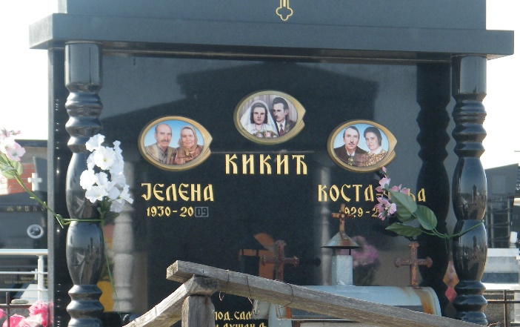
Image 3. Dušanovac cemetery. © Author.

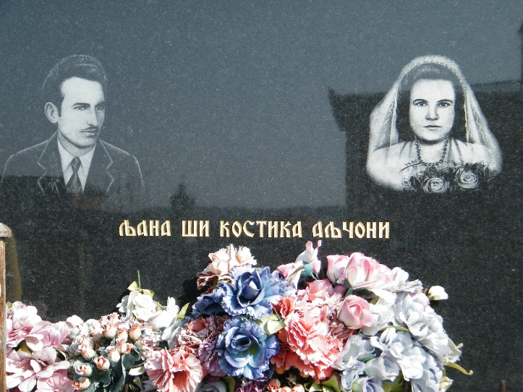
Image 4. Dušanovac cemetery. © Author.

An Audience of Outsiders
A similar indexical use of Vlach Romanian can be discerned in the case in which the intended audience is no longer the community, but the outsider (an “indexical audience”, as Blommaert (2013, p. 54) calls it).
In a first situation we encountered, the intended audience is the outsider who sees the language on the signs but cannot decipher its linguistic meaning. In their discussion of the commodification of language and ethnicity in Chinatown (Washington DC), Jennifer Leeman and Gabriella Modan notice how the use of Chinese in the linguistic landscape has more an aesthetic than a communicative value, promoting “an exotified landscape that appeals to an outsider’s perspective” (Leeman & Modan, 2009, p. 358). In Serbia, Vlachs are well known for practicing white magic (it is even called “Vlach magic” by Serbs and Vlachs alike – see Ivkov-Džigurski, Babić, Dragin, Košić & Blešić, 2012 for more details) and are sought out by people from all over Serbia. Images 5 and 6, taken in the village Neresnica (Kučevo municipality), depict the workplace of one of these Vlach sorcerers, who includes his activity in a wider framework of cultural, rural tourism. Since his main audience is Serbian, the main information and the main catchphrases are in Serbian, while Vlach Romanian is used symbolically, always marked by inverted commas. This “language on display” type of public signage (Curtin, 2009) usually employs foreign-looking scripts, as is the case with Hangul letters on shop signs in a neighborhood in Oakland, California (Malinowski, 2009), or specific fonts, such as Celtic-style ones in Ireland (Kallen, 2009) or Gothic typeface in Northern Germany (Reershemius, 2020). In our case, the signs use the Latin script, both in Serbian and in Vlach Romanian, so a speaker of Serbian can actually recognize the letters and read the words, but cannot associate any linguistic meaning to them. Vlach Romanian has therefore a symbolic function; its purpose is not to be read and understood, but merely to be noticed and recognized as Vlach Romanian, as something exotic, different, traditional, that indexes authenticity.

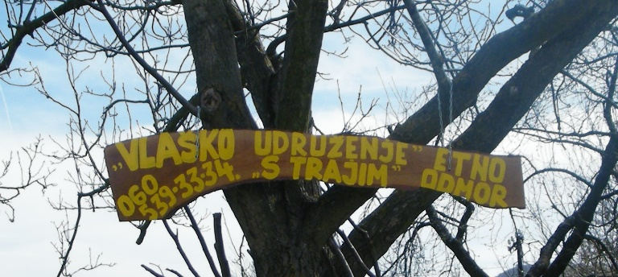
Image 5. Neresnica. © Author.
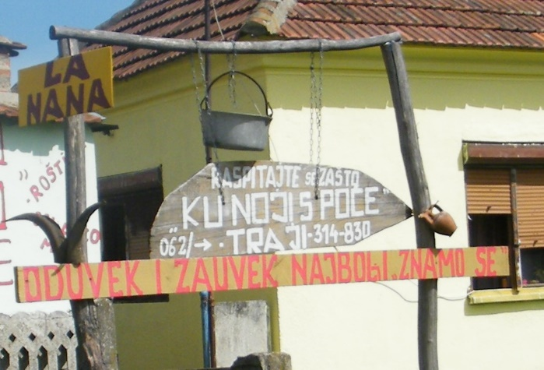
Image 6. Neresnica. © Author.

However, besides this symbolical, indexical value, using Vlach Romanian for touristic purposes can also have an informational function in the case of the marketplace (signs related to the buying and selling of products and services) and of the portals (signs related to mobility – be it physical, capital or electronic) (see Kallen’s, 2010 classification). The intended audience is still mainly the outsider, but this time an outsider that understands the language and takes advantage of this knowledge. Especially in Kladovo (the town situated 26 km away from Romania), but not only, we encountered signs whose addressee was the Romanian tourist.
While the signs on the supermarket or on cash machines might be just a form of politeness, a nod that acknowledges the presence of the Romanian tourists (and not necessarily an indication of competence in the language), other signs in Vlach Romanian (in front of restaurants or fast-food stands (see Image 7), pointing towards agricultural supply stores or identifying a Serbian-Romanian translator’s office) inform the Romanian tourists that their language or a variety of their language is spoken and understood there. In Blommaert’s words, the signs have a “recruitment function: they invite particular groups of people into interaction with their producers” (Blommaert, 2013, p. 54). Our own observation of the Romanian tourists’ linguistic practices testifies that this “recruitment function” is recognized as such: very often, Romanian tourists visiting Kladovo address locals directly in Romanian, sometimes even in places with no signs in Vlach Romanian.
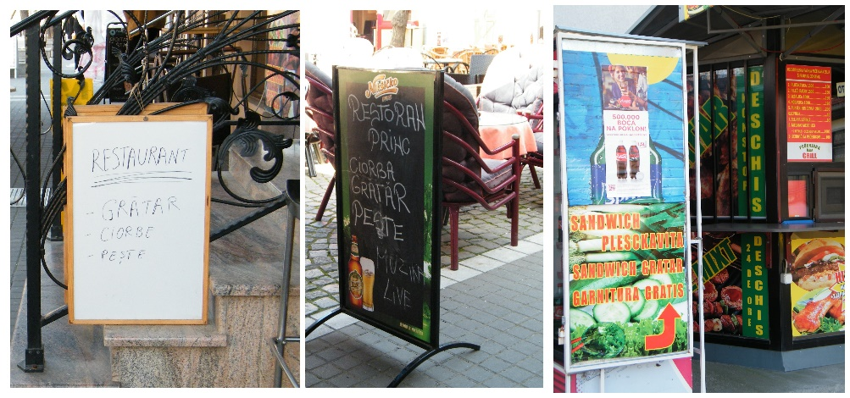
Image 7. Kladovo. © Author.

A comparison of different signs advertising exchange offices (Image 8) suggests that the authors are mainly members of the community, with different and partial competence in (written) Vlach Romanian and in standard Romanian. The name of the language and the ideologies behind preferring one glossonym to the other become irrelevant in the private linguistic practices. The members of the community understand their language’s economic value in the context, as the signs (here and elsewhere), even if written in non-standard orthography, manage to communicate more effectively and reach the Romanian tourist more directly. Moreover, the owner of an ice cream parlor told us that although he was not part of the community and he did not speak the language, he asked someone to write the names of the different flavors in (Vlach) Romanian for him. This perspective on language as a commodity gives advantage to those who keep an open mind and address a wider audience.
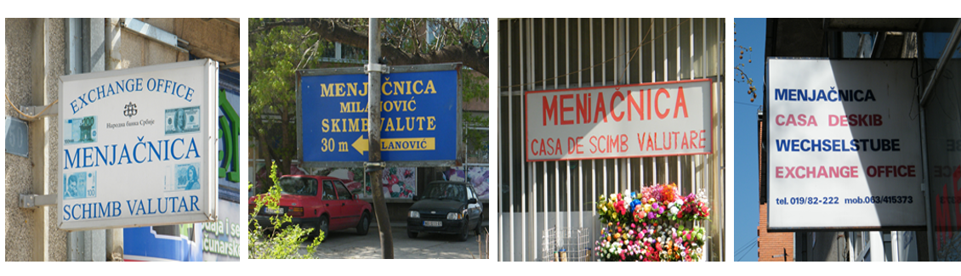
Image 8. Negotin (first two pictures), Kladovo (last two pictures). © Author.

CONCLUSIONS
Our paper focused on the recent changes in the linguistic landscape of Eastern Serbia, which we envisage as a possible outcome of the revitalization and status planning measures taken within the last 20 years. In the previously predominantly monolingual landscape of Eastern Serbia, the Vlach community started to overtly express their ethnolinguistic presence and identity, including through displaying their language in the public space.
However, Vlach Romanian is still hardly visible in the linguistic landscape, a fact that can be attributed to several factors. First, most of the community is still low-literate or non-literate (Juffermans et al., 2012) in the vernacular. Despite the recent standardization, there is still no commonly accepted linguistic norm. The official writing system, adopted in 2012, is still contested by the reintegrationist faction; Vlach Romanian is still taught only as an optional class in a few schools. To this, we can add the general low level of education in Eastern Serbia. According to the 2011 Census, 54% of the population over 15 years old living in our area of observation has only primary education or less (2011 Census of Population, Households and Dwellings in the Republic of Serbia: Educational attainment, Literacy and Computer Literacy, p. 80, 84). We also cannot disregard the linguistic assimilation policies of the Serbian authorities throughout the time and the fact that the language still has no official status in Serbia, which resulted in low prestige and language shift to Serbian. Lastly, the internal divergence within the community, as reflected in the two factions, generated a widespread reluctance of the speakers to affiliate with either group, thus avoiding conflict, but also possibly refraining from using their vernacular in writing.
However, in comparison with the previous years, the mere presence of inscriptions in Vlach Romanian in the public space is a distinct sign of progress. As we have seen, the signs have mainly symbolic values, being used as identity markers, as support for legitimization or as indexes of authenticity. There are still no official regulations regarding the use of Vlach Romanian in the public space, therefore its informational value is apparent for now only in relation with its commodification (Heller, 2010). However, as Gorter notices, the language of the signs “can influence the perception of the status of the different languages and affect linguistic behaviour” (Gorter, 2013, p. 202), so it remains to be seen, in the future years, whether the revitalization measures and the timid steps taken so far will be reflected in bigger visibility of the language. Last but not least, it remains to be seen whether the presence of the minority language in the public space will be able to challenge stereotypes, influence people’s perception and affect their linguistic behavior towards a greater use of the language.

REFERENCES

2011 Census of Population, Households and Dwellings in the Republic of Serbia: Comparative Overview of the Number of Population in 1948, 1953, 1961, 1971, 1981, 1991, 2002 and 2011. Data by settlements. Belgrade, 2014 <https://pod2.stat.gov.rs/ObjavljenePublikacije/Popis2011/Knjiga20.pdf>.
2011 Census of Population, Households and Dwellings in the Republic of Serbia: Educational attainment, Literacy and Computer Literacy. Data by municipalities and cities. Belgrade, 2013 <https://publikacije.stat.gov.rs/G2013/Pdf/G20134001.pdf>.
2011 Census of Population, Households and Dwellings in the Republic of Serbia: Religion, Mother Tongue and Ethnicity. Data by municipalities and cities. Belgrade, 2013. <http://pod2.stat.gov.rs/ObjavljenePublikacije/Popis2011/Knjiga4_Veroispovest.pdf>
Backhaus, Peter (2007). Linguistic Landscapes: A Comparative Study of Urban Multilingualism in Tokyo. Multilingual Matters.
Blommaert, Jan (2013). Ethnography, superdiversity and linguistic landscapes. Chronicles of complexity. Multilingual Matters.
Cenoz, Jasone & Durk Gorter (2006). Linguistic landscape and minority languages. International Journal of Multilingualism 3.1, 67-80.
Coulmas, Florian (2009). Linguistic Landscaping and the Seed of the Public Sphere. In Elana Shohamy and Durk Gorter (Eds.). Linguistic Landscape. Expanding the Scenery. New York: Routledge, 13-24.
Curtin, Melissa L. (2009). Languages on Display: Indexical Signs, Identities and the Linguistic Landscape of Taipei. In Elana Shohamy and Durk Gorter (Eds.). Linguistic Landscape. Expanding the Scenery. New York: Routledge, 221-237.
Dal Negro, Silvia (2009). Local Policy Modeling the Linguistic Landscape. In Elana Shohamy and Durk Gorter (Eds.). Linguistic Landscape. Expanding the Scenery. New York: Routledge, 206-218.
Dunlevy, Deirdre A. (2012). Linguistic Policy and Linguistic Choice: A Study of the Galician Linguistic Landscape. In Christine Hélot, Monica Barni, Rudi Janssens and Carla Bagna (Eds.). Linguistic Landscapes, Multilingualism and Social Change. Frankfurt-am-Main: Peter Lang, 53-68.
Durlić, Paun Es (2020). Rumînji în zovîrnjit đi suare. Povješć alu Rumînj đin Poreśa, Pjeku al đi Sus šî cînuturlji veśinje / Vlasi na zalasku sunca. Usmeno stvaralaštvo Vlaha Poreča, Gornjeg Peka i susednih oblasti [Vlachs at the Sunset. Oral Creations of the Vlachs from Poreč, Gornji Pek and Neighbouring Areas]. Majdanpek: Udruženje građana “PEKUS”.
Friedman, Victor A. (2001). The Vlah Minority in Macedonia: Language, Identity, Dialectology, and Standardization. In Juhani Nuoluoto, Martii Leiwo, Jussi Halla-aho (Eds.). Slavic, Balkan, and Balkan Studies (Slavica Helsingiensa 21). Helsinki, 26-50.
Gacović, Slavoljub (2000). Petrecătura (pesma za ispraćaj pokojnika) u Vlaha Ungurjana [Petrecătura (A Farewell Song to the Deceased) among the Ungureni Vlachs]. Zaječar: Matična biblioteka “Svetozar Marković”.
Golubović, Milena (2014). Vuorba šî kultura Vlaha. Udžbenik iz predmeta vlaški govor sa elementima nacionalne kulture za prvi razred osnovne škole. [Vlach Language and Culture. Textbook for the Subject Vlach Speech with Elements of National Culture for the First Grade of Primary School]. Beograd: Zavod za udžbenike, Petrovac na Mlavi: Nacionalni Savet Vlaha.
Golubović, Milena (2016). Vuorba šî kultura Vlaha 2 [Vlach Language and Culture 2]. Petrovac na Mlavi: Nacionalni Savet Vlaha.
Golubović, Milena, Braniša Đorđević & Ankica Babić (2017). Škuoala. Prva zbirka dečijih likovnih i literarnih radova na vlaškom jeziku [The School. The First Collection of Children’s Art and Literary Works in the Vlach Language]. Beograd: Matica Vlaha.
Golubović, Milena, Braniša Đorđević & Mirela Savić (2018). Juo šî drugarji amjiei. Zbirka dečijih likovnih i literarnih radova na vlaškom jeziku [Me and My Friends. A Collection of Children’s Art and Literary Works in the Vlach Language]. Beograd: Matica Vlaha.
Golubović, Slobodan (2013). Panda învacǎ kung fu [Panda learns kung fu]. Petrovac na Mlavi: Nacionalni savez Vlaha, Negotin: Udruženje za očuvanje identiteta, jezika, kulture i tradicije Vlaha “Gergina”.
Gorter, Durk (2013). Linguistic Landscapes in a Multilingual World. Annual Review of Applied Linguistics 33, 190-212.
Heller, Monica (2010). The Commodification of Language. Annual Review of Anthropology. 39, 101-114.
Huebner, Thom (2009). A Framework for the Linguistic Analysis of Linguistic Landscapes. In Elana Shohamy and Durk Gorter (Eds.). Linguistic Landscape. Expanding the Scenery. New York: Routledge, 70-87.
Author (2021).
Authors (2018a).
Authors (2018b).
Authors (2016).
Ivkov-Džigurski, Anđelija, Vedrana Babić, Aleksandra Dragin, Kristina Košić & Ivana Blešić (2012). The Mystery of Vlach Magic in the Rural Areas of 21st century Serbia. Eastern European Countryside. 18, 61-83.
Jovanović Nadica N. (2013). Gramatika vlaškog jezika. Negotin.
Jović Kolerović, Slavica, Dragomir Dragić, Filip Paunjelović, Dragan Stojanjelović & Vića Mitrović Mitra (2014). Pră valja Kăluculuj/ Pră vaľea Căluțului̯/ Pe valea Căluțului. Dečje vlaške pesme. Petrovac na Mlavi.
Juffermans, Kasper & Jannet Coppoolse (2012). How literate, low-literate and non-literate readers read the linguistic landscape in a Gambian village. In Christine Hélot, Monica Barni, Rudi Janssens and Carla Bagna (Eds.). Linguistic Landscapes, Multilingualism and Social Change. Frankfurt-am-Main: Peter Lang, 233–248.
Kallen, Jeffrey (2009). Tourism and Representation in the Irish Linguistic Landscape. In Elana Shohamy and Durk Gorter (Eds.). Linguistic Landscape. Expanding the Scenery. New York: Routledge, 270-283.
Kallen, Jeffrey L. (2010). Changing Landscapes: Language, Space and Policy in the Dublin Linguistic Landscape. In Adam Jaworsky and Crispin Thurlow (Eds.). Semiotic Landscapes. Language, Image, Space. London: Continuum, 41-58.
Kotze, Chrismi-Rinda & Theodorus Du Plessis (2010). Language visibility in the Xhariep – a comparison of the linguistic landscape of three neighbouring towns. Language Matters 41.1, 72-96.
Landry, Rodrigue & Richard Y. Bourhis (1997). Linguistic landscape and ethnolinguistic vitality: An empirical study. Journal of Language and Social Psychology 16.1, 23-49.
Leeman, Jennifer & Gabriella Modan (2009). Commodified language in Chinatown: A contextualized approach to linguistic landscape. Journal of Sociolinguistics. 13.3, 332-362.
lu Boža Kići, Ljubiša (2015). Vlaško-srpski rečnik. Vlarumünesk-srbjesk vorbarju (2. dopunjeno izd.) [Vlach-Serbian Dictionary (2nd updated edition)]. Bor: Tercija.
lu Boža Kići, Ljubiša (2011). Albina: povješć rumŭnješć = vlaške pripovetke (dopunjeno izdanje) [(The Bee: Vlach stories (updated edition)]. Negotin: Nacionalni Savet Vlaha, Petrovac: Štamparija Stojadinović.
lu Boža Kići, Ljubiša (2010). Vlaške pesme [Vlach Songs]. Bor: Grafomed.
lu Boža Kići, Ljubiša (2006). Jevangelja sfüntë [The Holy Gospel]. Bor: Grafomed.
lu Boža Kići, Ljubiša (2004). Vlaško-srpski rečnik. Vlarumünesk-srbjesk vorbarju [Vlach-Serbian Dictionary]. Bor: Grafomed.
Malinowski, David (2009). Authorship in the Linguistic Landscape: a Multimodal-Performative View. In Elana Shohamy and Durk Gorter (Eds.). Linguistic Landscape. Expanding the Scenery. New York: Routledge, 107-125.
Marten, Heiko F., Luk Van Mensel & Durk Gorter (2012). Studying Minority Languages in the Linguistic Landscape. In Durk Gorter, Heiko F. Marten and Luk Van Mensel (Eds.). Minority Languages in the Linguistic Landscape. Palgrave MacMillan, 1-15.
Pavlenko, Aneta (2012). Transgression as the Norm: Russian in Linguistic Landscape of Kyiv, Ukraine. In Durk Gorter, Heiko F. Marten and Luk Van Mensel (Eds.). Minority Languages in the Linguistic Landscape. Palgrave MacMillan, 36-56.
Pietikäinen, Sari, Pia Lane, Hanni Salo & Sirkka Laihiala-Kankainen (2011). Frozen actions in the Arctic linguistic landscape: a nexus analysis of language processes in visual space. International Journal of Multilingualism 8.4, 277-298.
Reershemius, Gertrud (2020). Semiotic rural landscapes and the performance of community in villages. A case study from low German-speaking northern Germany. Linguistic Landscape 6.2, 128-154.
Shohamy, Elana & Durk Gorter (2009). Introduction. In Elana Shohamy and Durk Gorter (Eds.). Linguistic Landscape. Expanding the Scenery. New York: Routledge, 1-10.
Sisay Mendisu, Binyam, David Malinowski & Endashaw Woldemichael (2016). Absence from Linguistic Landscape as de facto Language Policy: The Case of Two Local Languages in Southern Ethiopia. In Robert Blackwood, Elizabeth Lanza and Hirut Woldemariam (Eds.). Negotiating and Contesting Identities in Linguistic Landscapes. Bloomsbury, 117-130.
Author (2012).
Authors (2019).
Authors (2017).
Spolsky, Bernard (2009). Prolegomena to a Sociolinguistic Theory of Public Signage. In Elana Shohamy and Durk Gorter (Eds.). Linguistic Landscape. Expanding the Scenery. New York: Routledge, 25-39.
Troyer, Robert A., Carmen Cáceda and Patricia Giménez Eguíbar (2015). Unseen Spanish in Small-Town America: A Minority Language in the Linguistic Landscape. In Rani Rubdy and Selim Ben Said (Eds.). Conflict, Exclusion and Dissent in the Linguistic Landscape. Palgrave MacMillan, 52-76.
Gustav Weigand (1900 (2008)), Dialectele românești ale Valahiei mici, ale Serbiei și ale Bulgariei [Romanian dialects of the little Wallachia, Serbia and Bulgaria]. In Românii din Timoc. [Romanians from Timok]. Resource book by C. Constante and A. Golopenţia. Edited by Nicoleta Muşat. Vol. I. Timişoara: Marineasa, 71-87.
Yigezu, Moges & Robert Blackwood (2016). Harari Linguistic Identity in the LL: Creation, Legitimization and Omission in the City of Harar, Ethiopia. In Robert Blackwood, Elizabeth Lanza and Hirut Woldemariam (Eds.). Negotiating and Contesting Identities in Linguistic Landscapes. Bloomsbury, 131-143.

Промена језичког пејзажа: појава влашког НА НАТПИСИМА у источној Србији

Резиме
Рад анализира појаву и видљивост влашког, недоминантног варијетета румунског језика, у језичком пејзажу источне Србије. Иако је међугенерацијски пренос језика веома опао, недавне мере које су ангажовани чланови заједнице предузели, као што су стварање службеног влашког писма, објављивање различитих превода, фолклорних збирки, али и оригиналних творевина, увођење изборног предмета влашки говор са елементима националне културе у неколико основних школа, те стандардизација влашког варијетета сведоче о томе да језик пролази кроз интензиван процес ревитализације.
Истраживање је спроведено током 2016. и 2017. године у претежно руралном подручју које обухвата четири суседне општине у источној Србији, у којима живи велики проценат влашког становништва. Откривене су различите врсте натписа на влашком, који су се појавили претежно у последњих 10 година: графити, плакати, погребни натписи, комерцијални натписи, итд. Ови натписи су углавном приватни, незванични, и карактерише их висок степен варијабилности услед одсуства општеприхваћене језичке норме (упркос недавној, али оспораваној стандардизацији). Иако још увек нема званичних натписа и језичких политика у вези са употребом влашког у јавном простору, сама појава ових натписа дефинитивно указује на значајне промене (Blommaert 2013). У раду се анализира циљана публика ових натписа и њихова функција, а анализа показује да неки од натписа имају углавном симболичку вредност, будући да се користе као индекси идентитета или за легитимацију овог новог стандардизованог мањинског језика, док су други повезани са комодификацијом језика.
Појаву јавних натписа на влашком, као и на стандардном румунском језику, у традиционално једнојезичном пејзажу ове области треба посматрати у контексту наведених мера ревитализације, имајући у виду да је утицај видљивости језика на његову виталност, статус и опште шансе за опстанак добро познат (Landry, Bourhis 1997; Cenoz, Gorter 2006; Gorter, Marten, Van Mensel (eds.) 2012).

