SOCIAL COMPETENCE AND ANTISOCIAL BEHAVIOR IN STUDENTS WITH ADHD DURING COVID-19 ERA

Abstract

The paper presents a study that aimed to determine the relation between social competence, antisocial behavior and severity of ADHD symptoms in older primary school students before beginning and after the end of online classes during the COVID-19 pandemic. The research sample included 52 students with ADHD of fifth, sixth and seventh grade. The School Social Behavior Scale – Second Edition was used to assess social competence and antisocial behavior, while ADHD-related symptoms were assessed by the teacher and parental form of the Conners ADHD Index Rating Scales – Third edition. The results show that peer relations, self-management and the quality of social competence as a whole were statistically significantly worse after conducting online classes than before they started. Students with ADHD showed a significant worsening of all examined forms of antisocial behavior after online classes. Mediation analysis found that antisocial behavior before online classes does not mediate the relation between results of social competence and severity of ADHD symptoms [β = 1.01, % 95 CI (−0.0034, 1.9989)]. After online classes, it was found that antisocial behavior played a mediating role mentioned relation [β = 1.42, % 95 CI (0.6124, 2.5768)].
Key words: social competence, antisocial behavior, online classes, ADHD, COVID-19

СОЦИЈАЛНА КОМПЕТЕНЦИЈА И АНТИСОЦИЈАЛНО ПОНАШАЊЕ КОД УЧЕНИКА С ADHD ТОКОМ COVID-19 ЕРЕ

Апстракт

Рад даје приказ истраживања које је имало за циљ да утврди везу између социјалне компетенције, антисоцијалног понашања и озбиљности испољавања симптома ADHD код ученика старијег основношколског узраста пре почетка и након завршетка онлајн наставе током пандемије COVID-19. Узорак истраживања укључивао је 52 ученика с ADHD V, VI и VII разреда. За процену социјалне компетенције и антисоцијалног понашања коришћено је друго издање Скале социјалног понашања у школи, док су симптоми везани за ADHD процењени наставничком и родитељском формом трећег издања Конерс рејтинг скале. Резултати показују да су односи са вршњацима, управљање сопственим понашањем и квалитет социјалне компетенције у целини били статистички значајно лошији после спроведене онлајн наставе него пре њеног почетка. Ученици с ADHD показали су значајно погоршање свих испитаних облика антисоцијалног понашања након онлајн наставе. Медијационом анализом утврђено је да антисоцијално понашање пре онлајн наставе не посредује у односу између резултата социјалне компетенције и озбиљности испољавања симптома ADHD [β = 1.01, % 95 CI (−0.0034, 1.9989)]. Након онлајн наставе пронађено је да је антисоцијално понашање остварило посредничку улогу у наведеном односу [β = 1.42, % 95 CI (0.6124, 2.5768)].
Кључне речи: социјална компетенција, антисоцијално понашање, онлајн настава, ADHD, COVID-19

Introduction

Social competence represents social, emotional and cognitive skills and behaviors that are key to successful social adaptation and social interaction (Petrović, 2008). Inadequate social competence is associated with inappropriate behavior that includes the risk of manifestations of antisocial behavior. Students with a lower score of social competence, in challenging social situations, are likely to resort to antisocial behavior, such as: lying, disrespect, some types of aggression, fights, violence, etc. (Đurišić & Gajić, 2016).
Attention deficit/hyperactivity disorder (ADHD) is most often diagnosed in childhood, before the age of 12, but it can also linger through adulthood (APA, 2013). It is estimated that about 5% to 10% of school-age children have symptoms of ADHD (Song, Zha, Yang, Zhang, Li, & Rudan, 2021). Research shows that the disorder is more common in boys than in girls, more than three times. The same source states that frequent violations of rules and non-compliance with instructions by these students are noted in the classroom, with frequent conflicts with peers and teachers (Roberts, Milich, & Barkley, 2015). Due to disruptive and inattentive behavior, they have difficulties in forming and maintaining friendships with peers (Hoza, 2007). Previous studies have found that students with ADHD tend to exhibit antisocial behavior especially in older elementary school age (Sibley et al., 2011).
DSM-5 identified a profile of symptoms related to low levels of social competence and pronounced antisocial behavior in students with ADHD. This profile includes impulsive and disruptive behaviors that are often negatively perceived by peers at school (e.g., frequent conversation interruptions, incessant speech, difficulty waiting in line) and careless behavior (e.g., rapid distraction, difficulty directing attention) (APA, 2013). Frequent negative verbalizations, breaking rules, complaints, teasing and disrespecting, as well as hyperactive and impulsive episodes make it even more difficult to engage in conversation and group activities with peers at school (Retz et al., 2021).
Given that these students show difficulties in initiating social interactions and maintaining relationships with peers outside of school, it is believed that they can improve social competence primarily in school (Ros & Graziano, 2020). The school experience of students with ADHD is shaped through their experiences with others and with school responsibilities. A good relationship with teachers, rules and structure, as well as school content that is of real interest to a student, are contributors to positive attitude (Ђурић-Здравковић, 2020).
Due to the COVID-19 pandemic, with the schools closing down and transitioning to online classes, students with ADHD were exposed to increased social isolation and the access to the necessary educational and therapeutic services was denied. In this environment, the pandemic has, at least in the short term, exacerbated risk factors for antisocial behavior and increased problems in social adjustment (Adegboye et al., 2021), especially in students with ADHD (Becker et al., 2020). Although the long-term impact of the pandemic on social competence and antisocial behavior is unknown, short-term adverse effects have been reported for most children with ADHD, i.e., declining attention quality and increased hyperactivity, as well as increased problems in behavior (Cost et al., 2021; Nonweiler, Rattray, Baulcomb, Happé, & Absoud, 2020). For this reason, previous papers emphasize the importance of examining the impact of the COVID-19 pandemic on complex problems that students from vulnerable groups have and the importance of establishing early interventions in a format that can be adapted to the challenges of the pandemic (Raballo, Poletti, Valmaggia, & McGorry, 2020).
Bearing in mind the deficits of social competence and the frequency of antisocial behavior of students with ADHD, it was important to determine if there are changes in these domains during the interruption of school teaching and transitioning to online mode. The aim of this paper is to determine the relation between social competence, antisocial behavior and severity of ADHD symptoms in older primary school students before beginning and after the end of online classes during the COVID-19 pandemic.

Material and Methods

Participants

The research sample included 52 students with ADHD (37 boys (71.15%) and 15 girls (28.85%)) of fifth, sixth and seventh grade, age 11 to 13 years and six months (AS = 12.22, SD = 0.88). The students attended primary schools in Belgrade, Zemun, Sremska Mitrovica, Šabac and Kragujevac.
Testing of the participants was conducted twice ‒ before online classes began and after they ended for older primary school students:
- The first testing was performed at the beginning of the second semester of the 2020/21 school year, in the period when older primary school students attended classes according to the combined model: one day they attended classes at school, one day at home online, before exclusively switching to online classes (January 18, 2021 - March 12, 2021),
- The second testing was conducted when regular teaching was reinstated in schools after the online classes for older primary school students (April 19, 2021 - June 1, 2021).
Inclusion criteria for this study were: involvement of students with ADHD of fifth, sixth and seventh grade of primary school (eighth grade was excluded due to preparations for the Final exam) and regular attendance of classes conducted in school. Exclusion criteria included intellectual disability, autism spectrum disorder, cerebral palsy, additional psychiatric or medical diagnoses, neurological diseases, hearing or vision impairment, and the use of medications that affect psychomotor functions.
All parents gave their written consent for the involvement of their child in the research and gave the access to the accompanying medical documentation. It was explained to them that they could withdraw from participating in the data collection at any time. The teacher councils of primary schools attended by the students from the sample, supported the implementation of the research and verified it with written decisions.
The initial sample consisted of 124 students with ADHD of fifth, sixth and seventh grade. However, 72 students were excluded from the study because they did not meet the inclusion criteria: 40 students had some form of associated intellectual disability, 3 students had autism spectrum disorder, 7 students had regular drug therapy included, and to 4 students, during the collection of the data, antiepileptic therapy was subsequently included. Twelve parents refused their child's participation in the study, and six students did not attend classes regularly. The remaining 52 students formed the final sample (See flowchart, Figure 1).

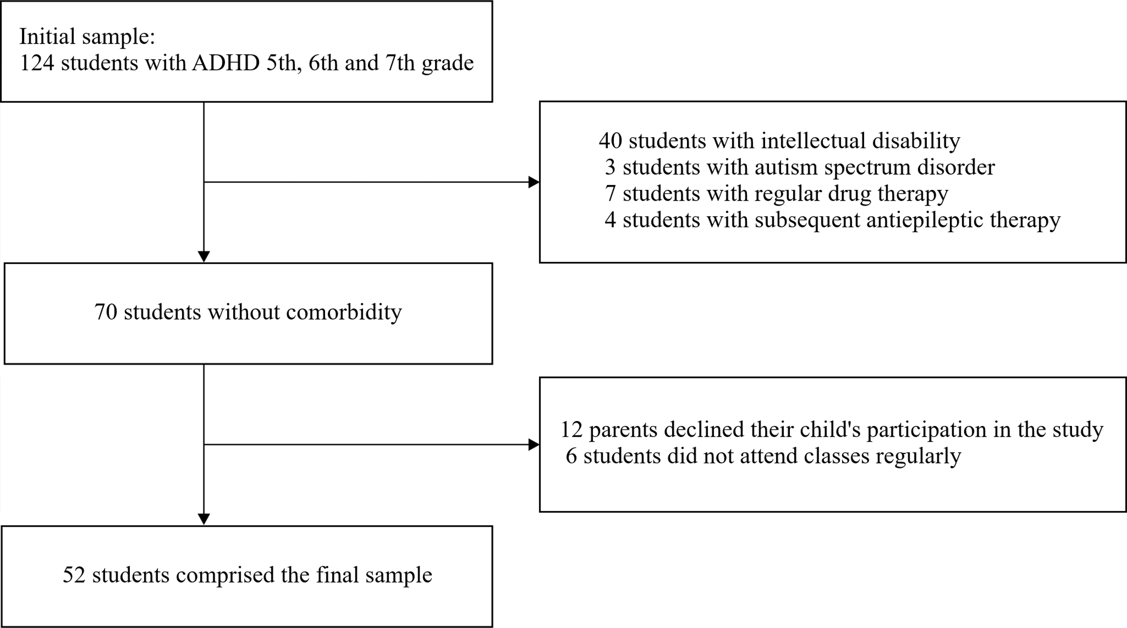

Figure 1. Flowchart of the study population selection.

Measures

The School Social Behavior Scale – Second Edition (SSBS-2, Merrell, 2002) was constructed with the aim of assessing the social competence and antisocial behavior of children and young people age five to 18. It is mostly used by educators in preschool institutions and teachers in schools, to evaluate the social and antisocial behavior of children and youth in kindergarten and school environment. There are 64 items grouped into two major scales: The Social Competence Scale (SCS) (Scale A) and The Antisocial Behavior Scale (ABS) (Scale B), each of which is comprised of 32 items. The SCS includes items that describe positive social skills and traits displayed by socially competent respondents. It is divided into three subscales: Peer Relations (14 items), Self-Management (10 items) and Academic Behavior (eight items). The Peer Relations subscale includes items that measure social skills important for establishing positive relationships with peers, as well as social acceptance by a peer group. The Self-Management subscale includes items that measure social skills related to self-restraint, cooperation, and compliance with the demands of school rules and expectations. The Academic Behavior subscale is made of items related to the quality of academic engagement. The ABS includes items that describe various socially problematic behaviors that can hinder successful socialization, include destructiveness, and cause negative social outcomes. It too, is divided into three subscales: Hostile/Irritable (14 items), Antisocial/Aggressive (10 items) and Defiant/Disruptive (eight items). The Hostile/Irritable subscale measures antisocial behavior in confrontational and antagonistic trends in academic tasks and social interactions with peers. The Antisocial/Aggressive subscale includes items that describe behaviors concerning intimidation or harms to other children and deliberate infringement of rules and boundaries. The Defiant/Disruptive subscale is made of items related to potentially disruptive behaviors to the classroom climate and unacceptable demands on teacher and child. Items in SSBS-2 are rated according to a five-point Likert-type scale (“1 = Never” to “5 = Frequently”). In this study, the Cronbach’s alpha coefficient for SSBS-2 was 0.92, for the SCS it was 0.89, and for the ABS 0.93.
Symptoms related to ADHD were assessed by the teacher and parental form of the Conners ADHD Index Rating Scales, 3rd edition (Conners 3 AI; Conners, 2008; Conners 3 DSM-5 Update, 2014). The Conners 3 AI is a reliable tool for multi-informative assessment of children and young people age six to 18 in detection of ADHD problems. The updated version from 2014 provides a new way of scoring for some of the items, in accordance with the met criteria for ADHD defined by the DSM-5. It includes 10 specifically selected items taken from full-length forms. Scoring is performed on a four-point frequency scale ranging from 0 (never) to 3 (very often). It is used when it is necessary to assess a larger group of children and adolescents for a limited time and when it is necessary to determine whether the assessment of ADHD is justified. A T-score of more than 60 can indicate that the child may have an issue such as ADHD. A T-score greater than 60 but under 70 may indicate moderately severe issues. A T-score above 70 may be a sign that the behavioral, academic, or emotional problems are severe. The Cronbach’s alpha coefficient for Conners 3 AI was 0.87 for the instrument as a whole.
Intellectual status assessment was performed by the Wechsler Intelligence Scale for Children – Fifth Edition (WISC-V; Wechsler, 2014). This instrument was used to assess the cognitive functioning of children and adolescents age six years to 16 years and 11 months. It gives a composite score that represents the child's general intellectual ability (full-scale IQ) and identifies cognitive delays.

Procedure

Determining ADHD-related symptoms by DSM-5 diagnostic criteria, as well as assessing by SSBS-2, was performed by the study authors. Diagnosis of ADHD, which is an integrative part of students' medical documentation, was performed by child psychiatrists and child neurologists within the competent pediatric departments in Serbia. Examining the intellectual level using WISC-V was performed by a psychologist at the school / developmental counseling center, as part of a regular assessment. At the beginning of the second semester of the 2020/21 school year, parents were contacted by phone, objectives of the study were explained and an agreement on potential participation was made. Due to compliance with the epidemiological measures that were in effect at the time of both tests, the collection of data from informants – homeroom teachers, was done through the Zoom, platform for digital distribution. During the individual data collection, the homeroom teachers gave answers to the questions orally, naming the answers they considered correct, with a detailed explanation. The researchers recorded the answers.

Statistical Analysis

All calculations were conducted in the statistical program IBM SPSS version 25.0 software. For all obtained values, which represent the results by subscales and the total score, the basic descriptive statistics were calculated for two time points. The reliability of the instruments was tested by applying the internal consistency coefficient (Cronbach's α). The paired sample t-test was used to compare normally distributed data. Correlations between variables were analyzed by the Pearson correlation test. The level of statistical inference was determined at p <0.05. The bootstrap method (Preacher & Hayes, 2008) was used to analyze mediation and determine the significance of the mediator effect in the study. If there is a mediator effect, zero should not be covered by confidence intervals. PROCESS Macro for SPSS, SAS, and R v3.3 was used for bootstrap score calculations.

Results

Table 1 shows the scores on the SCS, ABS and Conners 3 AI scales before and after online classes have ended during the COVID-19 pandemic. A paired t-test was applied to assess differences in the quality of social competence, the presence of antisocial behavior, and severity of ADHD symptoms during these two periods. It has been noted that, with reverting to school teaching, relationships with peers, self-management and the quality of social competence as a whole, were statistically significantly worse than before online classes. There was no statistically significant difference in the quality of academic behavior of students with ADHD after online classes ended. Regarding the antisocial behavior, it is noted that students with ADHD, when examining all forms of behavior, showed significant deterioration when they returned to school teaching. Likewise, it can be observed that the underlying symptoms associated with ADHD were more pronounced after students returned to school teaching.

Table 1. Distribution of SCS and ABS scores in relation to the period before and after online classes (M ± SD)
 | Before online classes | After online classes | t | p
 | M ± SD | M ± SD | t | p
Social Competence Scale  Peer Relations  Self-Management  Academic Behavior  Total SCS scores | 23.56 ± 9.14  17.27 ± 4.09  21.84 ± 9.18  62.79 ± 22.17  41.11 ± 18.47  25.36 ± 16.91  20.88 ± 9.54  87.49 ± 44.42  72.24 ± 18.62 | 18.16 ± 5.24  14.11 ± 6.81  20.13 ± 7.12  52.46 ± 19.27  50.42 ± 14.23  33.72 ± 12.07  24.41 ± 13.29  108.71 ± 39.19  84.88 ± 22.91 | 5.306  4.582  1.112  4.342 | < .001  < .001  .204  .001
Antisocial Behavior Scale  Hostile/Irritable  Antisocial/Aggressive  Defiant/Disruptive  Total ABS scores |  |  | –6.408  –5.811  –2.426  –7.268 | < .001  < .001  < .001  < .001
Total Conners 3 AI scores |  |  | –3.617 | .007
SCS – Social Competence Scale; ABS – Antisocial Behavior Scale; Conners 3 AI – Conners ADHD Index Rating Scales, 3rd edition

Tables 2 and 3 show Pearson's correlation analysis that determined whether the quality of social competence and the frequency of antisocial behavior will vary depending on the results of the Conners 3 AI score, before and after the online classes. After the online classes, a weak positive correlation between SCS and Conners 3 AI scores, a moderate positive correlation between ABS and Conners 3 AI scores and a strong negative correlation between SCS and ABS were recorded. When examining the relation of variables before online classes started, a statistically significant relation between SCS and Conners 3 AI scores, as well as ABS and Conners 3 AI scores was not determined. A weak negative correlation was recorded between SCS and ABS scores.

Table 2. Correlations between SCS, ABS and Conners 3 AI scores before online classes

 |  | Total SCS scores | Total ABS scores
Total SCS scores | r | –
 | p
Total ABS scores | r | –.276 | –
 | p | .031
Total Conners 3 AI scores | r | .189 | .162
 | p | .094 | .129
SCS – Social Competence Scale; ABS – Antisocial Behavior Scale; Conners 3 AI – Conners ADHD Index Rating Scales, 3rd edition

Table 3. Correlations between SCS, ABS and Conners 3 AI scores after online classes

 |  | Total SCS scores | Total ABS scores
Total SCS scores | r | –
 | p
Total ABS scores | r | –.734 | –
 | p | .000
Total Conners 3 AI scores | r | .398 | .601
 | p | .003 | .000
SCS – Social Competence Scale; ABS – Antisocial Behavior Scale; Conners 3 AI – Conners ADHD Index Rating Scales, 3rd edition

The mediating role of antisocial behavior in the relation between social competence and severity of ADHD-related symptoms was tested using mediation analysis, by dint of bootstrapping method. Figure 2a shows the relation between students' social competence and severity of ADHD symptoms before online classes started. It is noted that this ratio was not statistically significant (β = 0.63, p = .094). Inducing mediators in period before the online classes started, shows that the direct impact of social competence on antisocial behavior is significant (β = 0.76, p = .005), while the direct impact of antisocial behavior on severity of ADHD-related symptoms is not significant (β = 1.16, p = .092). The 95% bias-corrected confidence intervals included zero, indicating that antisocial behavior did not mediate the relation between the results of social competence and severity of ADHD symptoms in the period [β = 1.01, % 95 CI (−0.0034, 1.9989)]. After online classes ended, the overall impact of social competence on severity of ADHD-related symptoms was statistically significant (β = 1.18, p = .003). The direct impact of social competence on antisocial behavior (β = 0.47, p < .001) and the direct impact of antisocial behavior on severity of ADHD-related symptoms (β = 1.22, p < .001) were also statistically significant. Since the 95% bias-corrected confidence intervals did not include zero, it is noted that after online classes, antisocial behavior mediates between social competence and severity of ADHD-related symptoms [β = 1.42, % 95 CI (0.6124, 2.5768)]. The results support the full mediation effect of antisocial behavior on the relation between social competence and severity of ADHD-related symptoms after completing online classes. This mediation relation is given in Figure 2b. The overall effect of social competence on severity of ADHD symptoms was not significant (β = –0.24, p = .761).

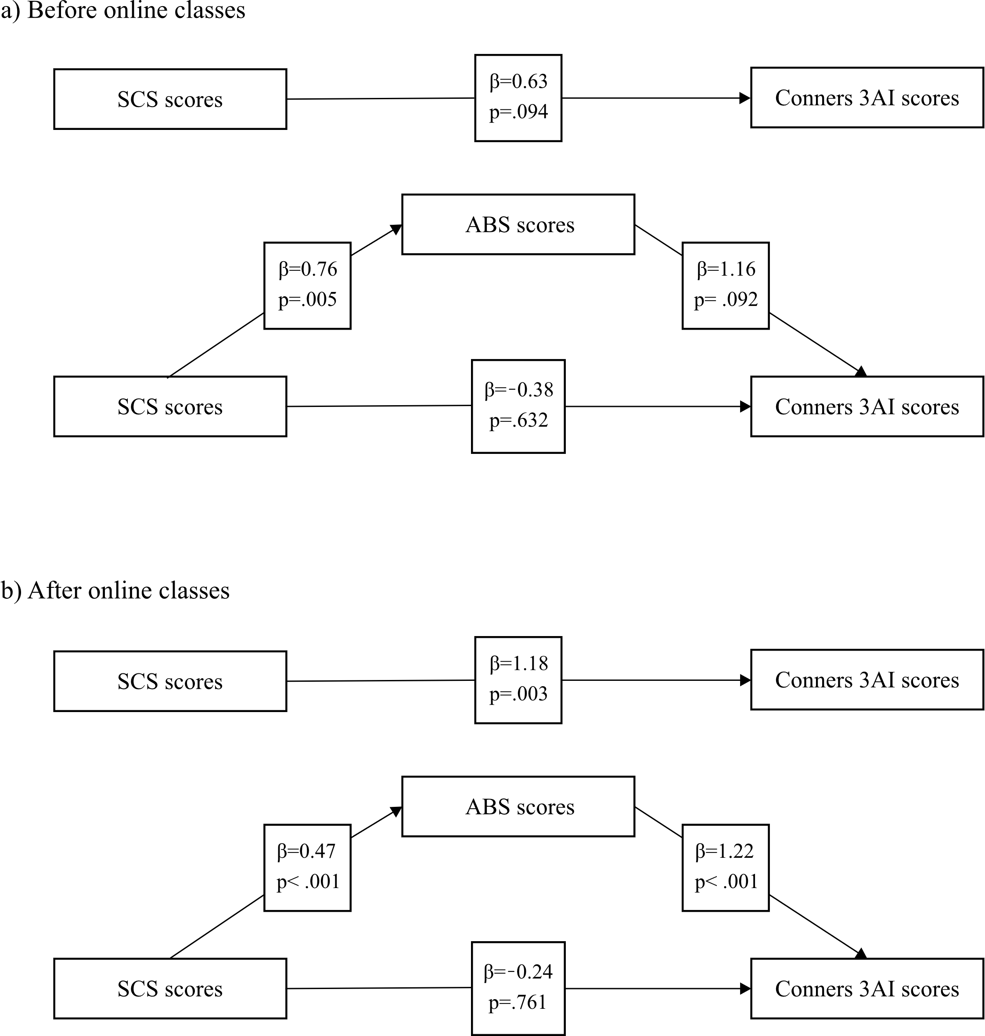

Figure 2. Meditator effects of antisocial behavior.

Discussion

In an attempt to compare the effects that occurred before beginning and after the end of online classes during the COVID-19 pandemic, in students with ADHD the relation between social competence, antisocial behavior, and severity of the symptoms of this clinical picture was examined.
Reinstating school teaching, peer relations, self-management and quality of social competence as a whole were significantly worse than before online classes started. The results registered significantly less frequent contacts with peers at school, and when that joining happens, it is inadequate and causes resentment of peers. Initiating peer conversations or being involved in them rarely existed after online classes, and an increased inadequate way of advocating for one's own needs has been noted. Previous studies have found that students with ADHD spend less time with friends outside of school (Marton, Wiener, Rogers, & Moore, 2015), which is potentially another indicator of a lack of closeness in peer relations that were more compromised during online classes. There was no statistically significant difference in the quality of academic behavior of students with ADHD after online classes ended, compared to the previous period. Teachers stated that the results of students' work corresponded to their abilities. School interventions on students with ADHD are mostly focused on academic behavior (Tresco et al., 2017), and this may be the reason why we did not find differences in scores during two testing periods.
Results within antisocial behavior are more dramatic. Participants, when examining all forms of behavior, showed a significant deterioration when they returned to school teaching, after online classes ended. The results showed that there was a significantly more frequent interference with ongoing activities, lying, causing fights and quarrels, impulsive reactions, defiance and a tendency to temper tantrums. Informants stated that the students had great problems complying to preventive epidemiological measures and in classroom it was characterized as antisocial behavior (intentionally not keeping physical distance, spitting at another, spitting on a desk, removing a face mask, spilling disinfectant, etc.). Research aimed at examining the main problems of adolescents with ADHD during the COVID-19 pandemic indicated that social isolation and online classes increases the risks for some of antisocial forms of behavior (Sibley et al, 2021).
The findings of the study show that the basic symptoms related to ADHD were more pronounced after students returned to school teaching. Given the described risks of social isolation and closing of schools can do to students with ADHD, such result was expected. Some of the previous studies yield similar results examining the worsening of symptoms associated with this clinical picture during the COVID-19 pandemic (Becker et al., 2020; Nonweiler et al., 2020).
The results indicating lower scores of social competence and higher scores of antisocial behavior in subjects with ADHD during the COVID-19 pandemic coincide with ours and were noted in the Israeli sample (Pollak, Shoham, Dayan, Gabrieli-Seri, & Berger, 2021). Unfortunately, the authors failed to find available research that would compare the results of social competence and antisocial behavior in the population of students with ADHD of primary school age before and after online classes, so the data obtained by our study are the first in this field.
Although, no significant correlation was found between results of social competence, antisocial behavior, and severity of ADHD symptoms before online classes began, symptom severity increased as results of antisocial behavior increased and results of social competence decreased after online classes ended and previous school teaching continued. Antisocial behavior was found to be a full mediating factor in the relation between social competence and severity of ADHD symptoms after online classes. Antisocial behavior has been singled out, as in previous studies, as a disproportionate but common factor in students with ADHD that includes internalizing behaviors such as social withdrawal and externalizing behaviors that include aggression, high irritability during daytime, and hyperactivity (Fogleman, Leaberry, Rosen, Walerius, & Slaughter, 2018; Kuja‐Halkola, Lichtenstein, D'Onofrio, & Larsson, 2015).
One of the limitations of this study relates to the absence of a comparison group of subjects without ADHD. This would explain whether the data obtained were exclusively specific to students with ADHD. Also, students with ADHD and comorbid conditions (intellectual disability, autism spectrum disorder, epilepsy, etc.) are not included in the sample and this makes it difficult to adequately represent the entire population of students with ADHD. Although we compared social competence, antisocial behavior, and severity of ADHD-related symptoms during significant changes related to the COVID-19 pandemic in Serbia, we did not evaluate these variables before the pandemic. Finally, the sample consisted largely of boys, which is expected for ADHD, but this means that the results may not be able to be generalized for girls.
This study highlighted the need to focus the education system in Serbia during the COVID-19, on vulnerable groups such as students with ADHD. The pandemic has caused introduction of online classes in primary schools. During this challenging period, it is noted that ADHD can be considered as an additional risk factor for lowering social competence and increasing the frequency of antisocial behavior. Timed and organized support from peers, teachers, schools and the Ministry of Education, Science and Technological Development can increase the resilience of students with ADHD to the challenges posed by the COVID-19 pandemic.
Students with ADHD should, due to the deterioration of the clinical picture caused by the COVID-19 pandemic (Jefsen, Rohde, Nørremark, & Østergaard, 2021) be provided with timely intensive support that should be carried out immediately as school 2021/22 year starts. If, because of social difficulties in participating in the educational process, in accordance with legal rights the student with ADHD would have a need for additional support, (Đurić-Zdravković, Japundža-Milisavljević, Milanović-Dobrota, 2019), the authors strongly encourage such a way of providing support in order to overcome the problems caused by the COVID-19 pandemic. In that sense, it is proposed to implement interventions that will bring positive experiences in different social situations in the post-COVID-19 period.

CONCLUSION

Changes that happened in the education system of the Republic of Serbia during the COVID-19 pandemic were a significant source of social danger for many students, especially for students with ADHD. Our research determined that students with ADHD showed significantly more frequent problems in exhibiting antisocial behavior and a lower level of social competence after online classes ended and students returned to school teaching. The research determined the following relations: a decrease in social competence leads to an increase in manifestations of antisocial behavior, and more frequent antisocial behavior leads to a worsening of the basic symptoms related to ADHD after online classes ended. Therefore, online classes pose an obvious risk for deepening problems within social competence and antisocial behavior in students with ADHD.

REFERENCES

Adegboye D., Williams F., Collishaw S., Shelton, K., Langley, K., Hobson, Ch., Burley, D., van Goozen, S. (2021). Understanding why the COVID‐19 pandemic‐related lockdown increases mental health difficulties in vulnerable young children. JCPP Advances, 1(1), e12005. https://doi.org/10.1111/jcv2.12005
American Psychiatric Association (APA) (2013). Diagnostic and Statistical Manual of Mental Disorders, 5th ed. (DSM-5). Arlington, VA: American Psychiatric Association.
Becker, S. P., Breaux, R., Cusick, C. N., Dvorsky, M. R., Marsh, N. P., Sciberras, E., & Langberg, J. M. (2020). Remote learning during COVID-19: examining school practices, service continuation, and difficulties for adolescents with and without attention-deficit/hyperactivity disorder. Journal of Adolescent Health, 67(6), 769-777. https://doi.org/10.1016/j.jadohealth.2020.09.002
Conners, C. K. (2008). Conners 3rd Edition. Toronto, Ca: Multi-Health Systems, Inc.
Conners, C. K. (2014). Conners 3rd Edition DSM-5 Update. Toronto, Ca: Multi-Health Systems, Inc.
Cost, K. T., Crosbie, J., Anagnostou, E., Birken, C. S., Charach, A., Monga, S., Kelley, E., Nicolson, R., Maguire, J. L., Burton, C. L., Schachar, R. J., Arnold, P. D., & Korczak, D. J. (2021). Mostly worse, occasionally better: impact of COVID-19 pandemic on the mental health of Canadian children and adolescents. European Child and Adolescent Psychiatry. https://doi.org/10.1007/s00787-021-01744-3
Ђурић-Здравковић, А. (2020). Педагогија особа с поремећајем интелектуалног развоја. [Pedagogy of persons with intellectual developmental disorder] Београд: Универзитет у Београду – Факултет за специјалну едукацију и рехабилитацију.
Ђурић-Здравковић, А., Јапунџа-Милисављевић, М., Милановић-Доброта, Б. (2019). Висока подршка ученичкој аутономији и академска регулација ученика у инклузивној настави. Теме – часопис за друштвене науке, XLIII(1), 133-153. http://teme2.junis.ni.ac.rs/index.php/TEME/article/view/1102/351
Đurišić, M. M., & Gajić, J. (2016). Social functioning of students with internalizing behavioral problems. Research in Pedagogy, 6(2), 32-42. https://doi.org/10.17810/2015.33
Fogleman, N. D., Leaberry, K. D., Rosen, P. J., Walerius, D. M., & Slaughter, K. E. (2018). Relation between internalizing behaviors, externalizing behaviors, and peer victimization among children with and without ADHD. ADHD Attention Deficit and Hyperactivity Disorders, 10(3), 209-222. https://doi.org/10.1007/s12402-018-0248-y
Hoza, B. (2007). Peer functioning in children with ADHD. Journal of Pediatric Psychology, 32(6), 655-663. https://doi.org/10.1093/jpepsy/jsm024
Jefsen, O.H., Rohde, C., Nørremark, B., & Østergaard, S.D. (2021). Editorial perspective: COVID-19 pandemic-related psychopathology in children and adolescents with mental illness. Journal of Child Psychology and Psychiatry, 62(6), 798-800. https://doi.org/10.1111/jcpp.13292
Kuja‐Halkola, R., Lichtenstein, P., D'Onofrio, B. M., & Larsson, H. (2015). Codevelopment of ADHD and externalizing behavior from childhood to adulthood. Journal of Child Psychology and Psychiatry, 56(6), 640-647. https://doi.org/10.1111/jcpp.12340
Marton, I., Wiener, J., Rogers, M., & Moore, C. (2015). Friendship characteristics of children with ADHD. Journal of Attention Disorders, 19(10), 872-881. https://doi.org/10.1177/1087054712458971
Merrell, K. W. (2002). School Social Behavior Scales, Second Edition. Eugene, OR: Assessment-Intervention Resources.
Nonweiler, J., Rattray, F., Baulcomb, J., Happé, F., & Absoud, M. (2020). Prevalence and associated factors of emotional and behavioural difficulties during COVID-19 pandemic in children with neurodevelopmental disorders. Children, 7(9), 128. https://doi.org/10.3390/children7090128
Петровић, Ј. (2008). Социјална компетенција: концептуална и теоријска питања [Social competence: conceptual and theoretical issue]. Теме – часопис за друштвене науке, XXXII(3), 611-623.
Pollak, Y., Shoham, R., Dayan, H., Gabrieli-Seri, O., & Berger, I. (2021). Symptoms of ADHD predict lower adaptation to the COVID-19 outbreak: Financial decline, low adherence to preventive measures, psychological distress, and illness-related negative perceptions. Journal of Attention Disorders https://doi.org/10.1177/10870547211027934
Preacher, K. J., & Hayes, A. F. (2008). Asymptotic and resampling strategies for assessing and comparing indirect effects in multiple mediator models. Behavior Research Methods, 40(3), 879-891. https://doi.org/10.3758/BRM.40.3.879
Raballo, A., Poletti, M., Valmaggia, L., & McGorry, P. D. (2020). Editorial Perspective: Rethinking child and adolescent mental health care after COVID-19. Journal of Child Psychology and Psychiatry and Allied Disciplines. https://doi.org/10.1111/jcpp.13371
Retz, W., Ginsberg, Y., Turner, D., Barra, S., Retz-Junginger, P., Larsson, H., & Asherson, P. (2021). Attention-deficit/hyperactivity disorder (ADHD), antisociality and delinquent behavior over the lifespan. Neuroscience & Biobehavioral Reviews, 120, 236-248. https://doi.org/10.1016/j.neubiorev.2020.11.025
Roberts, W., Milich, R., & Barkley, R. A. (2015). Primary symptoms, diagnostic criteria, subtyping, and prevalence of ADHD. In R. A. Barkley (Ed.), Attention-deficit hyperactivity disorder: A handbook for diagnosis and treatment, 4th ed. (pp. 51-80). New York, NY: Guilford Press.
Ros, R., & Graziano, P. A. (2020). A transdiagnostic examination of self-regulation: Comparisons across preschoolers with ASD, ADHD, and typically developing children. Journal of Clinical Child & Adolescent Psychology, 49(4), 493-508. https://doi.org/10.1080/15374416.2019.1591280
Sibley, M. H., Ortiz, M., Gaias, L. M., Reyes, R., Joshi, M., Alexander, D., & Graziano, P. (2021). Top problems of adolescents and young adults with ADHD during the COVID-19 pandemic. Journal of Psychiatric Research, 136, 190-197. https://doi.org/10.1016/j.jpsychires.2021.02.009
Sibley, M. H., Pelham, W. E., Molina, B.S., Gnagy, E. M., Waschbusch, D. A., Biswas, A., MacLean, M. G., Babinski, D. E., & Karch, K. M. (2011). The delinquency outcomes of boys with ADHD with and without comorbidity. Journal of Abnormal Child Psychology, 39, 21-32. https://doi.org/10.1007/s10802-010-9443-9
Song, P., Zha, M., Yang, Q., Zhang, Y., Li, X., & Rudan, I. (2021). The prevalence of adult attention-deficit hyperactivity disorder: A global systematic review and meta-analysis. Journal of Global Health, 11, 04009. https://doi.org/10.7189/jogh.11.04009
Tresco, К., Kessler, Ј., & Mautone, J. (2017). Attention deficit/hyperactivity disorder. In J. L. Matson (Ed.). Handbook of social behavior and skills in children (pp. 273-292). Cham, Switzerland: Springer International Publishing.
Wechsler, D. (2014). Wechsler Intelligence Scale for Children - Fifth Edition. Bloomington, MN: Pearson.

СОЦИЈАЛНА КОМПЕТЕНЦИЈА И АНТИСОЦИЈАЛНО ПОНАШАЊЕ КОД УЧЕНИКА С ADHD ТОКОМ COVID-19 ЕРЕ

Резиме

Под социјалном компетенцијом најчешће се подразумевају социјалне, емоционалне и когнитивне вештине и понашања која су релевантна за успешну социјалну адаптацију и социјалну интеракцију. Ученици са нижим скором социјалне компетенције у изазовним социјалним ситуацијама вероватно ће прибегавати антисоцијалном понашању. Ученици с ADHD, којих има од 5% до 10% од укупних школараца, имају тенденцију ка испољавању антисоцијалног понашања. Овај рад имао је за циљ утврђивање везе између социјалне компетенције, антисоцијалног понашања и озбиљности испољавања симптома ADHD код ученика старијег основношколског узраста пре почетка и након завршетка онлајн наставе током пандемије COVID-19. Узорак истраживања укључивао је 52 ученика с ADHD V, VI и VII разреда. За процену социјалне компетенције и антисоцијалног понашања коришћено је друго издање Скале социјалног понашања у школи, док су симптоми везани за ADHD процењени наставничком и родитељском формом трећег издања Конерс рејтинг скале. Уочено је да су поновним повратком на школску наставу односи са вршњацима, управљање сопственим понашањем и квалитет социјалне компетенције у целини били статистички значајно лошији него пре почетка онлајн наставе. Што се тиче антисоцијалног понашања, уочава се да су ученици с ADHD при испитивању свих облика понашања показали значајно погоршање приликом поновног доласка на школску наставу, након завршетка периода спровођења онлајн наставе. Исто тако, уочава се да су основни симптоми везани за ADHD били израженији након повратка ученика на школску наставу. Медијациона улога антисоцијалног понашања у вези између социјалне компетенције и озбиљности симптома везаних за ADHD испитана је помоћу медијационе анализе, путем бутстрапинг методе. Однос социјалне компетенције ученика и озбиљности испољавања симптома ADHD пре почетка онлајн наставе није био статистички значајан (β = 0,63, p = ,094). Увођењем медијатора у периоду пре почетка онлајн наставе уочава се да је директни утицај социјалне компетенције на антисоцијално понашање значајан (β = 0,76, p = ,005), док директни утицај антисоцијалног понашања на озбиљност испољавања симптома везаних за ADHD није значајан (β = 1,16, p = ,092). Резултати подржавају потпуни медијацијски утицај антисоцијалног понашања на однос између социјалне компетенције и озбиљности испољавања симптома везаних за ADHD након завршетка онлајн наставе [β = 1.42, % 95 CI (0.6124, 2.5768)].
Након спровођења онлајн наставе уочило се да се ADHD може сматрати додатним фактором ризика за снижавање социјалне компетенције и повећање учесталости антисоцијалног понашања.

