DEVELOPMENT OF MUSICAL HEARING IN SOLFEGGIO TEACHING THROUGH MULTIMODAL TREATMENT OF ATONAL AND EXTENDED-TONAL MUSIC BY SERBIAN COMPOSERS

Abstract
The subject of this paper is the development of musical hearing of university students through solfeggio learning in which selected passages from extended-tonal and atonal music of Serbian composers are treated multimodally (by activating several sensory modalities). The development of musical hearing was carried out through the process of literal parallelism in the perception and performance of extended-tonal and atonal music of Serbian composers. The research method is a pedagogical experiment in parallel groups – the testing technique was applied. The aim of the research is to examine the influence of literal parallelism in auditory perception and performance on improving musical hearing in third-year university students.
The authors conclude that the application of literal parallelism in auditory perception and performance in third-year students’ solfeggio instructions only partially contributed to the development of hearing. We believe that the reasons for this result lie in the limitations of applied experimental research – the experimental program itself was conducted in classes for only half an hour on a weekly basis. Also an appropriate sample of students is, although common for smaller faculties such as art ones, small in number to draw general conclusions. With all of the above in mind, the authors believe that the application of literal parallelism should be included at earlier levels of education, which is a necessary condition for working on complex content of extended-tonal and atonal music.
Key words: solfeggio, aural skills, multimodal approach, pedagogical experiment, Serbian composers

РАЗВОЈ МУЗИЧКОГ СЛУХА У НАСТАВИ СОЛФЕЂА КРОЗ МУЛТИМОДАЛНИ ТРЕТМАН АТОНАЛНЕ И ПРОШИРЕНО-ТОНАЛНЕ МУЗИКЕ СРПСКИХ КОМПОЗИТОРА

Сажетак
Предмет овог рада јесте развој музичког слуха студената кроз универзитетску наставу солфеђа у којој се одабрани одломци из проширено-тоналне и атоналне музике српских композитора третирају мултимодално (активацијом више чулних модалитета). Развој музичког слуха вршен је кроз процес дословног паралелизма у опажању и извођењу проширено-тоналне и атоналне музике српских композитора. Као метод истраживања примењен је педагошки експеримент у паралелним групама – техника тестирања. Циљ истраживања је испитивање утицаја дословног паралелизма у слушном опажању и извођењу на побољшање музичког слуха код студената треће године студија.
Аутори закључују да је примена дословног паралелизна у слушном опажању и извођењу у настави са студентима треће године, само делимично допринела развоју слуха. Сматрамо да разлози за овакав резултат леже и у ограничењима примењеног експерименталног истраживања будући да је истраживач за експериментални програм имао на располагању само време од пола сата на недељном нивоу. Такође пригодни узорак студената је, иако уобичајен за мање факултете какви су уметнички, малобројан да би се донели генерални закључци. Са свим реченим у вези, аутори сматрају да би примену дословног паралелизма требало укључити у раније нивое образовања, који су неопходни услов за рад на сложеним садржајима проширено-тоналне и атоналне музике.
Кључне речи: солфеђо, слушне вештине, мултимодални приступ, педагошки експеримент, српски композитори

INTRODUCTION
Successful interpretation of extended tonality and atonal musical works created during the 20th and current 21st century is by default one of the main tasks of the entire university-level music education, as well as a precondition of professional competence. The fact is, however, that music without a tonal support, and especially composed by Serbian composers, is not given proper attention. This phenomenon was also noticed by Dragana Stojanović Novičić (2010: 138), naming it as an exaggerated use of “tonal narrative” in solfeggio teaching. The consequences of the above may be the following: 1. insufficient competence of musicians to perform works created in the 20th and 21st centuries; 2. failure to reach the ultimate range of musical hearing development; and 3. insufficient motivation to perform these works on stage.
Composers and musicologists who support atonality believe that the problem is not in music, yet we are in need of a new perception (Masnikosa, 1998: 30). Being aware that accurate perception of atonal combinations (including serial ones) is almost impossible, these music experts suggest that, instead of focusing on the perception of pitches (or micro-structure), one should attempt to perceive macro-structure, i.e., musical form, chords, and so on (Aguila, 2005). This kind of perception should be nurtured in all school subjects; however, since solfeggio (aural skills) is the only subject oriented toward developing auditory sensitivity, it is unacceptable to give up on accurate intonation and rhythmical precision in performance and perception.
It is proven that the abilities to perceive music develop under the influence of unconsciously internalized sounds of a culture, and a genetically-based and culturally-shaped mechanism of expectation (Nikšić, 2021). The authors Cvetković and Đurđanović explain the cultural experience by the fact that the audience was exposed to e.g. Mozart, rather than Stockhausen (Cvetković & Đurđanović, 2014: 329).
There are numerous factors that make atonal music more difficult to perceive, understand, memorize, and reproduce compared to tonal music. Speaking about the characteristics of listening to contemporary music, Jelena Cvetković (2015) states, “A listener who was musically raised on the basis of traditional art music, when listening to new music, feels a kind of disintegration of sound flow, which prevents him from understanding the musical connections within composition” (Cvetković, 2015: 153). Most of our musical experience is based on tonality. In addition, atonality is characterized by a lack of tonal statics and kinetics (primarily functional), as well as the polarity of consonance–dissonance. Composers often pay attention to the music piece (Lehman, Sloboda & Woody, 2012: 256) and follow their own very rich musical language, ignoring the fact that such a language is felt in a positive sense and understood by a small number of listeners. During cognitive processing, the central issue is the mechanism of grouping, which is carried out according to the laws of gestalt, and atonal achievements are predominantly not in accordance with them. As a logical consequence of such predispositions to cognitive processing of atonality, there is a negative reaction – negative feelings, including frustration and anxiety. Cvetković (2015) offers the possibility of interpreting this phenomenon in light of Festinger’s theory of cognitive dissonance (Festinger, 1957, according to Cvetković, 2015), according to which everyone strives for the consistency of their opinions, attitudes, and behavior. Thus, if the two phenomena are psychologically inconsistent, there is a feeling of unpleasantness and the impression of inconsistency (Cvetković, 2015: 154).
Research shows that both musicians and non-musicians express a lack of emotional reactions to atonal music compared to tonal music. Feelings are inevitably reflected in the learning process, and the atonal context affects the increase of insecurity when performing on the instrument. It has been proven that atonality creates distraction or confusion while playing a prima vista (Udtaisuk, 2005: 89). An accurate premonition for otherwise unexpected musical turns is built through gaining experience; individuals manage to adapt to “contraaesthetics” and adopt such a complex musical language (Huron, 2006: 333), far from the diatonic foundations of children’s, folklore, and popular music, and even the largest part of art creation. Therefore, to arouse, but also to maintain the interest of most students in the music of these characteristics is not an easy task. The correct way to do this is repeated exposure. More precisely, with the repetition of the exposure to previously perhaps unpleasant musical content, with the help of (new) existing experience, new types of expectations develop, and the next encounter even with atonal music is perceived as less stressful (Huron, 2006: 292). At the same time, expectations that get confirmed in the future as accurate become accelerated by the motor reactions that are the foundation of every kind of performance (Huron, 2006: 357).
The concept of literal parallelism in the perception and performance of extended-tonal and atonal music of Serbian composers is based on repetition and directed against forgetting, i.e., the disappearance of sound information in memory. In it, musical information is treated bilaterally or multiple times, primarily through reproduction, but also through deeper cognitive processing of sound information. Literal parallelism is based on a multimodal approach in teaching solfeggio (Beočanin, 2017). As solfeggio represents a complex set of skills whose acquisition depends on practice, literal parallelism in perception and performance – since it basically contains repetition – is a specific form of guided practice. Literal parallelism implies an approach based on vocal performance from sheet music and auditory perception (recognition) of the same musical passages with possibly subsequent instrumental performance in order to further substantiate sound impressions. This approach contains certain specifics that deviate from the usual teaching procedures. Contrary to the practice of singing and perceiving similar or related sound phenomena at one time (thereby consolidating the sound impression in consciousness), literal parallelism provides for the singing of a particular example in one class, and then its renewal by dictation in the next, as well as in later classes. The renewal, except through dictation, is carried out by encouraging students to play, on their instrument or piano, previously processed melodies, as well as to create improvisations of those same examples themselves. This concept, therefore, exceeds ordinary repetition. Repetition alone makes learning exclusively reproductive and stereotypical. This is especially inconvenient in the case of music of extended tonality and especially atonality, very difficult to mentally process. Repetition, but with a new combination of elements, proves to be a better option. Therefore, here it is proposed that the reproductive basis of literal parallelism gets supplemented with productive exercises, done in class and/or in the form of homework. Productive exercises are a kind of counterpart to traditional preparatory instructional exercises since they arise after the first stage of mastering the original melody. These exercises, student improvisations, should affirm active learning and contribute to the additional determination of the pitch relations regardless of the rhythmization within the original melodies. This simple principle combines different teaching procedures and in the form used in this research does not exist in the available methodical suggestions. However, we can say that it is most similar to the methods of two American authors – Herder (1977) and Friedmann (1990).

RESEARCH METHODOLOGY
The aim of the research is to examine the influence of literal parallelism in auditory perception and performance on the improvement of musical hearing in third-year university students. In accordance with the aim set in this way, the following tasks are defined:
- choose suitable teaching content – excerpts from extended-tonal and atonal Serbian musical works, which would represent indicators for an independent variable (literal parallelism in perception and performance);
- form a corresponding sample in university classes and divide it into parallel groups;
- organize work with an experimental group and work with a control group in which the experimental factor will not act;
- construct an initial and final test to examine the level of melodic hearing (accuracy in the auditory perception of atonal melodies) and harmonic hearing (accuracy in the perception of non-tertian based chords).
Hypothesis. Literal parallelism through the perception and performance of extended-tonal and atonal music of Serbian composers contributes not only to the enrichment of the fund of stable musical-auditory representations, but also to the improvement of musical hearing expressed through accuracy in perceiving unknown instructive musical content. The research method is a pedagogical experiment in parallel groups. The testing technique was applied. The independent variable is our model of literal parallelism in the performance and auditory perception of concrete selected passages from extended-tonal and atonal Serbian music.
The dependent variables are the following:
- achievement on the initial test, as an indicator of the degree of sensitivity of musical hearing (at the same time melodic and harmonic). As the total number of pitches and chords to be perceived due to recognition was 54 (30 for melodic hearing and 24 for harmonic hearing), musical hearing as an integral phenomenon was measured by numbers from 0 to 54;
- achievement on the final test, as an indicator of the change in the degree of sensitivity of musical hearing (at the same time melodic and harmonic) after the experimental period. Musical hearing was again measured as an integral phenomenon by numbers from 0 to 54;
- the difference between the achievements on the initial and final tests, as an indicator of the change in the degree of sensitivity of musical hearing (at the same time melodic and harmonic).
Measuring instruments are the initial and final written tests, which were constructed for the purpose of this research. To measure the improvement of musical hearing, scales of points were applied in the corresponding tasks of the written test where each accurately recognized pitch or chord brought one point. The written test was created in order to obtain the most precise results on the level of musical hearing of students, i.e., on their auditory sensitivity. This caused the composition of assignments, completely new for students. The parallel form of the initial and final written tests was carried out through identical requirements, but with a difference in concrete intonation (transposition was performed). This means that students did not solve the identical assignment in the final test, but the same only at different starting pitches (in transposition).
As musical hearing is manifested through the perception of linear flow (melodies) and vertical components – written test represented the requirements of both types. The written test consisted of six tasks grouped into two parts:
I – notation of three unknown atonal (dodecaphonic) melodies (metrically and rhythmically simple, at a moderate or light tempo), characterized by interval diversity (all quality and distance types between tones are represented ― all the way to compound second). These tasks measured the sensitivity of the melodic hearing of the subjects (Figures 1 and 2).
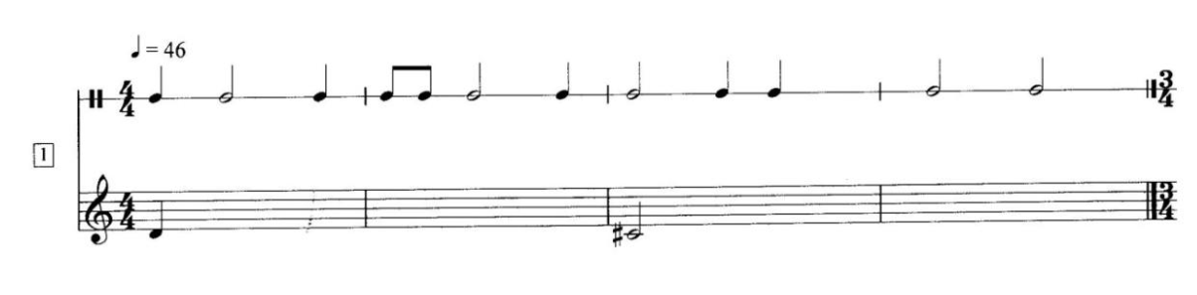
Figure 1. The first task of the written test – students’ copy
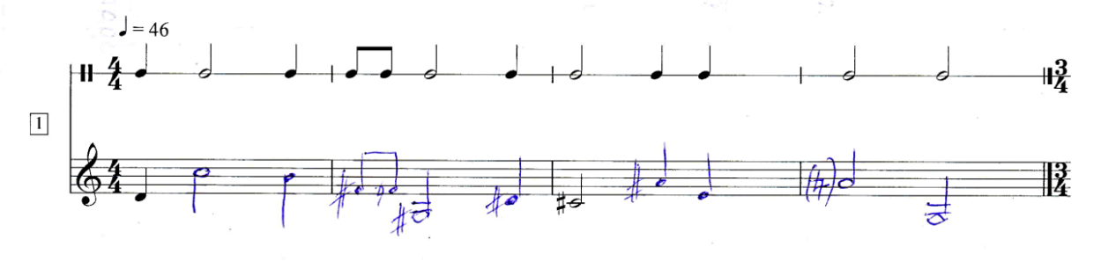
Figure 2. The first task of the written test – examiner’s copy
II – notation of the chords (two, four, and three notes) of a different non-tertian assembly. These tasks measured the sensitivity of the subject’s harmonic hearing (Figures 3 and 4).
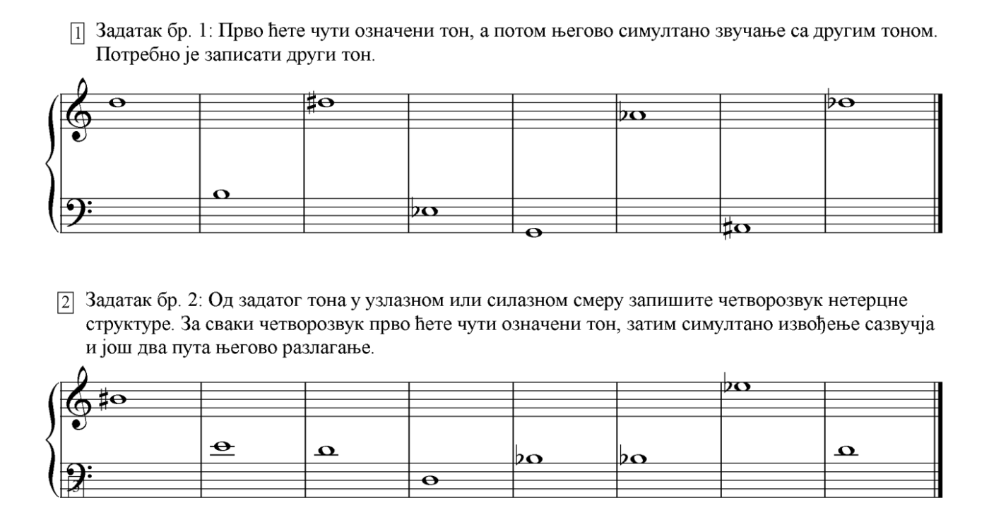
Figure 3. Tasks for measuring the sensitivity of harmonic hearing – students’ copy
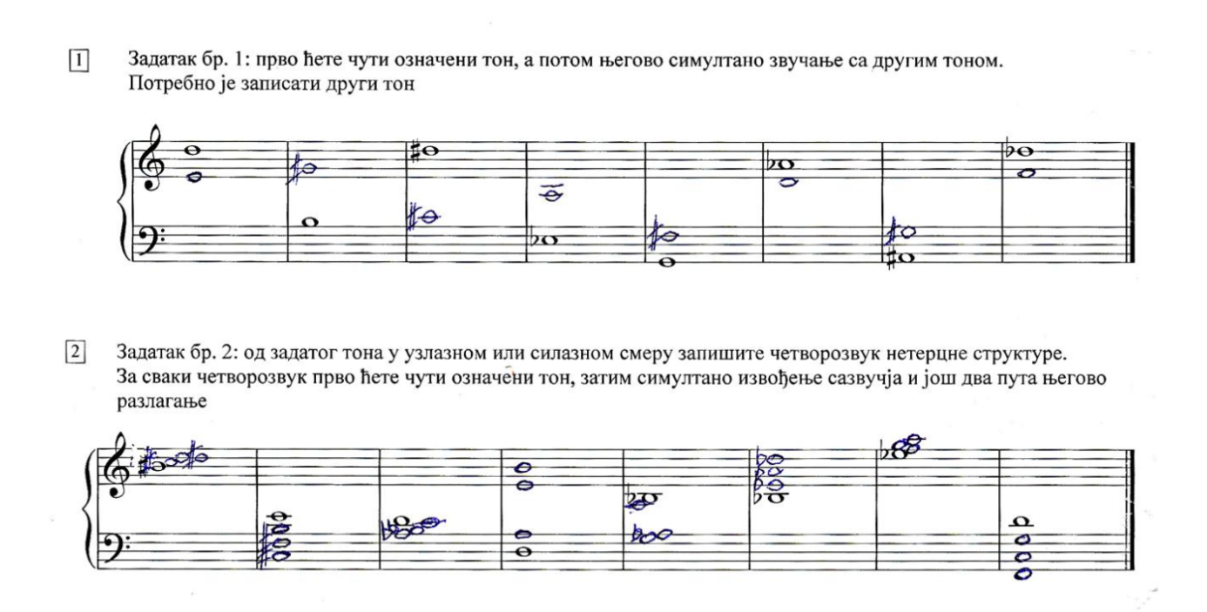Figure 4. Tasks for measuring the sensitivity of harmonic hearing – examiner’s copy
Time, place, and sample of research. The pedagogical experiment lasted six months in experimental groups in two cities. The research began when students attended their one-semester subject Solfeggio 5, and was completed during their one-semester subject Solfeggio 6. The pedagogical experiment was conducted in parallel groups at two faculties: the Faculty of Music in Belgrade and the Faculty of Philology and Arts in Kragujevac. One experimental and one control group were formed at each of the two faculties. A convenient homogeneous sample was formed from third-year students of General Music Pedagogy in Belgrade and a suitable heterogeneous sample from students of mostly different performing profiles in Kragujevac. The number of examinees was approximately the same in the two higher education institutions, as shown in Table 1.
Table 1. The Sample
Faculty | Frequency | Percentage (%)
Belgrade | 17 | 48.58
Kragujevac | 18 | 51.42
Total | 35 | 100.0

The sample was divided into subsamples: the experimental and control group of students from Belgrade and the experimental and control group of students from Kragujevac. The reasons for this division stem from the importance that solfeggio had for students of music pedagogy from Belgrade, compared to students, mostly performers from Kragujevac. In this way, there were actually four groups: the experimental and control one in Belgrade and the experimental and control one in Kragujevac. The classification of respondents into two parallel groups (both Kragujevac and Belgrade samples) was carried out according to the result on the initial written test. A relatively uniform sample of different educational profiles in experimental and control groups was formed, and this is what it looks like (Table 2):
Table 2. Number of points by groups on the initial test
Mixed group – Kragujevac | General music pedagogy – Belgrade
Е-group (N=9) = 138  Average achievement by student: 15.33 | Е-group (N=8) = 189  Average achievement by student: 23.63
C-group (N=9) = 136  Average achievement by student: 15.11 | C-group (N=9) = 201  Average achievement by student: 22.33

Statistical data analysis. IBM SPSS version 20 and GraphPad were used when processing test results. Descriptive statistics were applied, as well as nonparametric tests.
Organization and research process. The research was conducted in several stages:
- making a research plan,
- selecting fragments of extended-tonal and atonal music for experimental treatment,
- designing tests and questionnaires,
- conducting initial tests with the entire sample and sorting into parallel groups based on these results,
- experimental treatment in experimental groups,
- organizing final tests with the entire sample and
- analysis and interpretation of the results.

EXPERIMENTAL PROGRAM
The experimental program with students classified into experimental groups lasted fifteen weeks. Excerpts from the extended-tonal and atonal music of Serbian composers were processed through a specific multimodal approach, i.e., the methodical concept of literal parallelism over eleven weeks, and during the last four meetings a colloquium was organized, which was an integral part of the experiment. In consultation with subject teachers, students classified in E-groups attended experimental classes for 30 minutes each working week. During this time, work took place in control groups, which differed from working in experimental groups in two key elements: 1) there was no literal parallelism in perception and performance and vice versa, and 2) no passages from Serbian extended-tonal and atonal pieces were applied.
In the experimental course, excerpts from compositions of Serbian music were processed in two ways:
- direction 1: vocal performance ⭢ auditory perception ⭢ instrumental performance (mostly) and
- direction 2: auditory perception ⭢ vocal performance ⭢ instrumental performance (in one case).
The first direction is common for the melodies that begin with a large number of melodic leaps, which are considered relatively difficult for auditory perception. The beginning of the learning process was achieved by singing from the score. In the next class, the same passage was processed through oral dictation, from the original sound recording and/or piano, where students sang what they heard by solmization, and then named the tones alphabetically. In compositions with a poetic text, this text was an aggravating factor for recognizing tones, so piano was necessary to be used for auditory perception. In addition, in each class, at least one student played the last melody from memory. It was followed by writing one’s own melodic and harmonic improvisation to the last processed melody, and then singing certain texts among them. Melodic improvisations were created on the backbone of the same pitches sequence, but of different meters and rhythms, mostly shifted strong and weak beats, with occasional consecutive repetition of the same pitch or even more desirable – melodic movements. Harmonic improvisations were created by arranging the tones of the original melody to sound simultaneously. The procedure was as follows: the student noted the first two (successive) tones from the original melody, while the others (as simultaneous chords) are added by choice. Then he takes the second and third tones of the melody, repeats the procedure, and so on. The chords are then sounded by singing broken down from the lowest or highest tone, and their sonivity is checked on the instrument through simultaneous and broken playing. The aim was to activate musical thinking, since creation in the processing of teaching content of any type should represent the final stage (after reproduction) and the same relations between tones should be practiced in different metro-rhythmic contexts.
In the first case – vocal performance ⭢ auditory perception ⭢ instrumental performance – the beginning was based on analysis, primarily tonal. Given that students already have pre-developed musical thinking, they did not receive specific guidelines on which associations should be applied, but the whole group with the teacher made suggestions. Thus, some of the strategies involved remembering previously sung pitch or functional interpretation of intervals. After repeatedly singing with solmization syllables, in the case of vocal pieces it was once sung with a poetic text.

AN EXAMPLE OF EXPERIMENTAL WORK
The specifics of the experimental program will be shown on one example of working on the composition for solo soprano and mixed choir by Vojislav Ilić Nema leba (Zapis 1492). It is composed within the extended-tonal framework, in which the linear flow leads to the whole tone clusters. It was chosen because the fortification of whole tone clusters should accelerate their differentiation from chromatic and other cluster structures and further improve the performance and perception of whole tone sequences. Students were presented with the initial (Figure 5) and final part (Figure 6) of the composition, characterized by these chords.

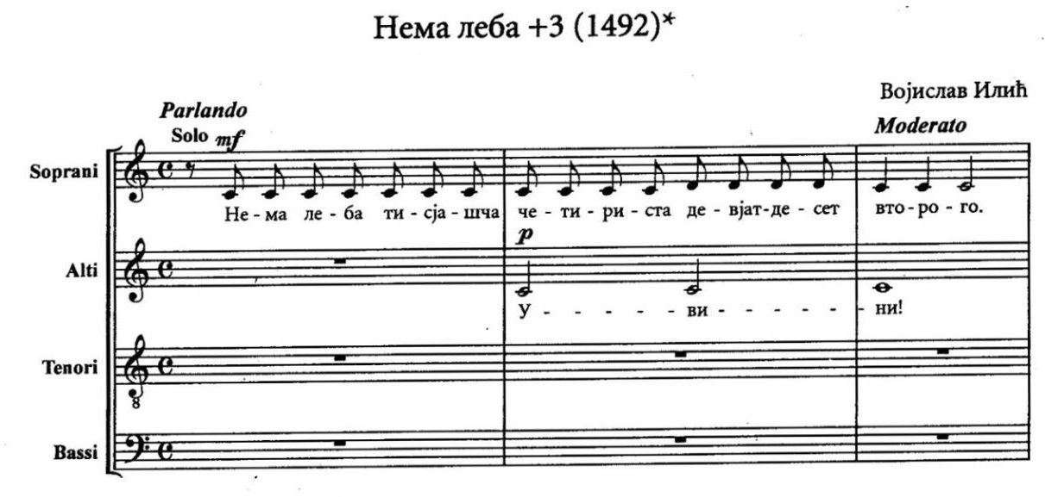
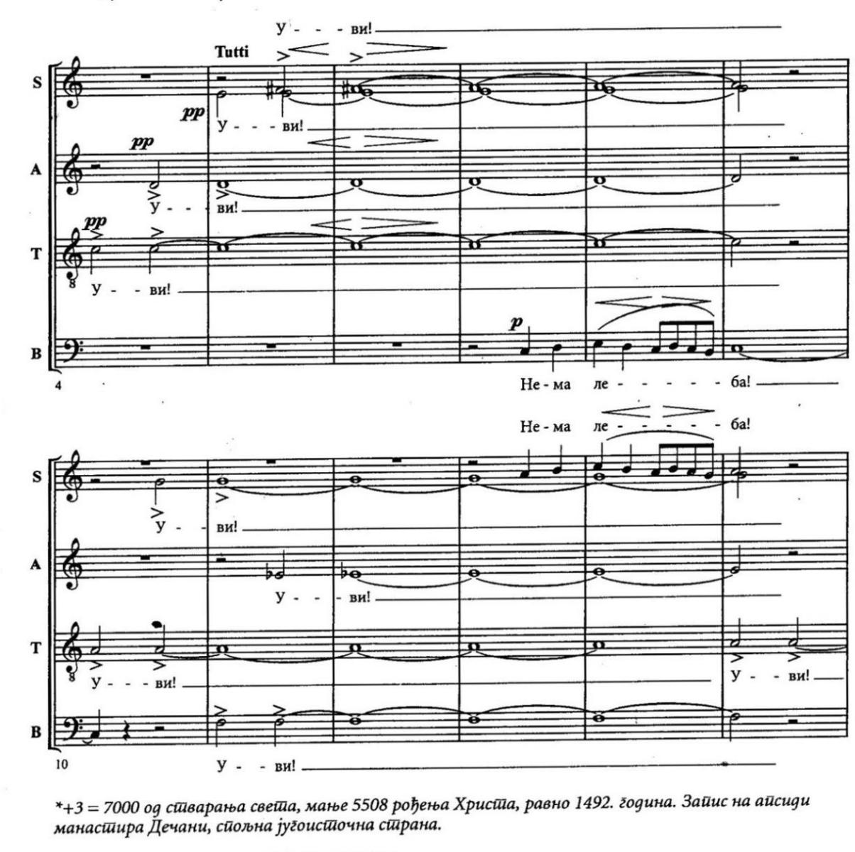
Figure 5. The beginning fragment (bars 1-15) of ‘Nema leba’ by V. Ilić

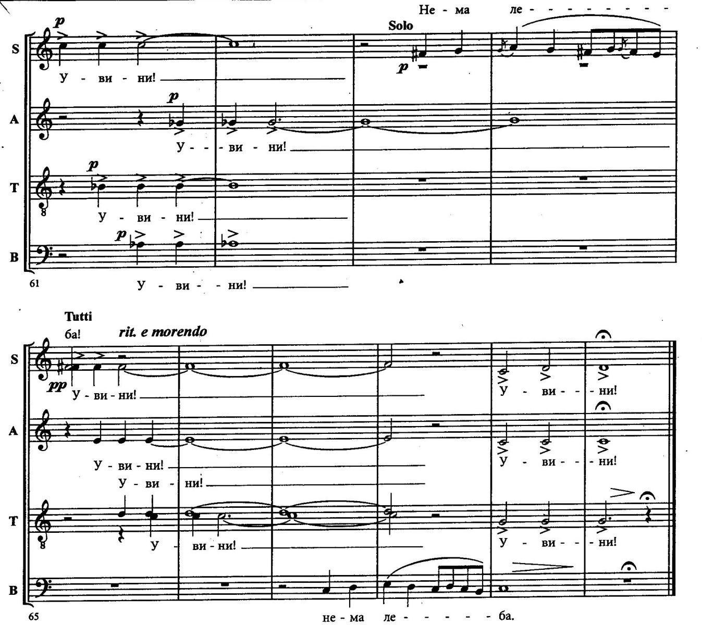
Figure 6. The ending fragment (bars 55-70) of ‘Nema leba’ by V. Ilić
After the analysis, the fragments were repeatedly sung in a multi-voice texture. Then, without insight into the sheet music, the original sound recording was listened to, and the students would simultaneously pronounce alphabetically the tones in clusters. In the subsequent class, two passages from Nema leba were written as fill-in dictation exercise. In the next class, the fragments were renewed; then a melodic improvisation was written on the given tonal series drawn from the fragments of the composition.
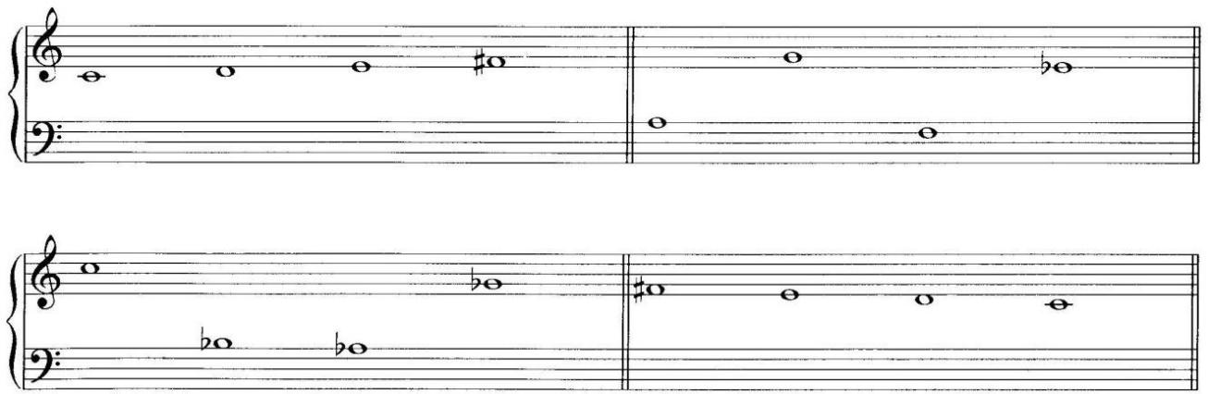
Figure 7. Pitches drawn from the clusters (‘Nema leba’)
It has been suggested that tonal relationships within the whole tone clusters should be memorized by improvising a melody in a 5/8 metric type, with each of the clusters being broken down several times. At the same time, the pitch order does not have to be the same as in the composition, it is even desirable to focus on the melodic leaps of the minor seventh and the compound major second (from the original score) and their successive repetition, because “repetition is the mother of all learning” (Figure 8).

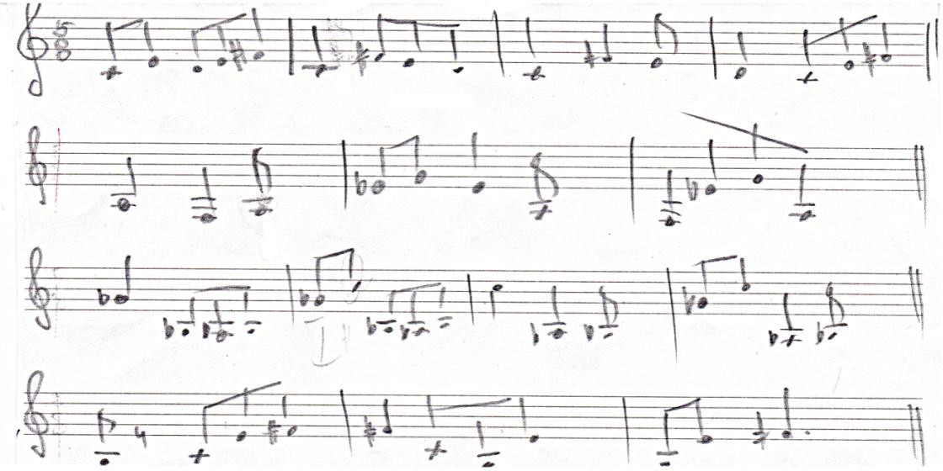
Figure 8. Student’s task – improvisation on given clusters
The end of the work on this fragment was based on the singing of student improvisations. In addition to the presented passage from Vojislav Ilić’s composition Nema leba, the experimental program consisted of excerpts from four other compositions by Serbian composers.
One of the factors that were estimated to influence the motivation for exercise during experimental work was the inclusion of the experimental program in a regular colloquium program. The results of the colloquium showed that the pace of progress in terms of mastering new passages from Serbian extended-tonal and atonal literature was somewhat slower compared to the original expectations.

PRESENTATION AND DISCUSSION OF RESULTS
The aim of the research was to examine the influence of a multimodal approach, more precisely the previously described literal parallelism on improving musical hearing in third-year university students, i.e., in the last year of learning solfeggio. The results we received will be displayed – due to the limited length of this text – only partially.

1. Achievement on the initial test – an indicator of the degree of sensitivity of musical hearing as an integral phenomenon (both melodic and harmonic)
The total number of pitches and chords that needed to be written or marked when recognized was 54 (30 for melodic hearing and 24 for harmonic hearing). Members of the E-group in Kragujevac achieved an average of 15.33 out of the possible 54 points per test, and members of the C-group in the same city almost equally – 15.11. In contrast, members of the Belgrade E-group scored an average of 23.63 points, while the subjects of the Belgrade C-group gained 22.33 points each (also out of the possible 54 points per test). The fact that no group scored on average even half out of the maximum 54 points showed that there was room for advancement in terms of improving musical hearing, but also that the tasks set regarding the auditory perception of unknown dodecaphonic melodies and non-tertian chords are very demanding.

2. Achievement on the final test – an indicator of the degree of sensitivity of musical hearing as an integral phenomenon (both melodic and harmonic)
Musical hearing was re-measured on the final test by numbers from 0 to 54 (30 for melodic hearing and 24 for harmonic hearing). Members of the E-group in Kragujevac achieved cumulatively 193 points, i.e., an average of 21.44 out of the possible 54 points per student. C-group respondents (Kragujevac) achieved a total of 124 points, which means an average of 13.78. Members of the Belgrade E-group scored an aggregate of 212 points, i.e., an average of 26.5 points, while members of the Belgrade C-group gained a total of 224 points, i.e., 24.89 average per tested student. There is a noticeable better achievement of the E-group compared to the C-group in Kragujevac, but only a slight advantage of the Belgrade E-group compared to the C-group.

3. The difference between the achievements on the initial and final tests, as an indicator of the change in the degree of sensitivity of musical hearing (both melodic and harmonic)
There is no statistically significant improvement at the Faculty of Philology and Arts in Kragujevac. Analogous to the progress of the entire sample, although the E-group improved significantly in points while the C-group performed slightly weaker on the final test than on the initial test, the difference is not statistically significant (Chart 1).
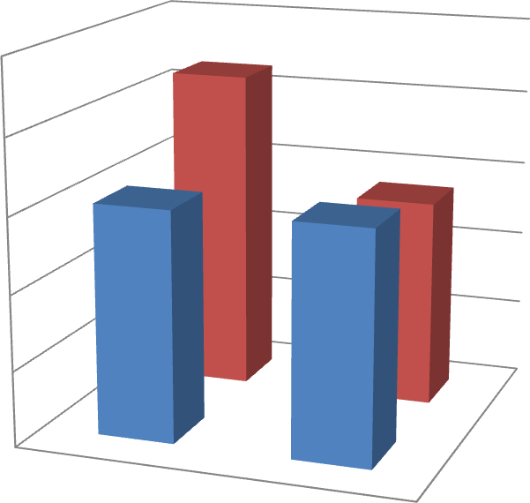
25
21.44
20
15.33
13.78
15.33
15
10
initial test
final test
5
final test
0
inital test
E-group
C-group
Chart 1. Change in musical hearing sensitivity of E- and C-group in Kragujevac
Then, at the Faculty of Music in Belgrade, a more uniform improvement in musical hearing of the two groups is observed. The E-group progressed slightly more in points, but the improvement is not statistically significant in the case of either group (Chart 2).

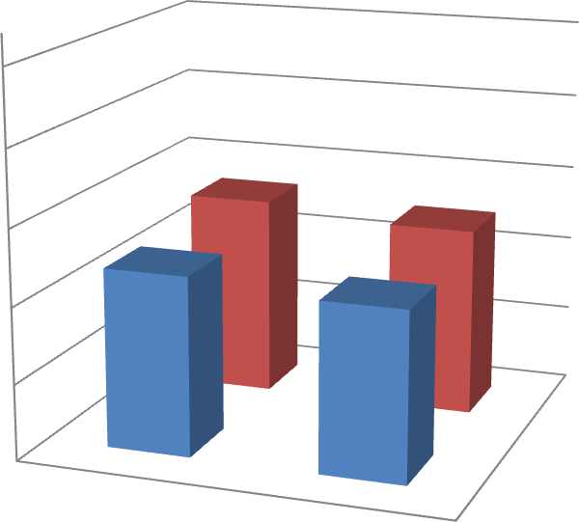
Chart 2. Improvement in musical hearing of E- and C-group in Belgrade
50
40
26.5
24.89
30
23.63
22.33
20
initial test
final test
10
final test
0
initial test

Е-group
C-group

4a) The difference between the achievements on the initial and final tests, as an indicator of the change in the level of melodic hearing of the subjects
At the Faculty of Philology and Arts in Kragujevac, the E-group slightly improved its achievement, and the C-group lowered it.

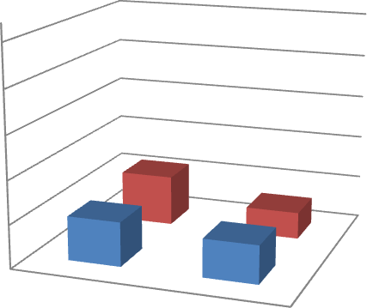
50
40
30
20
10
0
11.67
10.22
6.22
8.78
Initial test
Final test
Final test
Initial test
E-group
C-group
Chart 3. Change of achievement from test to re-test by melodic hearing parameter in Kragujevac

None of the two groups at this faculty achieved a statistically significant change in performance.

Table 3. Results of descriptive statistics and t-tests of C- and E-groups on initial and final measurement (melodic hearing, Kragujevac, N=18)
INITIAL MEASUREMENT |  |  |  |  |  |  |  | FINAL MEASUREMENT
Variable | Group |  | M |  | t | df | p | M | SD | t | df | p
 |  | N |  | SD
Melodic hearing | E | 9 | 10.2  2 | 5.78 | 0.450  7¹ |  | 0.658  3 | 11.6  7 | 7.68 | 0.529  4³ | 16 | 0.6038
Melodic hearing |  |  | 10.2  2 |  | 0.450  7¹ | 16 | 0.658  3 | 11.6  7 |  | 0.529  4³
 | C | 9 | 8.78 | 5.76 | 0.961  0² |  | 0.350  8 | 6.22 | 5.52 | 1.728  7⁴ | 16 | 0.1031
 |  |  |  |  | 0.961  0² | 16 | 0.350  8 |  |  | 1.728  7⁴
Results:
^{1.} t-test of initial and final measurement of E-group
^{2.} t-test of initial and final measurement of C-group
^{3.} t-test of initial state of both groups
^{4.} t-test of final state of both groups
Unlike the Faculty of Philology and Arts in Kragujevac, at the Faculty of Music in Belgrade, the experimental group gained on average the same number of points on both the initial and final tests, and the C-group’s performance was slightly reduced (Chart 4).

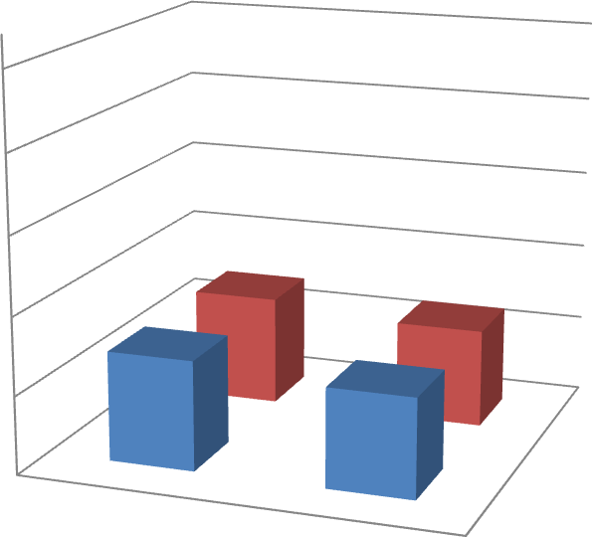
50
40
30
14.13
12.67
20
14.13
Initial test
Final test
12.78
10
Final test
0
Initial test
E-group
C-group
Chart 4. Change of achievement from test to re-test by melodic hearing parameter in Belgrade
There is no statistically significant difference from test to re-test.

Table 4. Results of descriptive statistics and t-tests of E- and C-groups on initial and final measurement (melodic hearing, Belgrade, N=17)
INITIAL MEASUREMENT |  |  |  |  |  |  |  | FINAL MEASUREMENT
Variable | Group |  | M |  | t | df | p | M | SD | t | df | p
 |  | N |  | SD
Melodic hearing | E | 8 | 14.1  3 | 5.22 | 0.000  0¹ |  | 1.000  0 | 14.1  3 | 8.25 | 0.378  0³ | 15 | 0.7107
Melodic hearing |  |  | 14.1  3 |  | 0.000  0¹ | 14 | 1.000  0 | 14.1  3 |  | 0.378  0³
 | K | 9 | 12.7  8 | 8.80 | 0.031  5² |  | 0.975  3 | 12.6  7 | 5.89 | 0.423  8⁴ | 15 | 0.6777
 |  |  | 12.7  8 |  | 0.031  5² | 16 | 0.975  3 | 12.6  7 |  | 0.423  8⁴
Results
^{1.} t-test of initial and final measurement of E-group
^{2.} t-test of initial and final measurement of C-group
^{3.} t-test of initial state of both groups
^{4.} t-test of final state of both groups

4b) The difference between the achievements on the initial and final tests, as an indicator of the change in the level of harmonic hearing of the subjects
In the mixed group in Kragujevac, members of the E-group achieved a statistically significant improvement in harmonic hearing, while members of the C-group also progressed, but not statistically significantly.

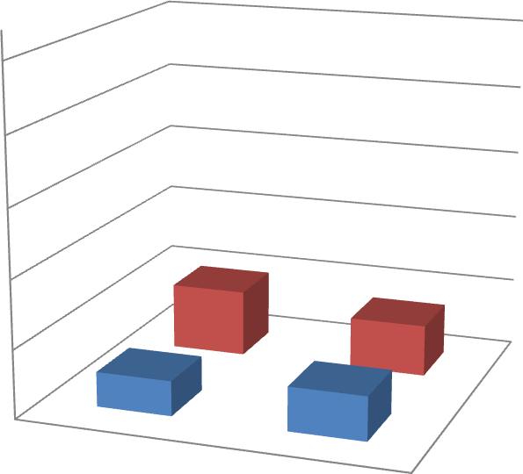
Chart 5. Changes in harmonic hearing (Kragujevac)
50
40
30
9.78
20
Initial test
Final test
7.56
10
5.11
6.44
Final test
0
Initial test
E-group
C-group

Table 5. Results of descriptive statistics and t-tests of E- and C-groups on initial and final measurement (harmonic hearing, Kragujevac, N=18)
INITIAL MEASUREMENT |  |  |  |  |  |  | FINAL MEASUREMENT
Variable | Group | M |  | t | df | p* | M | SD | t | df | p
 | N |  | SD
Harmonic hearing | E | 5.11 | 3.89 | 2.5327  1 | 16 | 0.0222 | 9.78 | 3.93 | 0.6725  3 | 16 | 0.5109
Harmonic hearing | 9 |  |  | 2.5327  1 |  |  |  |  | 0.6725  3
 | C | 6.44 | 4.48 | 0.5476  2 | 16 | 0.5915 | 7.56 | 4.13 | 1.1682  4 | 16 | 0.2598
 | 9 |  |  | 0.5476  2 |  |  |  |  | 1.1682  4
Therefore, the results of the experimental group (Kragujevac) were statistically (at the level of 0.05) better than the results of the control group (Kragujevac).
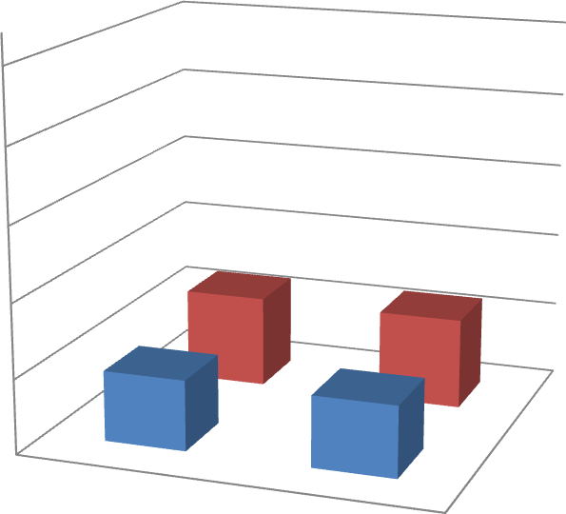
At the Faculty of Music in Belgrade, both groups achieved improvement, but none statistically significantly.
50
40
30
12.38
20
12.22
Initial test
Final test

9,5
10
9.56
Final test

0
Initial test

Е-group
C-group
Chart 6. Changes in harmonic hearing (Belgrade)

Table 6. Results of descriptive statistics and t-tests of E- and C-groups on initial and final measurement (harmonic hearing, Belgrade, N=17)
INITIAL MEASUREMENT |  |  |  |  |  |  |  | FINAL MEASUREMENT
Variable | Group |  | M |  | t | df | P | M | SD | t | df | p
 |  | N |  | SD
Harmonic hearing | E | 8 | 9.50 | 5.07 | 0.915  8¹ |  | 0.375  3 | 12.3  8 | 7.29 | 0.027  5³ | 15 | 0.9784
Harmonic hearing |  |  |  |  | 0.915  8¹ | 14 | 0.375  3 | 12.3  8 |  | 0.027  5³
 | C | 9 | 9.56 | 3.91 | 1.492  7² |  | 0.155  0 | 12.2  2 | 3.67 | 0.058  2⁴ | 15 | 0.9543
Results:
^{1.} t-test of initial and final measurement of E-group
^{2.} t-test of initial and final measurement of C-group
^{3.} t-test of initial state of both groups
^{4.} t-test of final state of both groups

CONCLUSION
The hypothesis (a specific form of multimodal approach – literal parallelism through the perception and performance of extended-tonal and atonal music of Serbian composers – contributes not only to the increase of the fund of stable musical-auditory representations, but also to the improvement of musical hearing expressed through accuracy in the perception of unknown musical content) is partly proven. Namely, only members of the E-group (Kragujevac), mostly musical performers, improved hearing, only not hearing observed integrally (with the ability to accurately perceive melodies), but harmonic hearing, compared to the parallel C-group. For members of the E-group (Belgrade), future music pedagogues, there was no significant difference in relation to the achievements of the parallel C-group. It is possible that the cause is that the E-group (Kragujevac) at the beginning of experimental classes showed weaker foreknowledge than the E-group (Belgrade), and also had more room for advancement. Experimental learning based on singing, auditory perception, and playing the same passages seems to have influenced the strengthening of auditory representations. In addition to creating multimodal representations, it is likely that singing intervals (which was one of the requirements of the colloquium and was an integral part of the preparation for singing during the experimental period) influenced better recognition of other pitches compared to the given pitch, in harmonic tasks.
In general, the E-group (Kragujevac) proved to be more receptive to processing complex sound content than the E-group (Belgrade), and progressed more during the experimental period, although the E-group (Belgrade) both on the initial and final tests showed greater success in terms of the average number of points per student.
In view of the results obtained, the limitations of empirical research should be mentioned. Namely, the limiting factor was primarily a small number of participants, which is also common at art faculties, especially in the case of research that goes beyond the survey as an interrogation technique. Another aggravating factor was the limited working time (30 minutes per week and the number of working weeks), since the time, apart from the selection of the sample (group of students), was practically appropriate, i.e., this is the maximum amount of time that the lecturers could give to the researcher for the realization of experimental teaching. In future research, the effectiveness of the methodical concept of literal parallelism in perception and performance, i.e., performance and perception, should be examined on the results primarily in elementary music education (which is the most important), and then at subsequent levels of education. Without solid mental representations of tonality, people with relative pitch can hardly progress in terms of performing and perceiving extended-tonal and atonal music. Also, it would be interesting to examine how literal parallelism in the perception and performance of extended-tonal and atonal music of Serbian composers affects the improvement of musical hearing expressed through the interpretation of tonal music. Also, the success of students with passive absolute pitch should be examined in the framework of research with the same goals and tasks.

REFERENCES
Aguila, J. (2005). Harmonic perception in post-Webernian compositions: some
strategies for listening to serialist composers. In A. Nowak (ed.), Dzieło muzyczne, jego
estetyka, struktura i recepcja (1) (pp. 211-217). Bydgoszcz: Akademia muzyczna.
Beočanin, J. (2017). Multimodalne predstave i multimodalni pristup u nastavi solfeđa [Multimodal representations and multimodal approach in solfeggio teaching]. Časopis za muzičku kulturu Muzika, 21(2), 55-68.
Friedmann, M. (1990). Ear Training for Twentieth-Century Music. New Haven: Yale University Press.
Herder, R. (1977). Tonal/Atonal: Progressive Ear Training, Singing and Dictation Studies in Diatonic, Chromatic and Atonal Music. New York: Continuo Music Press.
Huron, D. (2006). Sweet anticipation: music and the psychology of expectation.
Cambridge, MA: MIT Press.
Leman, A. K. et al. (2012). Psihologija za muzičare. Razumevanje i sticanje veština [Psychology for Musicians. Understanding and Acquiring the Skills]. Beograd: Fakultet muzičke umetnosti; Novi Sad: Psihopolis institute.
Udtaisuk, D. (2005). A Theoretical Model of Piano Sightplaying Components (PhD thesis). Retreived from https://mospace.umsystem.edu/xmlui/bitstream/handle/10355/4123/research.pdf?sequence=3.
Мasnikosa, M. (1998). Мuzički minimalizam – američka paradigma i
differentia specifica u ostvarenjima grupe beogradskih kompozitora [Musical minimalism – american paradigm and differentia specifica in the works of a group of Belgrade composers]. Београд: Clio.
Nikšić, N. (2021). The role of one’s native musical idiom in the development of music abilities and acquisition of new music material. Teme XLV, No. 2, 511-524. https://doi.org/10.22190/TEME190310030N
Стојановић-Новичић, Д. (2010). Ослушкујући редуковано: Шест
двогласних корала Владана Радовановића [Listening reduced: Six two-part choral works by Vladan Radovanović]. У Гордана Каран (уред.), Зборник XII
Педагошког форума одржаног 2009. године (134-142). Београд: Факултет музичке уметности.
Цветковић, Ј. и Ђурђановић, М. (2014). Слушање савремене музике као изазов музичког образовања данас. Teme XXXVIII, No. 1, 317-329.
Цветковић, Ј. (2015). Иманентни слух и рецепција музике [Immanent hearing and music reception]. Ниш: Факултет уметности, Универзитет у Нишу, Центар на научноистраживачки рад САНУ и Универзитета у Нишу.

Резиме

Успешно тумачење музичког стваралаштва проширено-тоналног и атоналног насталог током двадесетог и актуелног 21. века, представља један од подразумеваних задатака целокупне наставе на студијама музике и предуслова професионалне компетентности. Чињеница је, ипак, да се музици без тоналног упоришта, а посебно компонованој од стране српских композитора, не посвећује одговарајућа пажња.
Много је фактора који утичу на то да се атонална музика теже опажа, разуме, меморише и репродукује у односу на тоналну. Приликом когнитивне обраде централно је питање механизма груписања који се врши према законитостима гешталта, а атонална остварења претежно нису у складу са њима. Као логична последица таквих предиспозиција за когнитивну обраду атоналности произлази негативно реаговање – негативна осећања укључујући фрустрацију и узнемирење.
Истраживања показују да и музичари и немузичари показују мањак емоционалних реакција на атоналну музику. Осећања се неминовно одражавају на процес учења. Изазов пред којим се налази наставник јесте како побудити, али и задржати интерес већине студената за музику ових карактеристика. Адекватно средство на том путу су поновљена излагања.
Концепт дословни паралелизам у опажању и извођењу проширено-тоналне и атоналне музике српских композитора, односно мултимодални третман, заснован је на понављању и усмерен против заборављања, тј. ишчезавања звучних информација у памћењу. У њему се музичка информација двострано или вишеструко третира, пре свега кроз репродукцију, али и кроз дубљу когнитивну обраду звучних информација.
Са циљем да се испита утицај дословног паралелизма у слушном опажању и извођењу на побољшање музичког слуха код студената треће године студија на два факултета, урађено је експериментално истраживање. На основу теоријског истраживања постављена је хипотеза да дословни паралелизам кроз опажање и извођење проширено-тоналне и атоналне музике српских композитора доприноси не само обогаћењу фонда стабилних музичко-слушних представа, већ и побољшању музичког слуха исказаног кроз тачност у опажању непознатих инструктивних музичких садржаја. Хипотеза је само делимично потврђена, што се може објаснити релативно малим бројем (студената) испитаника, уобичајеним за уметничке факултете у Републици Србији.
У будућим истраживањима требало би испитати делотворност методичког концепта дословног паралелизма у опажању и извођењу, односно извођењу и опажању, на музички слух првенствено у основношколском образовању, а потом и на наредним нивоима музичке едукације.

http://www.graphpad.com
Descriptive statistics show basic data on a single variable, the number of subjects examined, the minimum and maximum achievement on the task, average achievement (arithmetic mean), and standard deviation (i.e., scattering from the average value).

