DEMOGRAPHIC RESOURCES OF DISTRICTS IN THE REPUBLIC OF SERBIA: CLUSTER ANALYSIS APPROACH

Milan Stamenković^{1*}, Petar Veselinović², Marina Milanović¹

¹University of Kragujevac, Faculty of Economics, Department for Statistics and Informatics, Kragujevac, Serbia
²University of Kragujevac, Faculty of Economics, Department for General Economics and Economic Development, Kragujevac, Serbia

*address: Djure Pucara Starog 3, 34000 Kragujevac, Serbia;
E-mail: m.stamenkovic@kg.ac.rs;
Telephone number: 064/259-0-254.

Milan Stamenković is a teaching and research assistant at the Department of Statistics and Informatics, Faculty of Economics, University of Kragujevac, Serbia. He is engaged in teaching the subject Fundamentals of Statistics. He is currently working on Ph.D. thesis at the same Faculty. He is the author and co-author of numerous scientific and research papers in various kinds of publication. Fields of his research interest are statistical data analysis, application of multivariate statistical methods in economy and demographic analysis.

Ph.D. Petar Veselinović, Full-time Professor at Faculty of Economics, University of Kragujevac, Serbia. He holds Ph.D. degree in the field of General Economics and Economic Development, teaching following courses: Regional economics (PhD level of studies), Globalization and transition (Master level), National economics and Demographics and economic development (bachelor studies). Regarding his scientific career, he is the author and co-author of large number of scientific papers published in journals and conference proceedings (domestic and foreign). The main areas of his research interest are national economy, transition, regional development, globalization, economic policy and economic development. In addition, professor Veselinović is a member of the Presidency of the Serbian Association of Economists, President of the Association of Economists of city of Kragujevac and, from 2016, Dean of the Faculty of Economics University of Kragujevac.

Marina Milanović graduated and defended her Master thesis at the Faculty of Economics, University of Kragujevac, Serbia. At the same Faculty, she was engaged as a teaching and research assistant, within the Department of Statistics and Informatics. She is currently working on Ph.D. thesis at the Faculty of Economics, University of Niš, Serbia. She is author and coauthor of numerous scientific and research papers in various kinds of publication. Fields of her research interest are statistical data analysis in economy, data mining and statistical process control.

DEMOGRAPHIC RESOURCES OF DISTRICTS IN THE REPUBLIC OF SERBIA: CLUSTER ANALYSIS APPROACH

Abstract

Bearing in mind how important demographic resources are for the socio-economic development of specific administrative-territorial units, the objective of this paper is to classify the districts in the Republic of Serbia according to available demographic resources and to create the adequate typology of demographic areas, based on a comparison of values of relevant indicators of demographic and educational resources. These values were calculated using 14 demographic and educational variables, based mainly on data from the last census in 2011. For this purpose, hierarchical and non-hierarchical procedures of cluster analysis, as a method of multivariate statistical analysis, were used. The resulting typology and categorization clearly confirm the presence of unfavorable demographic tendencies and pronounced territorial disparities of demographic resources at the district level in the Republic of Serbia. More specifically, approximately 80% of the 25 analyzed districts belong to the type of demographically endangered areas, which are characterized by weak and very weak demographic resources. The obtained "snapshot" of the current demographic situation together with created typology of districts can serve as a useful source for understanding and monitoring of complex demographic phenomena and processes as well as for the definition of measures of population and regional development policies aimed at mitigating the effects of alarming demographic situation.
Key words: multivariate statistical analysis, cluster analysis, demographic resources, districts, typology of demographic areas.

1. INTRODUCTION

It is undisputable that population, as a large group of people who live and work in a particular territory, is an important factor of production, economic and regional development of that territory. Therefore, the formulation of economic, social, educational and other dimensions of macroeconomic policy, and generally, planning and directing the overall socio-economic development, requires the assessment of demographic situation and dynamics of demographic changes within the territorial units at different administrative levels in particular country. In other words, the changes in all spheres of economic and social life have significant repercussions on demographic development, as an integral part of the overall socio-economic development. At the same time, changes in population size (caused by changes in the birth rates, mortality and migrations), distribution of population, demographic structure (in terms of various characteristics, such as gender, age, education level, etc.) have a crucial impact on the current social, economic and regional development. This strong interdependence is the reason why it is necessary to include relevant indicators that properly reflect both processes (socio-economic and demographic) when determining level of socio-economic development and evaluating development potentials of certain territories (at different administrative levels). In this context, analysis of demographic resources and understanding of demographic changes represent an indispensable component of such comprehensive research work.
Generally, demographic resources are defined as the total qualitative and quantitative, used and potential, social and biological characteristics of the population in a certain area at a particular time (Oliveira-Roca, 1991). Since regional disparities are one of the main manifestations of unequal economic development, demographic resources, as a key development resource and potential of a particular area, represent a significant source for mitigation of inequalities in socio-economic development and an important factor, in the long term, in achieving balanced regional development. Therefore, discovering regularities in demographic development is increasingly attracting the attention of general public and academic community, evidenced by numerous scientific papers.
This study was additionally motivated by the following: (1) there is a lack of an updated analysis of available demographic resources, based on data from the last census in 2011, covering the entire territory of the Republic of Serbia, (2) it is necessary to acknowledge recently defined methodological innovations regarding the calculation of relevant composite demographic resources indicators, and (3) there is a possibility to extend the existing methodological framework by multivariate statistical analysis methods.
Thus, the subject of the research are demographic resources and potentials of districts (administrative territorial units of level NUTS3) in the Republic of Serbia, viewed in the context of two composite indicators – demographic index and education index. The objective of the study is, to use cluster analysis, as a method of multivariate statistical analysis, to identify districts in Serbia that are most similar in terms of available demographic resources, i.e. the demographic (in the narrow sense) and educational potentials, and consequently, to create the precise classification of the observed demographic areas. In other words, the existing methodological approach in analyzing demographic strength of territorial units and their potential to contribute to demographic, and thus the overall socio-economic development of a given territory in the future, is supplemented by cluster analysis in order to create a statistically based and evaluated typology of districts in Serbia. The purpose of this research is to provide a clear and informative overview of the current demographic resources and potentials, or demographic "blood count" of districts in Serbia, which can serve as a suitable basis for formulating appropriate measures and activities within the strategy of demographic development of the observed territories in order to alleviate the existing regional disparities. Accordingly, following three research hypotheses were formulated:
(H₁): In general, the territory of Serbia is characterized by weak demographic resources and expressed demographic disparities;
(H₂): In terms of available demographic resources, the situation in most districts within the Region of Southern and Eastern Serbia is worse than in districts of other regions;
(H₃): Districts whose territory contains major administrative, economic, cultural, and university centers are best ranked according to the selected demographic and educational indicators.
When exploring these hypotheses, a cluster analysis was used in order to demonstrate the potential of multivariate statistical analysis in demographic research.

2. RESEARCH BACKGROUND

Comprehensive analysis of available demographic resources and potentials of territorial units at different administrative level within the particular country is based on various combinations of demographic (in a strict sense) and educational indicators. It consequently provides the appropriate classification of the observed territories into relatively homogeneous groups, in order to identify the degree of present regional disparities and formulate guidelines for their mitigation / elimination. It also represents an attractive research niche, as evidenced by a significant number of published scientific papers and empirical studies. Accordingly, Table 1 presents the key methodological guidelines and temporal / spatial scope of empirical studies similar to the research presented in this paper, which use the index of demographic resources to interpret the resulting typology.
The analyzed papers used demographic resources index (i_{der}) as methodological framework. This index was developed as a result of the efforts to create a single composite demographic indicator, which will facilitate comprehension of complex demographic phenomena and processes, and therefore ensure adequate inclusion of demographic component in valorization of development resources and potentials of a particular territory. This composite indicator, proposed, in its initial form, by Nejašmić (2005; 2007; 2008), and amended and improved by Nejašmić & Mišetić (2010), will be presented in Section 3.
Table 1: Comparative review of the relevant empirical studies
Author(s) /  (year of publication) | Time coverage  (Censuses) | Administrative level of  territorial units | State | Methodology
Nejašmić (2007; 2008) | 1991. – 2001 | Districts and border areas | Croatia | Nejašmić  (2005; 2007; 2008)
Spevec (2009) | 1991. – 2001 | Municipalities and towns of Krapina-Zagorje district | Croatia | Nejašmić  (2005; 2007; 2008)
RZR (2009) | 1991. – 2001 | Municipalities and districts | Serbia | Nejašmić  (2005; 2007; 2008)
Vojnović (2012) | 1991. – 2001 | Municipalities and towns of Istria district | Croatia | Nejašmić  (2005; 2007; 2008)
Spevec & Vuk (2012) | 2001. – 2011 | Municipalities and towns of Krapina-Zagorje district | Croatia | Nejašmić & Mišetić  (2010)
MICRO Project (2013) | 2003. – 2011 | Settlements of coastal area  (Municipality of Ulcinj) | Montenegro | Nejašmić & Mišetić  (2010)
PSMSLS (2014) | 2001. – 2011 | Municipalities of Autonomous  Province of Vojvodina | Serbia | Nejašmić  (2005; 2007; 2008)
Lovrić, Milanović &  Stamenković (2014) | 2001. – 2011 | Municipalities of Šumadija  and Pomoravlje districts | Serbia | Nejašmić & Mišetić  (2010)
Jakopin (2015) | 2001. – 2011 | Municipalities | Serbia | Nejašmić  (2005; 2007; 2008)
Note: RZR – Development Bureau of the Republic of Serbia,
PSMSLS – Province of Vojvodina Secretariat for Interregional Cooperation and Local Government;
Source: Authors
While most of the papers above thoroughly analyze the state of demographic resources in Croatia (Nejašmić, 2007, 2008; Spevec, 2009; Vojnović, 2012; Spevec & Vuk, 2012), the study at hand, focuses on demographic resources of districts in Serbia. Furthermore, it applies innovated methodological approach (Nejašmić & Mišetić, 2010) as opposed to the methodology (Nejašmić, 2005; 2007; 2008) that is used by most of authors who have studied this issue on the territory of Serbia (RZR, 2009; PSMSLS, 2014; Jakopin, 2015). However, being the first of its kind, it explores the phenomenon at the level of districts, rather than at municipality level within the individual districts (Lovrić, et al., 2014).
These previous studies used single i_{der} value to classify the analyzed territorial units into one of five (Nejašmić, 2005; 2007; 2008), or six types of demographic areas (Nejašmić & Mišetić, 2010). The authors of this paper, however, used the values of two constituent components of i_{der} (i.e. demographic index and index of education), as input variables in cluster analysis and obtained a new typology consisting of seven types of demographic areas.

3. RESEARCH METHODOLOGY FRAMEWORK

Precise and comprehensive consideration of demographic potential of territorial units at any administrative level (e.g. settlements, municipalities, districts, regions, states, etc.), necessarily implies a thorough analysis of a significant number of demographic variables, as partial indicators of various aspects of demographic structure of population within analytical spatial units. For the realization of formulated objective, a methodological framework of demographic resources analysis proposed by Nejašmić & Mišetić (2010) was used, supplemented by cluster analysis, in order to create a statistically based typology of districts in Serbia according to the degree of available demographic resources.

  - Methodological framework for analysis of demographic resources

In contrast to the apparent simplicity of final expression for calculation of demographic resources index (i_{der}), hidden complexity of this composite indicator is reflected in the use of fourteen demographic and educational variables necessary for calculation of its two basic constituent components: demographic (i_{dem}) and education index (i_{o}).
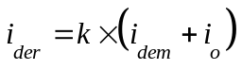 (1)
Complete procedure for calculation of two synthetic sub-indicators of i_{der} is schematically illustrated in Figure 1, which provides a clear insight into the used demographic and educational variables, along with the accompanying symbols and formulas.
In addition, for providing an objective insight into the demographic situation of a certain area, in calculating i_{der}, it is necessary to take into account the overall impact of demographic mass (total population of the individual territorial units), as an important element of demographic potential, by including the corrective coefficient (k), within the expression (1), (for details, see Nejašmić & Mišetić, 2010).
Determination of coefficient k is based on the process of z-standardization of numerical variable Pn, (Figure 1) into standardized, normally distributed variable Z_{Pn}, symbolically [P_{n} → Z_{Pn}: N (0; 1)], by the following expression:
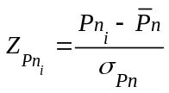, (2)
where symbols represent:
P_{ni} – population of the i^{th} territorial unit (for i=1, 2, ..., q);
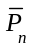 – average number of inhabitants per each of q territorial units;
σ_{Pn} – average deviation of population of q territorial units from .

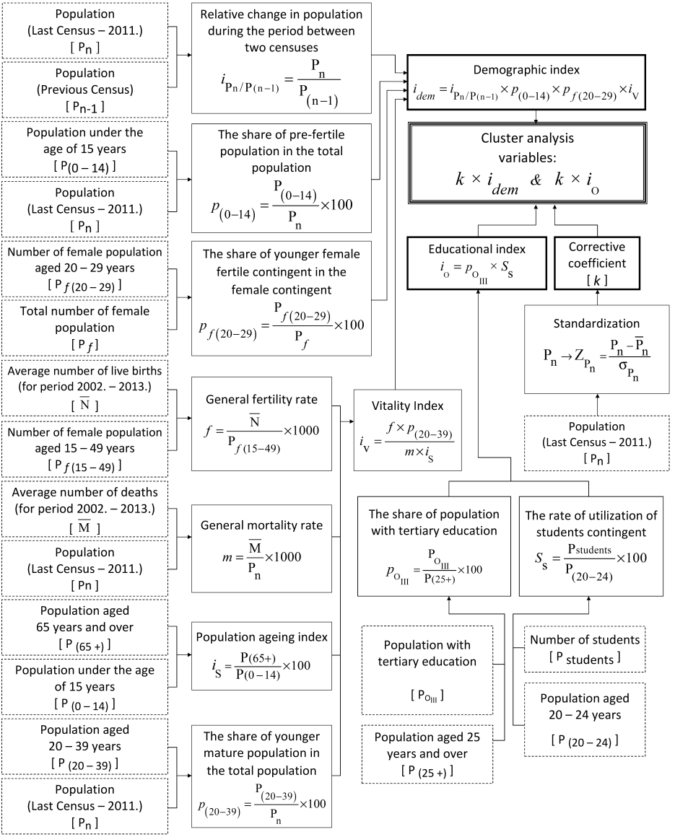
Figure 1: Schematic representation of the calculation process of demographic index and education index
Source: Authors’ representation
Depending on the position of the determined individual Z_{Pn} values on the ten-interval scale, a specific value of k coefficient is assigned for each of territorial units (Figure 2).
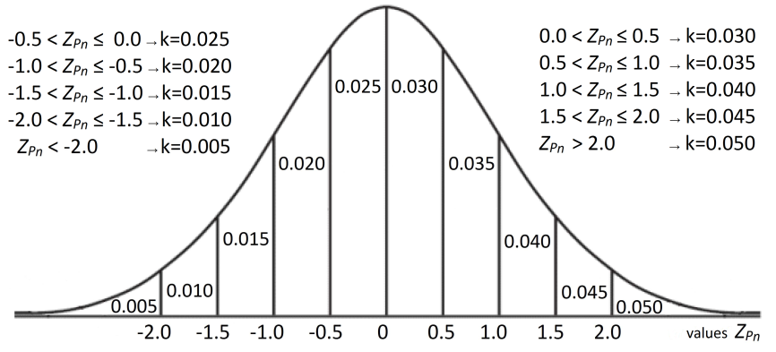
Figure 2: Scale for determination of the coefficient k values
Source: Authors’ representation, adapted according to Nejašmić & Mišetić (2010, р. 56)
As mentioned above, the approach of Nejašmić & Misetić, (2010) is based on the calculation of the summative i_{der} values and classification of territorial units in one of six types of demographic areas based on the ranking of those values. In our study, the determined final values of demographic index (k*i_{dem}) and education index (k*i_{o}), are used as input variables in the cluster analysis. The results will lead to a new typology of districts in Serbia.

  - Cluster analysis – methodological determinations

Cluster analysis is a multivariate statistical method designed for the classification of individual observation units (i.e. objects) in a certain number of groups (i.e. clusters), based on identified similarities and/or dissimilarities in terms of the values of selected variables (Đorđević, Lepojević, & Janković-Milić, 2011). By applying cluster analysis, q observation units, C={c₁, c₂, ..., c_{q}}, are classified into m mutually exclusive groups, C_{g}, (for g=1,2,...,m), where m<q and C_{g} C, but in such a way that objects within the same group are mutually similar, and very different from those belonging to the other groups. The starting point in grouping is a selection of appropriate distance measure, necessary for the formation of distance matrix, whose elements indicate a degree of similarity/distance between all pairs of objects (for details see: Aeker, Kumar, & Day, 2007; Hair, Black, Babin, & Anderson, 2010).
Within this multivariate method, there are two approaches to grouping objects:
- Hierarchical, which includes agglomerative methods (based on iterative merging of units and/or groups of units) and divisive methods (based on the partition of larger group(s) into smaller); and
- Non-hierarchical, based on a previously defined number of clusters, where the relocation of objects from one to another group is allowed during the grouping process if it is in compliance with the criteria for achieving the optimal solution;
The applied cluster analysis consists of the following steps:
- Detection of presence of non-standard observations (i.e. outliers), based on values of squared Mahalanobis distance measure and corresponding percentile of χ² distribution (Filzmoser, 2004; Varmuza & Filzmoser, 2009), and adequate graphical representations;
- Hierarchical agglomerative clustering procedure based on the application of Ward’s method and squared Euclidean distance measure, d_{ij}² (Kovačić, 1994):
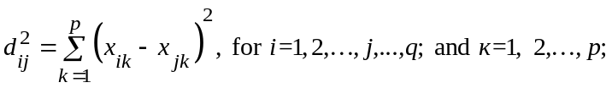 (3)
where p represents number of variables, x_{iк} – value of i^{th} observation unit (x_{i}), and x_{јк} – value of j^{th} observation unit (x_{j}), for variable X_{к}.
- Selection of optimal number of groups using following optimality criteria and statistical indicators:
- Fluctuation of distance measure values, at which merging of groups is carried out, and their absolute changes at each step of the clustering process;
- Pseudo F-statistic, as a measure of the degree of heterogeneity for each solution;
- R_{g}² and semi-partial ΔR_{g}² coefficients, as measures of the loss of homogeneity within formed groups, resulting from the performed joining;
- Cophenetic correlation coefficient, G(+), and γ coefficient of concordance;
- Statistical evaluation of the quality of the resulting hierarchical solution, in terms of the structure of separated groups, is performed, based on the implementation of non-hierarchical procedure using k-means method;
Data analysis and all the necessary statistical calculations were carried out using the statistical software package for social sciences, IBM SPSS Statistics, version 20.0. The final interpretation of the analysis results is complemented by adequate cartographic representation.

3.3. Sources of data and temporal and spatial scope of research

Using the current territorial organization, defined by the nomenclature of statistical territorial units (NUTS) in Serbia, data for fourteen demographic variables, used for the calculation of demographic and education index values (Figure 1), were collected and analyzed, for each of 24 administrative districts and Belgrade area (i.e. territorial units of level NUTS-3). Data were obtained from electronic databases of census publications, complex publications (i.e. Municipalities and regions & Statistical Yearbook) and vital statistics of the Statistical Office of the Republic of Serbia (SORS). Although the calculation of i_{dem} and i_{o} values is not limited to the use of two successive census data, respecting the general opinion that demographic indicators, based on census and vital statistics data, provide the best insight into the actual demographic trends and tendencies (Cziraky, Sambt, Rovan, & Puljiz, 2005; Nikitović, 2013), data from the last national census in 2011 and those from 2001 were used, except in the case of variables where otherwise is indicated in their name. In addition, since 1999 SORS provides no information for the districts within the Autonomous Province of Kosovo and Metohija, so they are not included in the conducted research.

4. EMPIRICAL RESULTS

In order to provide input variables for cluster analysis of districts in Serbia according to the presented methodological framework (Figure 1), calculation of the demographic (i_{dem}) and education index (i_{o}) values for each district is carried out (Appendix A). Multiplying the value of k coefficient with i_{dem} and i_{o}, the final values of these two components of demographic resources (k*i_{dem} and k*i_{o}) are determined. Since both of these indicators represent composite combinations of a large number of variables, and are not expressed in concrete measurement units, the standardization of their values is not performed. Descriptive statistical measures for the selected variables are presented in Table 2.
Table 2: Descriptive statistical measures
Variables | Mean | Median | Std.  deviation | Min | Маx | Inter-quartile  range (IQR) | 3rd quartile +3*IQR
k*i_{dem} | 3.14 | 2.21 | 3.22 | 0.40 | 15.22 | 1.73 | 8.22
k*i_{o} | 26.51 | 19.29 | 26.97 | 12.04 | 144.25 | 8.98 | 50.84
Source: Authors’ calculations, IBM SPSS Statistics 20.0
In order to check the compliance with prerequisites for a valid application of cluster analysis, an investigation of presence of one-dimensional and/or multivariate outliers, was performed, using graphic representations in the form of individual box-plot diagrams and multivariate Q-Q diagram (Figure 3), respectively.
Figure 3: Box-plot diagrams for variables k*i_{dem} (left) and k*i_{o} (center), and
multivariate Q-Q diagram (right)
Source: Authors’ representations, IBM SPSS Statistics 20.0
Negative deviation of median from mean value, for both variables, suggests the presence of one-dimensional outlier, which is confirmed by box-plot diagrams. Specifically, in the case of variable k*i_{dem}, three outliers (Raška, South Bačka and Belgrade area), i.e. two (Belgrade area and South Bačka) for variable k*i_{o}, were identified, since their values exceed the threshold level of three inter-quartile range value above the third quartile (Table 2). However, bearing in mind that one-dimensional outliers do not necessarily represent multivariate outliers, based on the calculated values of Mahalanobis distance for each district and corresponding percentile values of chi-square distribution (for details see: Kovačić, 1994; Ramzan, Zahid, & Ramzan, 2013), a multivariate Q-Q diagram is designed, clearly indicating a significant distance of points marking Raška, South Bačka and Belgrade area from the distribution of points marking other districts (which form an imaginary straight line). Comparing the Mahalanobis distance values of mentioned three districts (South Bačka [3.52], Raška [18.76] and Belgrade [19.51]) and value of the 97.5% chi-square distribution percentile (χ²_{2; 0.975} = 7.38), as a critical value, the presence of two multivariate outliers (Raška and Belgrade area) is confirmed. However, since these two observations represent a small but important part of the total number of analyzed districts, which may contain very useful information for comparison and objective mapping of available demographic resources in Serbia, their exclusion from further analysis will not be performed. However, in order to assess their impact on the obtained results, a cluster analysis without them will be conducted.
Results of hierarchical agglomerative clustering of 25 districts, according to k*i_{dem} and k*i_{o} values, based on the application of Ward’s method and squared Euclidean distance measure, are presented in the form of a dendrogram in Figure 4, and agglomeration schedule of districts and/or group of districts, with accompanying values of criteria for the selection of optimal number of groups, is given within Appendix B.
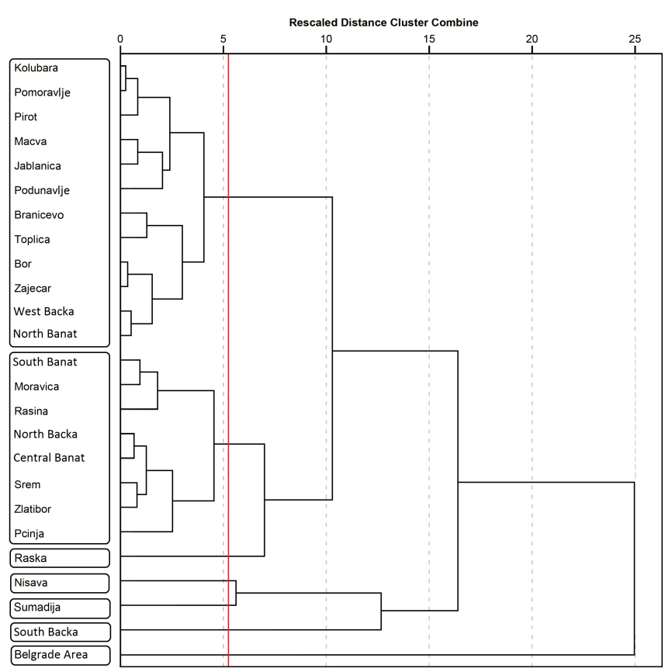
Figure 4: Dendrogram
Source: Authors’ representation, IBM SPSS Statistics 20.0
In order to identify the optimal number of groups and their structure, according to the values of selected variables, values of previously mentioned optimality criteria were analyzed.
In fact, analyzing the distance measure values between groups and their absolute changes in successive steps of the iterative process of hierarchical clustering (Appendix B, column V and VI), it is evident that their slight and gradual increase in the early stages is followed by a significant increase, particularly pronounced from the 17th step (i.e. the moment of forming 8 groups), due to the enlargement of hierarchical structure and joining of groups, that are, to a greater extent, different from each other. More specifically, on the basis of these values and their graphical representations for different number of groups (Figure 5), for the solution with 6 groups (step 19), compared to the previous steps, a drastic increase of distance measure value (from 62.26 [step 18] to 134.67 [step 19]), and its absolute change (from 23.45 [step 18] to 72.41 [step 19]), can be detected.

Figure 5: Graphical representations of distance measure values (left) and its absolute change (right) for solutions with different number of groups
Source: Authors’ representations

Comparing the values of pseudo F-statistic, R_{g}² and ΔR_{g}² coefficients, calculated for solutions ranging from eight to three clusters (Appendix B, column VII, VIII and IX), step 19, where Šumadija and Nišava district are joined in one cluster, forming a solution with six groups, clearly stands out as a step in which a sudden drop of pseudo F-statistic has occurred (Figure 6), signaling the association of significantly different districts. Previous finding is confirmed by the pronounced decline in the R_{g}² value recorded for solution with six groups (from 0.925 [7 groups] to 0.769 [6 groups]), as well the increase in the absolute value of ΔR_{g}² (from -0.038 [7 groups] to -0.156 [6 groups]).

Figure 6: Graphical representation of decrease of pseudo F-statistic for different solutions
Source: Authors’ representations
The results indicate that seven groups of districts is the optimal solution, obtained in the step previous to that in which the described drastic changes in the values of analyzed optimality criteria occurred. Extremely high value of the cophenetic correlation coefficient, r_{cp} = 0.968 (very close to 1), confirms the quality of the identified clustering solution. In addition, the validity and quality of the obtained solution is also confirmed by the values of relevant coefficients, such as γ coefficient of concordance and G(+) coefficient, calculated for solutions that include different number of groups (Table 3). The highest value of γ coefficient and the lowest value of G(+) coefficient, obtained for a solution with 7 groups, indicate a high degree of agreement between the classification of districts to particular groups and the size of the original distances between them, compared to the other possible solutions.
Table 3: Values of coefficients for statistical verification of validity and quality of the solution
Coefficients | Number of groups for different solutions
Coefficients | 7 | 6 | 5 | 4 | 3
γ coefficient of concordance | 0.9717 | 0.9612 | 0.8800 | 0.9522 | 0.9438
G(+) coefficient | 0.0061 | 0.0084 | 0.0271 | 0.0100 | 0.0116
Source: Authors’ calculations
Distribution of districts per each of seven groups, identified in the context of available demographic and educational potentials, is presented in the dendrogram and scatter diagram (Figure 4 and Figure 7). Previously identified presence of two two-dimensional outliers (Belgrade area and Raška), was confirmed by the results of hierarchical clustering, since these districts were singled out as separate (single-member) groups. It is important to emphasize that re-implementation of cluster analysis without these districts did not reveal any changes in agglomeration schedule, neither the changes regarding the optimal number of groups. Also, in order to verify the validity of structure of identified groups of districts, the results of hierarchical procedure were used in non-hierarchical cluster analysis, whereby the identical solution was obtained.
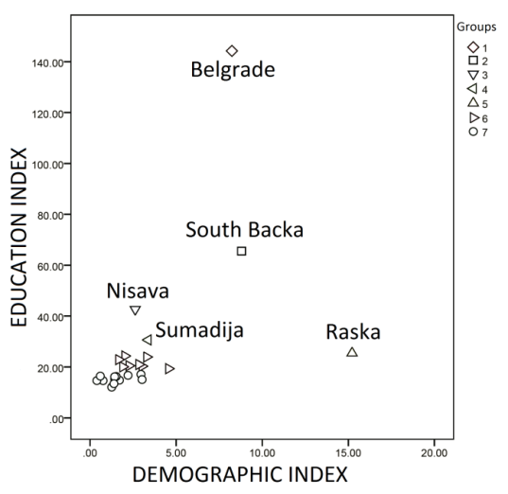
Figure 7: Scatter diagram of districts according to demographic and education index values
Source: Authors’ representation, IBM SPSS Statistics 20.0

5. INTERPRETATION OF THE TYPOLOGY OF DISTRICTS

Based on the clustering results, comparison of demographic and education index values and their constituent components for each of the formed groups, a statistically based typology of districts in Serbia, according to the level of available demographic resources is formed (Table 4). The cartographic representation of the results of district classification by defined types of demographic areas is shown in Figure 8.
Table 4: Typology of districts in Serbia, according to the available demographic resources
Group | Type of demographic area | Characteristics
1 | Exceptionally good  demographic resources | very good demographic characteristics,  and extremely high level of education;
2 | Very good  demographic resources | very good demographic characteristics,  and very high level of education;
3 | Good  demographic resources | good demographic characteristics,  and high level of education;
4 | Moderately good  demographic resources | good demographic characteristics,  and moderate level of education;
5 | Moderate  demographic resources | exceptionally good demographic characteristics,  and moderate level of education;
6 | Weak  demographic resources | poor demographic characteristics,  depopulation, mainly low level of education;
7 | Very weak  demographic resources | extremely poor demographic characteristics,  prominent depopulation, very low level of education;
Source: Authors
The discussion of the typology will start from the lowest ranking group and proceed to those with more favorable demographic resources.
Group 7 comprises 12 districts. About three-quarters of districts of the Region of Southern and Eastern Serbia belong to this cluster, representing 60% of its structure. The average i_{dem} value of districts within this group is 1.56, (below 50% of the national average), while the average i_{o} value (15.18) is below 60% of the national average. As a result of negative natural and mechanical movement of population, these districts are characterized by a prominent depopulation, as evidenced by the relative values of the inter-census population changes, ranging from 0.853 (Bor) to 0.948 (Podunavlje). For the same period, decrease in number of inhabitants more than 10% is recorded in as many as 7 districts in this group (Appendix A, column II). The share of young population is below average, values of ageing index exceptionally high (ranging from 111.9% to 210.3%), and vitality index values substantially lower than 1.00, which indicates unfavorable ageing structure, weakened demographic base and regressive reproduction of population in these districts (Appendix A). On the other hand, relatively low (compared to other groups) participation of population with completed tertiary education (9.77% [Braničevo] – 14.43% [Pirot]) and lower utilization rates of student contingent (47.32% [North Banat] – 60.23% [Bor]), caused a lower education index values. Since 12 out of 25 districts (approximately 50%) belong to this type of areas, the same can be considered as a modal demographic area in a statistical sense.
Group 6 includes 8 districts. In contrast to group 7, this cluster is dominated by districts from the Region of Vojvodina. Average values of i_{dem} and i_{o} within this group are 2.70 and 21.50 respectively, which is in the range of 80% to 100% of the national average for both indicators. Based on the values of coefficient of dynamics for territories within this group (ranging from 0.90 to 0.95), it can be seen that these districts, similarly to those in group 7, but to a much lesser extent, are characterized by the decrease of population during the inter-census period (2002–2011) by 5.4% to 10%. The exception is the Pčinja district (located in the far south of Serbia, inhabited mainly by ethnic Albanian population), which, although characterized by a positive rate of natural population change (1.48%), recorded by far the largest population decrease, by 30.13% in 2011, compared to the previous census, as a result of extremely high rates of negative migration balance (-31.61%). In addition, participation of young population mainly above the average level in Serbia (14.08%), ageing index values of 99.48% to 142.49% and vitality index values closely around the national average, indicate generally unfavorable, but in comparison with previous group, more favorable demographic image (Figure 7). On the basis of these observations, comparison with previous group and the fact that values of variables for these districts range relatively close to the median value of all districts, this group can be considered as a median demographic area in a statistical sense.
The remaining five single-district groups are Raška (group 5), Šumadija (group 4), Nišava (group 3), South Bačka (group 2) and Belgrade area (group 1). This clustering outcome is partly expected, given the fact that the Belgrade area and Raška district were identified as two-dimensional, and South Bačka and Nišava as one-dimensional outliers. Prior to the individual interpretations of these areas, it is necessary to point out that these five districts are the most developed, not only in the corresponding regions but in the entire state, because they include the cities of Belgrade, Niš, Novi Sad, Kragujevac and Novi Pazar, respectively, which are leading economic, cultural and largest administrative and university centers in Serbia. Because of this, they are attractive for immigration, which significantly affects the improvement of their demographic resources and potentials. Their average values of i_{dem} and i_{o}, together, are 7.65 and 61.71, respectively, which is much above the national average.
Raška district, located in the southwest of Serbia, inhabited by the majority Bosniak population, is the only district with a positive migration balance rate (2.3%) and natural population growth rate (3.89%), and an increase in the total population of 6.2%, during the inter-census period. Highly acceptable values of mortality rate, birth rate, ageing index and all other components of demographic index show extremely stable and favorable demographic characteristics (Figure 7), confirmed by the highest i_{dem} value in Serbia (15.22, approximately five times higher than the national average). However, compared to the other four districts, the lower participation of population with tertiary education and lower value of student contingent utilization rate have prevented a better positioning of this district.
Groups 3 and 4, representing Nišava and Šumadija district, in terms of i_{dem} values, are relatively close (2.63 and 3.37, respectively), as the values of almost all constituent components are identical, except for slight differences in ageing index values. The reason why they are not grouped together is the education index, whose value for Nišava district is some 30% higher. In addition, compared with Raška, both districts are characterized by worse demographic characteristics, but relatively higher educational potential.
Group 1 (Belgrade area) and group 2 (South Bačka district), have significantly better values of all components of demographic and education index, compared with the Nišava and Šumadija district. This is reflected in several times higher values of these two variables. These two districts are the only territories that, apart from Raška, recorded a population increase during the inter-census period by 5.3% and 3.7%, respectively. Despite a slightly more favorable position of South Bačka district in terms of demographic index values, the share of population with tertiary education and utilization rates of student contingent make Belgrade area absolutely dominant, with almost double value of education index.
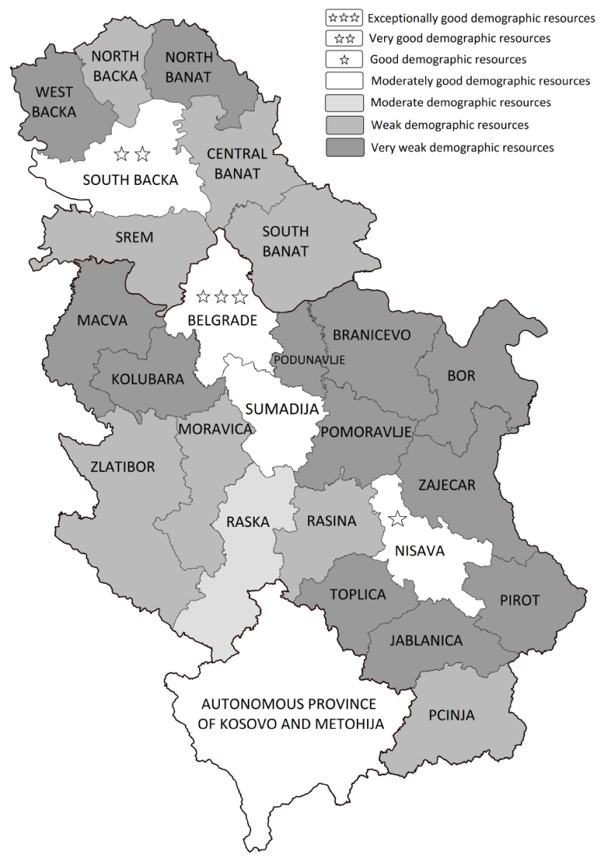
Figure 8: Cartographic representation of districts in Serbia by demographic area types
Source: Authors’ representation

6. CONCLUSION

In this paper, a classification of territorial units at district level in Serbia was carried out and analyzed, based on the selected composite indicators of demographic resources and potentials (i.e. demographic and education index), and application of cluster analysis. Selection of appropriate demographic variables and calculation methodology of demographic and education index was made on the model of research conducted by Nejašmić & Mišetić (2010). For the purpose of testing formulated research hypotheses and realization of the primary and additional research objectives, hierarchical agglomerative clustering analysis of districts in Serbia, was carried out, based on the application of Ward method and squared Euclidean distance as a distance measure. With the application of non-hierarchical procedure, the results of hierarchical clustering, regarding the number and structure of the extracted groups, are complemented and confirmed. Based on the results of implemented multivariate statistical clustering analysis, typology of demographic areas at district level in Serbia was formed, according to the degree of available demographic resources, consisting of seven different groups (i.e. types) of demographic areas.
Obtained analysis results indicate the presence of intensive depopulation, demographic aging, and significant regional demographic disparities in Serbia. More precisely, 12 out of 25 territories NUTS3 level (approximately 50%) are characterized by very weak demographic resources, while 8 districts were classified into areas of weak demographic and educational potentials (Figure 8). In other words, twenty districts (i.e. 80% of total), are characterized by below average demographic resources, confirming the first research hypothesis (H₁).
During the first decade of the 21st century, as a result of retrograde demographic processes, the population in Serbia decreased by 4.15%. The scale and seriousness of the reported effects of depopulation are additionally emphasized by the fact that presented demographic loss is approximately equivalent to the total population of Srem district (311,139 inhabitants), i.e., 26,000 people per year, in average. For a country of relatively small population power such as Serbia, a large-scale population loss as such is a luxury (Nikitović, 2015). Unfavorable migration trends and population growth rates are identified as the main causes of the presented (negative) population balance. Decades-long period of "drought" in the "field of birthrate" caused that Serbia, in terms of number of inhabitants, in 2011, is on the same level as in 1970 (Jakopin, 2013). The positive value of the relative changes in population (greater than 1.00), during the inter-census period, is recorded only in the Belgrade area, South Bačka and Raška district. Depopulation is observed in all other districts, but its intensity is most evident in the districts within the Region of Southern and Eastern Serbia. More precisely, since 7 of 9 districts (about 75%) of this region belong to the worst positioned group of demographic areas, it is not surprising that the second research hypothesis (H₂) is confirmed.
On the other hand, the structure of the first four types of demographic areas, suggests that those districts are actually the most developed (both demographically and economically), not only at regional, but also at national level. They comprise leading economic, cultural and largest administrative and university centers in Serbia. For these reasons, they attract immigration, which significantly improves their demographic resources. From the aspect of the population education level, intense concentration of active business entities and activities (requiring educated workforce) together with large number of institutions of higher education, within these districts, makes the high value of the education index logical. The fact that these districts represent bright spots (i.e. "green oasis") in demographic grayness (i.e. "desert") on the territory of Serbia (Figure 8) confirms the third hypothesis (H₃)
Generally, unfavorable demographic development, with uneven demographic potentials and pronounced concentration (i.e. centralization) of demographic resources and potentials is the essential characteristic of districts in Serbia. The obtained "snapshot" of the current demographic situation together with created typology of districts can serve as a useful source for understanding and monitoring of complex demographic phenomena and processes as well as for the definition of measures of population and regional development policies aimed at mitigating the effects of alarming demographic situation. In addition, the results of this study represent good basis for comparison with the outcomes of subsequent research, based on data of upcoming national census.
From a methodological point of view, incorporation of cluster analysis in the existing methodological framework for analysis and monitoring of demographic resources enables more precise detection of differences between the observed territorial units, since this approach is based on the simultaneous, separate monitoring of two key components rather than summing their values within a common indicator.

Acknowledgment: The authors would like to thank Professor Ivo Nejašmić for his expertise and valuable suggestions, as well as Ms. Snežana Lakčević, Head of the Department of Census of the Statistical Office of the Republic of Serbia, for the provision of necessary data, without which this study would not have been possible.

REFERENCES

Aeker, D., Kumar, V. & Day, G. (2007). Marketing research, (9th edition). USA: John Wiley & Sons.
Cziraky, D., Sambt, J., Rovan, J. & Puljiz, J. (2005). Regional development assessment: A structural equation approach. European Journal of Operational Research, 174(1), 427-442.
Đorđević, V., Lepojević, V. & Janković-Milić, V. (2011). Primena statističkih metoda u istraživanju tržišta [Application of statistical methods in market research]. Niš: Ekonomski fakultet Univerziteta u Nišu.
Filzmoser, P. (2004). A multivariate outlier detection method. In: Aivazian, S., Filzmoser, P. & Kharin, Yu. (Eds): Proceedings of the Seventh International Conference on Computer Data Analysis and Modeling, (vol. 1, 18-22). Minsk: Belarusian State University.
Hair, J.F.Jr., Black, W., Babin, B. & Anderson, R. (2010). Multivariate data analysis, (7th edition). Pearson Prentice Hall.
Jakopin, E. (2013). Izazovi regionalne politike u Srbiji [The challenges of regional policy in Serbia]. In: Marinković, S. (Ed): Posledice krize na regionalni razvoj i evropske integracije [The consequences of the crisis on regional development and European integration]. Niš: Ekonomski fakultet u Nišu.
Jakopin, E. (2015). Regional drivers of economic growth. Ekonomika preduzeća [SAE Journal of Business, Economics and Management], LXIII(1-2), 99-114.
Kovačić, Z. (1994). Multivarijaciona analiza [Multivariate analysis]. Beograd: Ekonomski fakultet Univerzitet u Beogradu.
Lovrić, M., Milanović, M. & Stamenković, M. (2014). Analiza indeksa demografskih resursa i tipologija opština Šumadijskog i Pomoravskog okruga [Analysis of demographic resources index and typology of municipalities of Šumadija and Pomoravlje districts]. In: Maksimović, Lj. & Stanišić, N. (Eds): Stanje i perspektive ekonomskog razvoja grada Kragujevca [The state and perspectives of economic development of Kragujevac city], (331-347). Kragujevac: Ekonomski fakultet Univerziteta u Kragujevcu.
MICRO Project d.o.o. Uključivanje civilnog društva u planiranje integralnog plana upravljanja obalnim područjem - Analiza stanja [Involving civil society in the planning of integrated coastal zone management plan - Analysis of the situation]. Podgorica, (2013).
Nejašmić, I. (2005). Demogeografija – Stanovništvo u prostornim odnosima i procesima [Demogeography–Population in spatial relationships and processes]. Zagreb: Školska knjiga.
Nejašmić, I. (2007). Demografski resursi hrvatskih županija: Analiza sintetičnih indikatora [Demographic resources of Croatian counties: Analysis of synthetic indicators]. In: Filipčić, A. (Ed.): Zbornik radova 4. Hrvatskog geografskog kongresa [Proceedings of the 4th Croatian geographical congress]. Zagreb: Hrvatsko geografsko društvo.
Nejašmić, I. (2008). Stanovništvo Hrvatske: demografske studije i analize [Croatian Population: demographic studies and analysis]. Zagreb: Hrvatsko geografsko društvo.
Nejašmić, I. & Mišetić, R. (2010). Sintetički pokazatelji demografskih resursa: doprinos tipologiji hrvatskog prostora [Synthetic indicators of demographic resources: contribution to the typology of the Croatian space]. Hrvatski geografski glasnik [Croatian Geographical Bulletin], 72(1), 49-62.
Nikitović V. (2013). Demografska budućnost Srbije na drugi način [Demographic Future of Serbia from a Different Angle]. Stanovništvo, (2) 53-81.
Nikitović, V. (2015). Za Srbiju luksuz gubitak 50.000 ljudi godišnje [For Serbia, the loss of 50,000 people a year is a luxury]. Politika, 17.06.2015. (www.politika.rs/vesti/najnovije-vesti/Nikitovic-Za-Srbiju-luksuz-gubitak-50_000-ljudi-godisnje.lt.html)
Oliveira-Roca, M. (1991). Demografski resursi regija Hrvatske: prijedlog konceptualno-metodološkog okvira istraživanja [Demographic resources of the Croatian regions: the proposal of conceptual and methodological framework of research]. In: Seferagić, D. (Ed.): Društvene promjene u prostoru. Zagreb: IDIS.
Pokrajinski sekretarijat za međuregionalnu saradnju i lokalnu samoupravu (PSMSLS). Program razvoja AP Vojvodina 2014-2020 [AP Vojvodina Development Programme], (2014).
http://www.region.vojvodina.gov.rs/Program_razvoja_APV, (21.02.2016)
Ramzan, S., Zahid, F.M. & Ramzan S. (2013). Evaluating Multivariate Normality: A Graphical Approach. Middle-East Journal of Scientific Research, 13(2), 254-263.
Republički Zavod za Razvoj (RZR). Regionalni razvoj Srbije 2009 [The regional development of Serbia in 2009], (2009).
http://www.regionalnirazvoj.gov.rs/Pages/GetFile.aspx?lid=dict&fid=13, (15.01.2014).
Republički zavod za statistiku (RZS). Vitalni događaji u Republici Srbiji, 2003. (Саопштење СН40, број 260, год. LIV) (2004).
Republički zavod za statistiku (RZS). Vitalni događaji u Republici Srbiji, 2004. (Саопштење СН40, број 306, год. LV) (2005).
Republički zavod za statistiku (RZS). Demografska statistika 2002-2003. (2006).
http://pod2.stat.gov.rs/ObjavljenePublikacije/G2006/pdf/G20064001.pdf, (11.02.2014).
Republički zavod za statistiku (RZS). Opštine u Srbiji, 2006. (2007).
Republički zavod za statistiku (RZS). Opštine u Srbiji, 2007. (2008).
Republički zavod za statistiku (RZS). Opštine u Srbiji, 2008. (2009).
Republički zavod za statistiku (RZS). Opštine u Srbiji, 2009. (2010-a).
Republički zavod za statistiku (RZS). Opštine u Srbiji, 2010. (2010-b).
Republički zavod za statistiku (RZS). Opštine i regioni u Republici Srbiji, 2011. (2011).
Republički zavod za statistiku (RZS). Opštine i regioni u Republici Srbiji, 2012. (2012).
Republički zavod za statistiku (RZS). Vitalni događaji u Republici Srbiji, 2012. (Саопштење СН40, број 197, год. LXIII). (2013-a).
Republički zavod za statistiku (RZS). Popis stanovništva, domaćinstava i stanova u 2011. u Republici Srbiji: Stanovništvo - školska sprema, pismenost i kompjuterska pismenost, podaci po opštinama i gradovima. (2013-b).
http://pod2.stat.gov.rs/ObjavljenePublikacije/G2013/pdf/G20134001.pdf, (11.02.2014).
Republički zavod za statistiku, (RZS). Opštine i regioni u Republici Srbiji, 2014. (2014).
Spevec, D. (2009). Populacijski potencijal Krapinsko-zagorske županije [The population potential of the Krapina-Zagorje County]. Hrvatski geografski glasnik [Croatian Geographical Bulletin], 71(2), 43-63.
Spevec, D. & Vuk, R. (2012). Demografski resursi i potencijali te organizacija primarnog obrazovanja u Krapinsko-zagorskoj županiji [Demographic resources and potentials and organization of primary education in Krapina-Zagorje County]. Hrvatski geografski glasnik [Croatian Geographical Bulletin], 74(1), 187-212.
Varmuza, K. & Filzmoser, P. (2009). Introduction to multivariate statistical analysis in chemometrics. Boca Raton: CRC Press (Taylor & Francis Group).
Vojnović, N. (2012). Demografski resursi općina i gradova Istarske županije [Demographic resources of municipalities and towns of the Istria County]. Annales. Series historia et sociologija, 22(1), 187-198.

Summary

Bearing in mind how important demographic resources are for the socio-economic development of territorial units at different administrative level within the country, the objective of this paper is to use cluster analysis to identify districts in the Republic of Serbia that are most similar in terms of available demographic resources, and consequently, to create the precise classification of the observed demographic areas. In other words, the existing methodological approach in analyzing demographic strength of territorial units and their potential to contribute to demographic, and thus the overall socio-economic development of a given territory in the future, is supplemented by cluster analysis in order to create a statistically evaluated typology of districts in the Republic of Serbia, based on a comparison of values of demographic and education indices.
These values were calculated using fourteen demographic and educational variables, based mainly on data from the last national census in 2011. For this purpose, hierarchical and non-hierarchical procedures of cluster analysis, as a method of multivariate statistical analysis, were used, along with appropriate indicators for statistical verification of validity and quality of the obtained solution.
The resulting typology and categorization, comprising seven different types of demographic areas, clearly confirm the presence of unfavorable demographic tendencies and pronounced territorial disparities of demographic resources and potential at the district level in the Republic of Serbia. More specifically, approximately 80% of the 25 analyzed districts belong to the type of demographically endangered areas, which are characterized by weak and very weak demographic resources. Apart from Belgrade area, South Bačka and Raška district, depopulation process is observed in all other districts, but its intensity is most evident in the districts within the Region of Southern and Eastern Serbia. More precisely, seven of nine districts of this region (approximately 75%) belong to the worst ranked group of demographic areas. On the other hand, districts that include leading economic, cultural and largest administrative and university centers within their territories, represent bright spots (i.e. "green oasis") in demographic grayness (i.e. "desert") on the territory of Serbia.
The obtained "snapshot" of the current demographic situation together with created typology of districts can serve as a useful source for understanding and monitoring of complex demographic phenomena and processes as well as for the definition of measures of population and regional development policies aimed at mitigating the effects of alarming demographic situation.

Appendix A: Final values of demographic index, education index, and their constituent components
Districts | k | i_{Pn/Pn-1} | p₍₀₋₁₄₎ | pf_{(20–29)} | f | m | i_{S} | p₍₂₀₋₃₉₎ | i_{V} | k*i_{dem} | p_{OIII} | S_{s} | k*io
Belgrade area | 0.050 | 1.053 | 14.03 | 12.94 | 45.59 | 12.18 | 116.77 | 28.94 | 0.86 | 8.24 | 31.90 | 90.45 | 144.25
West Bačka | 0.025 | 0.879 | 13.23 | 11.38 | 40.07 | 16.97 | 138.53 | 25.20 | 0.43 | 1.43 | 12.42 | 48.96 | 15.20
South Banat | 0.030 | 0.936 | 14.48 | 12.04 | 44.38 | 15.33 | 113.91 | 26.38 | 0.67 | 3.29 | 14.03 | 56.78 | 23.90
South Bačka | 0.040 | 1.037 | 15.11 | 13.67 | 44.35 | 12.67 | 99.09 | 29.12 | 1.03 | 8.80 | 22.56 | 72.60 | 65.53
North Banat | 0.025 | 0.891 | 13.87 | 11.50 | 42.22 | 17.54 | 127.84 | 25.34 | 0.48 | 1.71 | 12.49 | 47.32 | 14.78
North Bačka | 0.025 | 0.934 | 14.22 | 11.98 | 41.34 | 16.12 | 120.31 | 26.74 | 0.57 | 2.27 | 15.24 | 53.66 | 20.45
Central Banat | 0.025 | 0.900 | 14.06 | 11.53 | 42.27 | 16.95 | 121.68 | 25.38 | 0.52 | 1.91 | 14.47 | 55.34 | 20.03
Srem | 0.030 | 0.930 | 13.96 | 12.07 | 40.69 | 14.19 | 117.41 | 26.30 | 0.64 | 3.02 | 12.57 | 53.74 | 20.27
Zlatibor | 0.025 | 0.914 | 14.45 | 11.93 | 44.29 | 12.89 | 121.58 | 24.97 | 0.72 | 2.84 | 12.97 | 64.55 | 20.93
Kolubara | 0.025 | 0.908 | 13.44 | 11.49 | 40.29 | 16.42 | 141.25 | 24.75 | 0.43 | 1.52 | 12.02 | 54.05 | 16.24
Mačva | 0.030 | 0.907 | 14.41 | 11.77 | 43.68 | 15.10 | 116.40 | 25.53 | 0.64 | 2.96 | 11.69 | 48.64 | 17.06
Moravica | 0.025 | 0.946 | 13.58 | 11.65 | 41.47 | 14.09 | 138.76 | 25.19 | 0.54 | 2.02 | 14.29 | 68.00 | 24.29
Rasina | 0.025 | 0.933 | 13.58 | 11.05 | 41.89 | 15.43 | 142.49 | 24.68 | 0.47 | 1.66 | 14.33 | 63.81 | 22.85
Raška | 0.030 | 1.062 | 19.10 | 13.32 | 55.55 | 11.01 | 74.86 | 27.55 | 1.88 | 15.22 | 14.39 | 58.92 | 25.44
Šumadija | 0.030 | 0.982 | 13.90 | 12.38 | 42.66 | 13.87 | 122.49 | 26.51 | 0.67 | 3.37 | 16.51 | 61.77 | 30.60
Pomoravlje | 0.025 | 0.943 | 13.51 | 10.96 | 44.78 | 17.24 | 153.08 | 24.10 | 0.41 | 1.43 | 12.15 | 53.11 | 16.13
Bor | 0.020 | 0.853 | 12.59 | 10.23 | 43.27 | 17.96 | 164.61 | 23.22 | 0.34 | 0.76 | 12.11 | 60.23 | 14.59
Braničevo | 0.025 | 0.916 | 13.76 | 10.55 | 44.34 | 18.25 | 154.62 | 23.69 | 0.38 | 1.26 | 9.77 | 49.31 | 12.04
Zaječar | 0.020 | 0.872 | 11.49 | 9.67 | 40.47 | 20.81 | 210.32 | 22.17 | 0.21 | 0.40 | 12.36 | 59.10 | 14.61
Jablanica | 0.025 | 0.898 | 14.61 | 11.95 | 44.28 | 15.94 | 126.58 | 25.27 | 0.56 | 2.21 | 12.68 | 52.56 | 16.66
Nišava | 0.030 | 0.986 | 13.58 | 12.20 | 40.94 | 14.40 | 140.07 | 26.28 | 0.54 | 2.63 | 20.68 | 68.68 | 42.61
Pirot | 0.020 | 0.875 | 11.99 | 11.05 | 38.06 | 18.40 | 187.11 | 23.33 | 0.26 | 0.60 | 14.43 | 56.73 | 16.38
Podunavlje | 0.025 | 0.948 | 14.81 | 11.91 | 43.87 | 14.19 | 111.89 | 25.96 | 0.72 | 3.02 | 12.34 | 48.68 | 15.02
Pčinja | 0.025 | 0.699 | 15.77 | 12.76 | 75.58 | 15.81 | 99.48 | 26.46 | 1.30 | 4.56 | 14.50 | 53.24 | 19.30
Toplica | 0.020 | 0.899 | 14.60 | 11.06 | 46.64 | 16.73 | 139.72 | 23.73 | 0.48 | 1.39 | 12.48 | 53.69 | 13.40
National average | / | 0.924 | 14.08 | 11.72 | 44.52 | 15.62 | 132.03 | 25.47 | 0.63 | 3.14 | 14.61 | 58.16 | 26.51
Note: [k] - corrective coefficient; [i_{Pn/Pn-1}] - relative change in population during the inter-census period; [p₍₀₋₁₄₎] - share of pre-fertile population in the total population; [p_{f(20–29)}] - share of younger female fertile contingent in the female contingent; [f] - fertility rate; [m] - mortality rate; [i_{s}] - ageing index; [p₍₂₀₋₃₉₎] - share of younger mature population in total population; [i_{V}] - vitality index; [k*i_{dem}] - demographic index final values; [k*i_{o}] - education index final values; [p_{oIII}] - share of population with tertiary education; [S_{s}] - utilization rate of student contingent.
Data sources: Republički Zavod za Statistiku (RZS), (2004), (2005), (2006), (2007), (2008), (2009), (2010-a), (2010-b), (2011), (2012), (2013-a), (2013-b), (2014)

Appendix B: Agglomeration schedule of districts and/or groups of districts
step | Agglomeration |  | No.  groups | distance  measure  values | distance  measure  growth | Pseudo  F-stat. | R_{g}² | ΔR_{g}²
step | group 1 | group 2
1 | [10] | [13] | 24 | 0.010 | 0.000 | - | - | -
2 | [17] | [19] | 23 | 0.075 | 0.064 | - | - | -
3 | [2] | [5] | 22 | 0.204 | 0.129 | - | - | -
4 | [6] | [7] | 21 | 0.359 | 0.155 | - | - | -
5 | [8] | [9] | 20 | 0.591 | 0.232 | - | - | -
6 | [11] | [20] | 19 | 0.954 | 0.363 | - | - | -
7 | [10, 13] | [22] | 18 | 1.491 | 0.537 | - | - | -
8 | [6, 7] | [8, 9] | 17 | 2.336 | 0.845 | - | - | -
9 | [3] | [12] | 16 | 3.210 | 0.874 | - | - | -
10 | [18] | [25] | 15 | 4.141 | 0.931 | - | - | -
11 | [2, 5] | [17, 19] | 14 | 5.275 | 1.134 | - | - | -
12 | [3, 12] | [14] | 13 | 6.957 | 1.682 | - | - | -
13 | [11, 20] | [23] | 12 | 9.354 | 2.397 | - | - | -
14 | [10, 13, 22] | [11, 20, 23] | 11 | 12.941 | 3.588 | - | - | -
15 | [6, 8, 7, 9] | [24] | 10 | 17.322 | 4.380 | - | - | -
16 | [2, 5, 17, 19] | [18, 25] | 9 | 23.143 | 5.821 | 1399.57 | 0.984 | -
17 | [2, 5, 17,  18, 19, 25] | [10, 11, 13,  20, 22, 23] | 8 | 38.807 | 15.664 | 1003.49 | 0.963 | -0.021
18 | [3, 12, 14] | [6, 8, 7, 9, 24] | 7 | 62.262 | 23.455 | 772.10 | 0.925 | -0.038
19 | [16] | [21] | 6 | 134.675 | 72.413 | 447.29 | 0.769 | -0.156
20 | [3, 6, 7, 8, 9,  12, 14, 24] | [15] | 5 | 287.739 | 153.063 | 286.34 | 0.499 | -0.27
21 | [2, 5, 10, 11, 13,  17, 18, 19, 20,  22, 23, 25] | [3, 6, 7, 8, 9,  12, 14, 15, 24] | 4 | 555.826 | 268.088 | 196.61 | 0.261 | -0.238
22 | [4] | [16, 21] | 3 | 1135.879 | 580.053 | 138.96 | 0.109 | -0.152
23 | [2, 3, 5, 6, 7, 8, 9,  10, 11, 12, 13, 14,  15, 17, 18, 19, 20,  22, 23, 24, 25] | [4, 16, 21] | 2 | 3232.819 | 2096.940 | - | - | -
24 | [1] | [all other  districts] | 1 | 17701.539 | 14468.720 | - | - | -
Note: [1] Belgrade area, [2] West Bačka, [3] South Banat, [4] South Bačka, [5] North Banat, [6] North Bačka, [7] Central Banat, [8] Srem, [9] Zlatibor, [10] Kolubara, [11] Mačva, [12] Moravica, [13] Pomoravlje, [14] Rasina, [15] Raška, [16] Šumadija, [17] Bor, [18] Braničevo, [19] Zaječar, [20] Jablanica, [21] Nišava, [22] Pirot, [23] Podunavlje, [24] Pčinja, [25] Toplica district.
Source: Authors’ representation, IBM SPSS Statistics 20.0

The national average – the average value of the indicators of all 25 districts (Appendix A – last row).
For example, in the Zajecar district, for two persons aged 65 years and over, there is one person younger than 15 years (ageing index = 210.3%).
In order to provide a more precise explanation of the specifics related to Pčinja and Raška district, the calculation of migration balance rates and the rate of natural population changes, is subsequently carried out.

